Volume 7, Number 2
Assembled 2014
May 2014

Virtual Collaboration Spaces:
Bringing Presence to Distributed Collaboration

Austin Tate
Artificial Intelligence Applications Institute (AIAI)
School of Informatics, The University of Edinburgh, UK

Jeffrey T. Hansberger
Human Research and Engineering Directorate
US Army Research Laboratory, USA

Stephen Potter, Gerhard Wickler
Artificial Intelligence Applications Institute (AIAI)
School of Informatics, The University of Edinburgh, UK

Abstract
This paper concerns the use of virtual worlds alongside web technologies for on-line collaborative activities. The potential of this combination of technologies lies in the complementary notions of presence that these technologies offer their users. After discussing the nature of synchronous and asynchronous distributed collaboration, we describe a virtual collaborative environment that has been developed for task-focused communities and support to them through specific problem-solving episodes. This environment has been subject to experiments involving the development and provision of expert advice in the context of the response to a large-scale emergency crisis.
- Introduction
The web is no longer a static set of pages to be viewed. Social networks and content management systems provides an approach to generating web content that is always open to the possibility of – and explicitly encourages – the contribution and collaboration of others. A web page is often the result of the interplay of the activities of multiple authors or agents and the content may always be ‘under construction’. Explicit mechanisms may be provided for contributing and managing content and versions. Such web pages bear the traces or marks of the subjective presences at particular times of its various authors, and, with their open formats and contribution mechanisms, suggest the potential inputs that are yet to come from other presences. Indeed, one might go further and suggest that much of the appeal of social networking sites, blogs, wikis and so on lies in the means they give us to assert our own presence as member of some community and to have it later affirmed by the interaction of others (via commenting, supplementing, qualifying, contradicting and erasing) in an on-going editing process. Such social web sites encourage and reward collaboration, and as such represent an exciting development for those interested in exploiting the potential of joint activity.
While it may bear the traces of our presence, these traces consist of our having made a contribution at a particular point in cyberspace at some given time in the past. Most web pages will make few assumptions about the relative times when contributions are made beyond an assumption that these contributions (and hence our presences at the site) occur in a (more or less) temporally linear sequence (and one that has a virtually infinite temporal extension). This indicates a current blind spot in the social web: a mechanism for the simultaneous presence (and hence simultaneous collaboration) of individuals (some would argue that internet messaging and telephony systems such as Skype perform such a role, but this is difficult to support on the grounds of the functions or properties of these technologies). This ‘simultaneous presence’ represents an episode where each participant considers him- or herself to be both present and in the presence of his/her collaborators. For certain types of interactions and collaborations – those that require timely and agreed decisions, or the validation or authority conferred by the presence of certain individuals – shared presence still remains a necessity.
The typology commonly used to differentiate technologies within the Computer-Supported Cooperative Work (CSCW) community categorizes them according to “their abilities to bridge time and to bridge space” (Baecker et al., 1995). Collaborations can occur either with participants physically collocated or else at remote locations. Here we are exclusively interested in remote collaborations. Similarly, all participants may collaborate at the same time, or the participants may work in their own time. The former requires some mode of “synchronous communication”, the latter “asynchronous communication”. In this paper we present the idea that virtual spaces can enhance the same-time/different-place interaction of existing tele- and video-conferencing and instant messaging tools by providing synchronous virtual meeting support within a space that acts as a persistent repository of informational objects representing resources used and generated by the collaboration, and moreover in such a way as to complement the rich potential of web technologies as a means for asynchronous collaboration. The general term we use for this virtual meeting space is an I-Room (Figure 1).
Of course, interactions on the internet need not always be constructive in nature, nor be trained towards any particular end, although site ‘netiquette’ (itself a social phenomenon) and the background presence of site moderators may serve to filter or remove irrelevant or otherwise inappropriate additions. Here, however, we are interested in constructive collaborations (indeed, we assume that all involved will attempt to contribute positively, even if sometimes this leads to conflict with the contributions of others) and for a specific end (the participants are set a particular goal or task). The environment that would facilitate these collaborations for remote participants we term the Virtual Collaborative Environment (VCE).
- Virtual Collaborative Environment
Although the lessons learned should be applicable to other types of interaction, the desire to support the collaborative development of responses to large-scale emergency crises provided the impetus for the work described here. Crisis response situations require collaboration among individuals belonging to many different organizations and having different backgrounds, training, procedures and objectives. The response to the Indian Ocean Tsunami in 2004 and the Hurricane Katrina relief efforts in 2005 emphasized the importance of effective communication and collaboration. In the former, the Multinational Planning Augmentation Team (MPAT) supported brokering of requests for assistance by matching them with offers of help from deployed military and humanitarian assistance facilities. In the aftermath of Hurricane Katrina, the US Army and National Guard assisted state, federal, and non-government organizations with varying degrees of efficiency and expediency. Compounding the challenges associated with such situations is the distributed nature of the community of experts who can contribute to the analysis of the crisis and the planning of a response. As a result, opportunities for leveraging expertise and resources across organizations are haphazard at best, and the response to the crisis can appear as chaotic as the crisis itself.
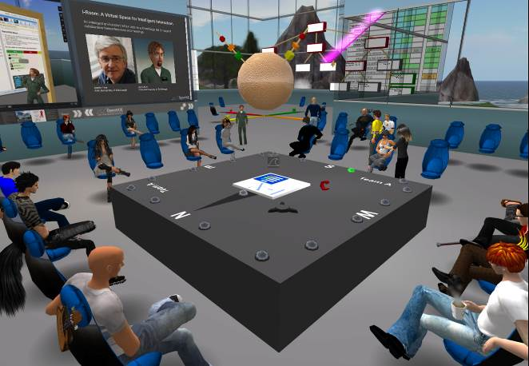
Figure 1: A synchronous meeting in an I-Room, a virtual collaborative space
Seeking more effective and efficient means to facilitate crisis response, in 2009 the US Joint Forces Command (USJFCOM) and the US Army Research Laboratory’s Human Research and Engineering Directorate (ARL HRED) launched a project under the direction of one of the authors (Hansberger) to design and evaluate a VCE, and hopefully to demonstrate its potential for distributed crisis response planning. More broadly, the project sought to discover implications for any distributed collaborative activity. The designers and developers of the VCE included groups from the University of Edinburgh, the University of Virginia, Carnegie Mellon University and Perigean Technologies LLC, each of which had an existing and complementary interest in collaborative work and so would bring specialized knowledge or technology to the program.
The initial technical concept behind the VCE was to investigate the potential of new media technologies, specifically social networking and virtual worlds, to provide a virtual environment that fosters community spirit and collaborative effort in some particular field (a field in which, we assume, there exists a potential community of users who have complementary knowledge or skills that contribute to problem-solving). Thus envisaged, the VCE would have several specific requirements:
- The creation and maintenance of a community of on-line users with diverse backgrounds (including those with little or no prior experience of virtual or on-line communities). In the first instance, the VCE was intended to support a Whole of Society Crisis Response (WoSCR) community, a loosely affiliated community of subject-matter experts and crisis responders drawn from international government and civilian organizations for the purpose of contributing their specialized knowledge to crisis response planning activities. In the course of the project an initial mailing list of 1600 people already involved in such activities was used to establish the community, of which, at the time of writing, some 300 are active within the VCE facilities that have been provided. It contains members from a number of countries (although initially with a strong US bias) drawn from the worlds of government, business and academia.
- The ability for users to conduct synchronous collaborations for the purpose of collective decision-making during specific problem-solving episodes.
- The provision for the users of mechanisms for the asynchronous creation and development of on-line material. This itself has two aspects: the short-term development of informational material as a part of the problem-solving process; and the long-term development of an on-line body of experience, knowledge and debate about the field in question.
In other words, collaborations in the environment would have two, quite different, aspects: a continuous asynchronous collaboration among users to discuss and develop on-line documentation pertaining to their field of interest (activities which would also help foster a sense of community); and interspersed synchronous problem-solving collaborations of relatively short duration in which their expertise is put into practice. It was envisaged that web and virtual worlds’ technologies together would provide the technical backbone for meeting these requirements. As a first step, in order to validate these initial assumptions, a Cognitive Work Analysis (CWA) was performed.
- Cognitive Work Analysis of Distributed Collaboration
The design of the VCE was guided by a Cognitive Work Analysis (Vicente, 1999; Lintern, 2009) of distributed collaboration, with the goal-directed phases of forming, storming, norming and performing (Tuckman, 1965) providing a framework for understanding and supporting specific instances of collaborative tasks.
Any group of humans brought together to perform some task can be considered to constitute a cognitive system: it has knowledge and understanding, can plan, decide, learn, and in general solve problems. However, this system invariably functions within a technological context: people use technical artifacts to perform their tasks (even natural language is such an artifact, properly speaking), and, moreover, apply particular, perhaps socially or culturally mediated, physical and mental techniques in their use of these artifacts. A CWA attempts to make explicit the constraints that hold on work – rather than the task, hence maintaining the focus on the human – that is done within complex cognitive systems (in short, those that have a certain amount of unpredictability and so cannot be proceduralized). It is also normative, in the sense that it is intended to identify the technical and organizational relationships that must be in place for the work to be performed effectively. In this manner, a CWA typically focuses on how work can be done compared to other types of task analyses that focus on how work should be done in a limited set of situations, which can decrease the flexibility and adaptability of the socio-technical system. While it is not itself a design method, the results of a CWA can be used to support particular design decisions, as was the case here.
A CWA progresses through multiple phases that systematically analyze the constraints on work, agents, organizations and activities. Here we restrict ourselves to discussing the results of the first – and probably the most difficult and important – phase: Work Domain Analysis.
This first phase of the CWA involves identifying the activity-independent constraints of the work domain; following Lintern (2009), here this has been done by decomposing the domain according to five levels of abstraction arranged hierarchically. This analysis results in the map shown in Figure 2, with content as follows:
- Domain purpose: the overarching goal to be achieved – in this case, distributed collaboration.
- Domain values and priorities: principles or qualities on which work in the domain is founded – in this case, we identify coordination, communication and activity awareness as essential components of distributed collaboration.
- Domain functions: the realization of the domain values and priorities (and fulfillment of the domain purpose) as abstract functions within the domain; in this case, we refer to the 4 stages of Tuckman’s goal-directed group behavior.
- Physical functions: the realization of the domain functions in terms of techniques (Pinelle, Gutwin and Greenberg, 2003).
- Physical objects: technological artifacts that provide some aspect of the identified physical functionality, with particular reference to the opportunities offered by social web technologies as well as existing content management technologies. Since we are trying to anticipate a collaborative environment that does not yet exist, or only partially, this level of the analysis is unavoidably biased by our interests and awareness of current technologies. The central position of the virtual 3D meeting space as a potential for supporting multiple physical functions lends a certain amount of credence to this as a potential tool for distributed collaboration; however, this can only be borne out by its successful use. It can be seen that the virtual space potentially offers all but one of the physical techniques that are provided by the other principal ‘synchronistic’ interaction technology, video conferencing (the omission being the loss of physical-gesture communication). In addition, the virtual space offers the opportunity for (persistent) information access and transfer. On this basis, for the VCE, a virtual space was chosen instead of video-conferencing.
Overall, the resulting analysis provides a coherent way of ensuring there is a technical solution for each of the identified domain functions and their physical manifestations, while avoiding the gratuitous introduction of technologies that add little or no useful functionality.
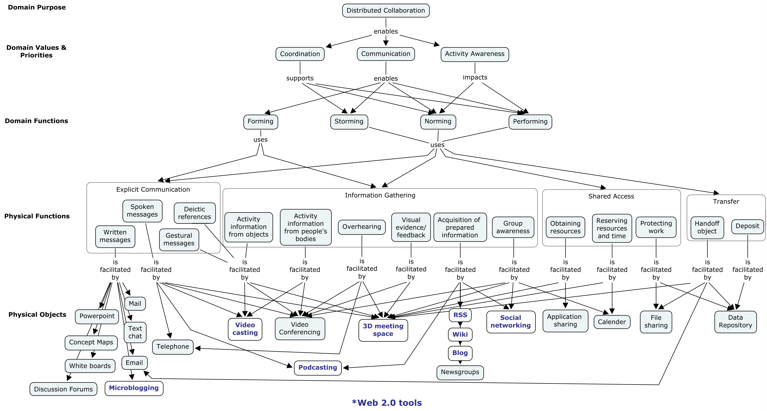
Figure 2: Cognitive Work Analysis Phase I – Work Domain Analysis
- OpenVCE: Virtual Collaboration Environment Package
So with the results of the CWA going some way to confirm the initial concept, we could begin to put the technologies in place for the VCE. In this section we discuss three of these technologies, namely a web-based portal, a virtual collaboration space, and the collaboration protocols that were introduced to guide the use of the VCE. In their generic forms, these, along with other contributory technologies, have been packaged as the OpenVCE solution – open, since in the technologies chosen there was a strong bias towards those that are open source or open access, ensuring that the system as a whole would be available to as wide a range of potential user communities as possible.
  - Community Web Portal
The VCE includes a web-based portal that would provide the platform for the diachronic aspects of collaboration and communication, and for creating and sharing resources, as well as more general group-building activity and event awareness (http://openvce.net – see Figure 3). After some experimentation and discussion (see http://openvce.net/forum-alternative-platforms and http://openvce.net/more), the open-source Drupal®-based software system was adopted as the platform for this site. Drupal is a widely used modular content management system, with an active development community of its own. It provides a user management system and social web functionality such as user profiles, individual blogs and forums. The site was specialized with a range of modules to provide, for instance, twitter-like activity awareness, picture sharing and group management facilities to allow ad hoc teams to be constructed from among the membership as a whole for specific purposes (such as working on a specific response problem). It also includes mechanisms that establish relationships of individuals to the virtual space, allowing users to associate their virtual personae with their real life web profiles. Links are provided to allow users to “teleport” into relevant locations of the virtual world. This site has been augmented by a wiki (powered by the popular open source MediaWiki software), to provide facilities for co-authoring text documents (a facility felt to be lacking at the time in Drupal).
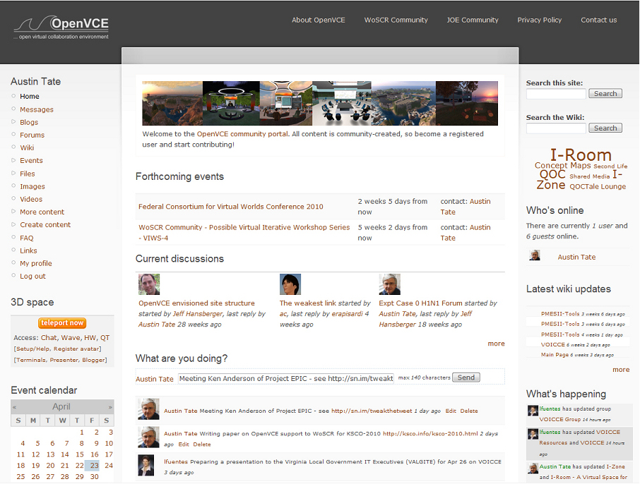
Figure 3: openvce.net web portal home page
The deployment and administration of this web portal requires appropriate hosting hardware and a certain amount of expertise to manage the site and its users. This approach also allows for additional functionality to be made accessible to the community by embedding appropriate tools within site pages. These tools can be generic community tools or introduced for specific tasks.
  - Virtual Space for Intelligent Interaction: the I-Room
In addition to its social and entertainment uses, as argued above, virtual worlds technology has the potential to enrich more serious forms of remote collaboration. We have developed these ideas into the concept of the I-Room. Put simply, an I-Room is an environment designed for intelligent interaction. It can provide support for formal business meetings, tutorials, project meetings, discussion groups and ad-hoc interactions. The I-Room can be used to organize and present pre-existing information as well as displaying real-time information feeds from other systems such as sensor networks and web services. It can also be used to communicate with participants, facilitate interactions, record and action the decisions taken during the collaboration.
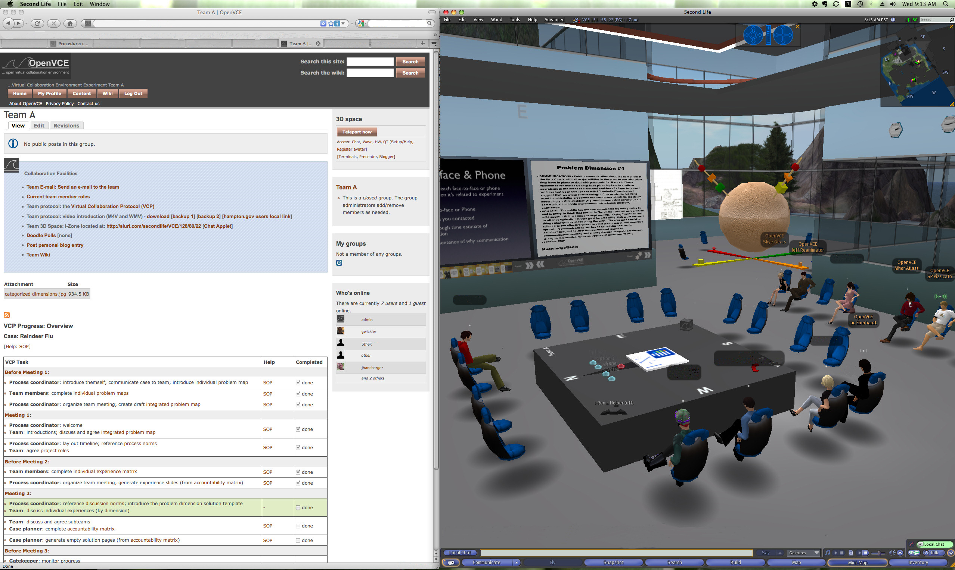
Figure 4: VCE web portal showing protocol support facilities, alongside an I-Room virtual space
In practice, Second Life® and OpenSimulator environments have been used to realize I-Rooms.Figure 4 shows an I-Room alongside a browser onto the web portal, typical of how a user’s screen might be laid out while using the VCE. Using the I-Room concept within virtual worlds gives a collaboration an intuitive grounding in a persistent space in which representations of the participants (their “avatars”) appear and the artifacts and resources surrounding the collaboration can be granted a surrogate reality – which, where these items consist of information, might be more meaningful or compelling than their physical reality. Although for the uninitiated the virtual space can initially be disorienting and video game-like, in our experience users quickly feel comfortable in the space once any technical issues are ironed out (as is the case for other video-conferencing systems, these issues are usually related to audio difficulties or firewalls). Through an avatar a user can see the avatars of other users of the space, and communicate with those in earshot using spatialized voice (communication is also possible using general text chat and instant messaging). This audio-visual positioning in 3D space provides a compelling sense of shared presence with any other users currently in the same space; however, unlike video-conferencing, this medium lacks reinforcing cues such as eye-contact and properly synchronized head-nods (along with other forms of accurate gestural communication) to confirm a speaker has the audience’s attention or even that the members of the audience are actually ‘in attendance’ at their computers. Another difficulty, at least in the case of the chosen virtual platforms, is the mutability of a user’s avatar – all aspects of its appearance, even its gender, can be changed on a whim – which could lead to doubt about just whose presence one is sharing; and although each avatar has its name floating above its head, since permitted names are tightly controlled to ensure uniqueness this is only of limited value until a sure association with a human user is made. The VCE includes certain technical mechanisms, such as the provision of virtual name-tags linked to the user’s web profile, to assist in this aspect. These characteristics of the virtual worlds threaten to undermine social structures such as authority and trust that are grounded in identity. (On the other hand, they could come to represent advantages of the virtual space, as visual prejudices must be put to one side.)
In addition to its use as a distributed access meeting space, the I-Room can be used to deliver intelligent systems and tool support for meetings and collaborative activities. In particular, the I-Room is designed to draw on I-X technology (Tate, 2000) which provides intelligent and intelligible (to human participants) task support, process management, collaborative tools and planning aids to participants. This technology encourages collaborators to share information about the processes or products they are working on through a common conceptual model called <I-N-C-A> (Tate, 2003). This framework allows access to automated capabilities or agents in a coherent way, providing participants in I-Room meetings with, for instance, access to knowledge-base content and natural language generation technology.
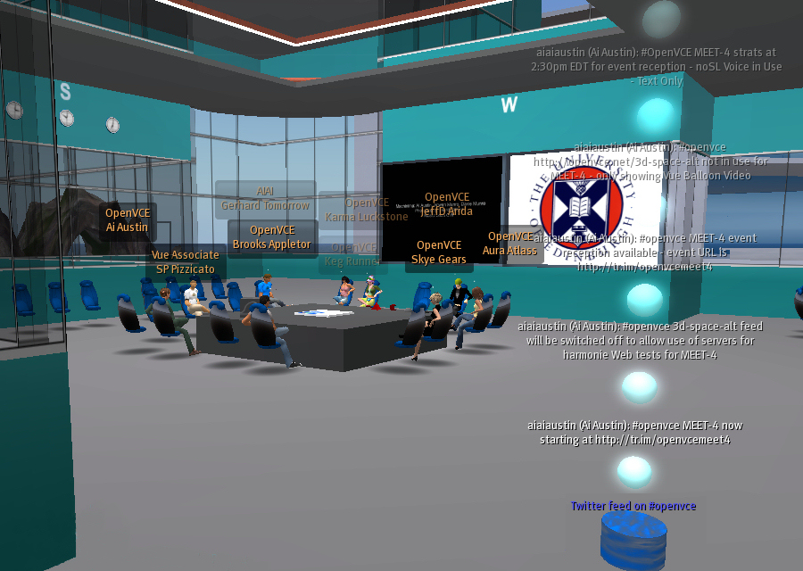
Figure 5: Sample I-Room showing information feeds and external agent links
I-Rooms have their origins in work to supplement video teleconferencing systems in the late 1990s and have been in use since early 2008 for a range of collaborative groups, meetings and training exercises (see Figure 5). Applications to date include emergency response operations, use for experimentation and exercises, and support to a geographically dispersed cross-disciplinary team engaged in the creation of a multi-media product, as well as collaborations with a ‘softer’, social goal (including tutored Scotch whisky tastings – involving real, not virtual, whisky and purely for educational purposes, of course) (Tate et al., 2010; Tate, 2011).
  - Virtual Collaboration Protocol
It is one thing to provide an appropriate environment for interaction; it is quite another to expect people to use it straight away in the most effective manner, especially when one considers the potential novelty of many of the technologies involved. Furthermore, the success of collaborations is often determined to a great extent by the experience of those involved and their collective ability to organize their efforts. Accordingly, so as to provide some structure for collaborations, it has been necessary to consider the use of “virtual collaboration protocols”, intended to guide distributed collaborative activities across the diverse tools and organizations typically involved in crisis response. An initial protocol was developed (see http://openvce.net/vce-protocol) by Dr. Rob Cross (University of Virginia) that is intended to guide the behaviour of a team comprised of WoSCR members convened in order to provide expert advice to an external agency; it is expected that the request would be of a complexity that demands alternating virtual meetings and periods of extended individual effort from the team members. The protocol is influenced by Tuckman’s forming-storming-norming-performing collaboration model and by how individuals communicate and collaborate through social networks (Cross and Parker, 2004). One particular challenge that the protocol has to accommodate is coordinating efforts among a team without an initially designated leader, which is the case in many large-scale crisis efforts with multiple organizations. Early stages, which might be curtailed or omitted in subsequent collaborations, aim to establish familiarity with the process, awareness of the characters and abilities of the participants and foster the sense of ‘group presence’. Managerial roles are assigned, distributing responsibilities and authorities among the collaborators, before the team progresses through a series of different tasks that decompose the problem and then compose a solution.
To accompany this protocol tools based on the <I-N-C-A> framework have been developed and made accessible through the web portal to help track the status of the collaboration, manage roles, communicate with team members, and enter and share information. Furthermore, a number of standard operating procedures have been written to further decompose the subtasks detailed in the protocol in terms of the specific social web and other technologies that might be used to complete them (Wickler and Potter, 2010; Wickler et al., 2013).
- Experiments
The VCE attempts to facilitate distributed collaboration by integrating asynchronous collaboration through social web technologies and synchronous collaboration through I-Rooms and virtual environments. Two experiments were conducted in 2010 to examine the impact the VCE had on crisis planning and collaboration when compared to traditional means of distributed collaboration among crisis response organizations and individuals. Results and conclusions from the second and more comprehensive of the two experiments will be discussed here.
The VCE experiment introduced a biological agent outbreak scenario to two teams of equally staffed crisis expert volunteers distributed across the U.S., U.K., Canada and Italy. The traditional group (control condition) used technology and means that would normally be used for distributed collaboration across these types of organizations (government, industry, non-government, military, and academia) during a crisis, including e-mail for asynchronous and telephone and teleconferencing for synchronous collaboration. The virtual group (experimental condition) used the full capability of the VCE as described in this paper. The traditional group consisted of 7 participants and the virtual group had 10 participants. Each group had what was considered equal expertise in crisis response and biological outbreaks and had no prior experience working with each other. Each group was given the same scenario and asked to generate a crisis response plan over four days.
Among one of the measurements taken each experiment day was a measure of uncertainty for each participant. Uncertainty was evaluated along two dimensions, namely goal and procedural uncertainty. Goal uncertainty is defined as the level of ambiguity a person has about the goals or objectives in their current situation or task. Procedural uncertainty, on the other hand, is how much ambiguity is associated with the steps or procedures necessary to accomplish the defined goals. Two seven-point Likert scale items measured each uncertainty dimension, which were averaged together. Choo (2005) has defined these uncertainty dimensions in terms of their interactions with each other. The amount of goal and procedural uncertainty possessed by an individual and group will dictate the mode (see Figure 6) of interactions and ultimately the success of the group.
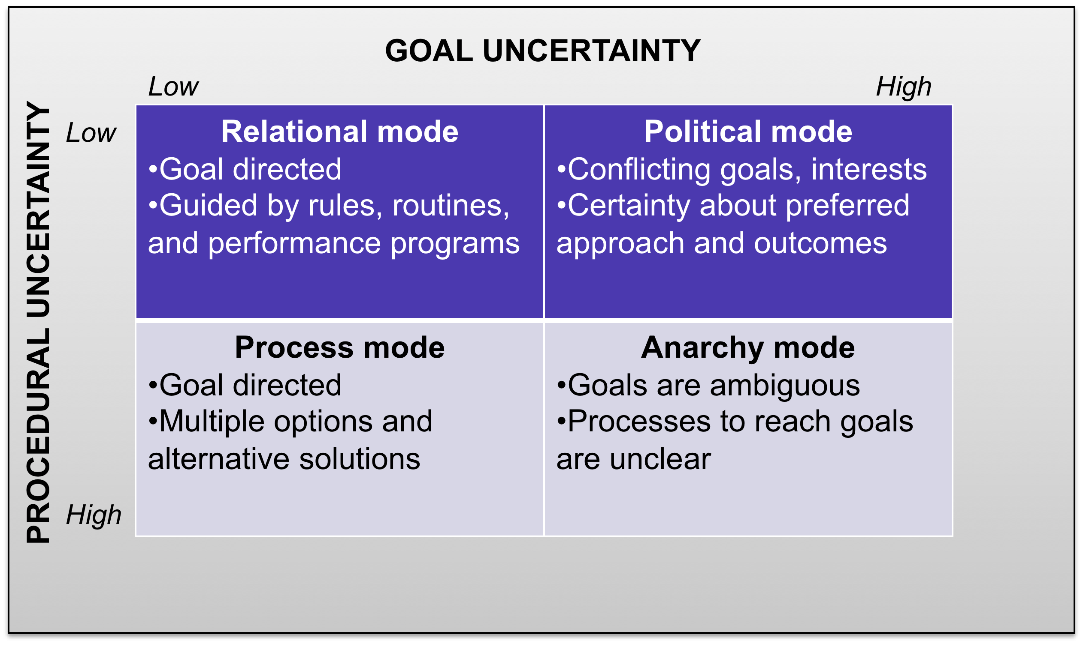
Figure 6: Goal and procedural uncertainty dimensions and the various modes of interaction they can create
based on the levels of uncertainty for each dimension.
Placing the results for goal and procedural uncertainty along the uncertainty dimensions presents a clear picture of how much uncertainty was involved for each group (Figure 7). The traditional group finds themselves interacting in the “anarchy mode” where there is ambiguity with both goals and procedures. Group and individual feedback after the experiment confirms this finding. There was considerable effort needed by this group to establish a common ground and understanding within the group before they could engage in any planning efforts. This is also indicative of collaboration efforts among many different organizations, involving people with different backgrounds and expertise, particularly when they have not worked together before. The virtual group using the VCE and collaboration protocol fared much better and found themselves working within the “relational mode” where goals and procedures are clear and understood. The overall difference between the two groups was statistically examined using repeated measures analysis of variance (ANOVA) and there was a significant difference between the two groups as suggested in Figure 7 (F(1, 15) = 10.31, p < .01). The virtual group had less goal and procedural uncertainty as they collaborated with their colleagues, which can result in increased efficiency and performance. These findings provide some evidence of the positive influence that can be gained using integrated technologies to support both asynchronous and synchronous collaboration over space and time.
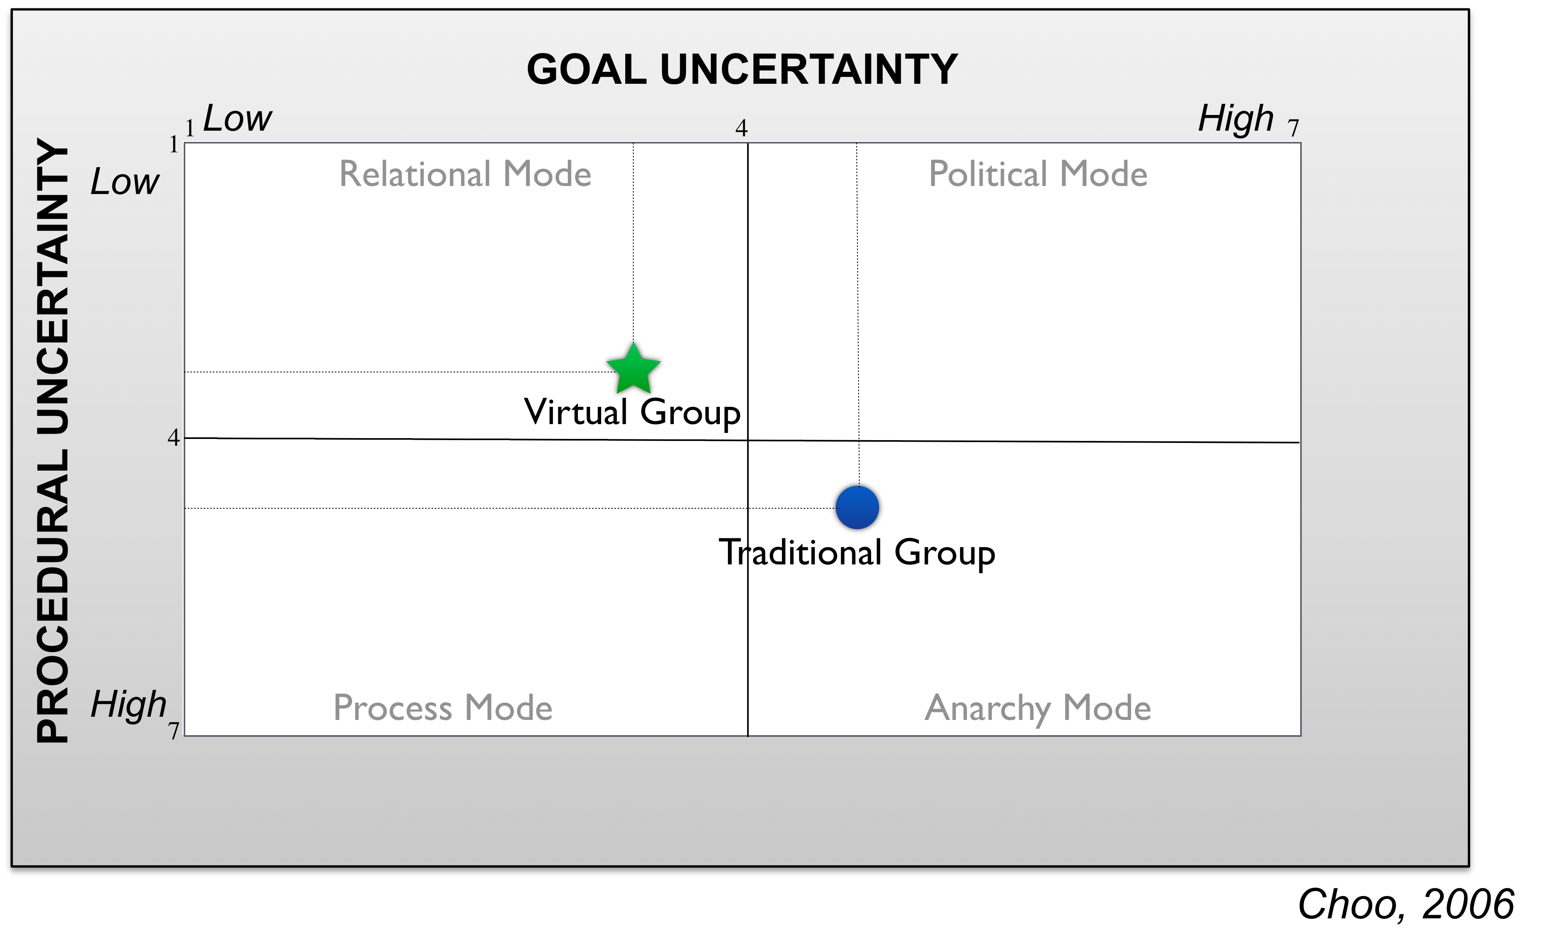
Figure 7: Goal and procedural uncertainty results from the virtual and traditional groups showing differences in uncertainty and the mode each group was interacting within.
- Conclusion
The Virtual Collaboration Environment has been developed as a means to support the activities of distributed communities, specifically – but not exclusively – the activities of the WoSCR community. It is intended to supplement existing social web with virtual spaces that provide a means for the simultaneous presence of individuals that is a prerequisite for certain aspects of collaborative activity. Collaboration protocols and other tools are provided to help with the use of this environment.
The efforts described in this paper have been driven by the idea that these novel technologies offer new possibilities for task-directed distributed collaboration, and the desire to experiment with these. The cognitive work analysis and the results of the experiments provide a certain amount of justification for their use, but further work is needed to put the technologies and the ways in which they are used on a firm theoretical footing. This need is both confirmed by and made more difficult by the rate at which social web and virtual technologies are developing, and are subject to the vagaries of fashion and popularity. Attempts to keep abreast of these developments have required a great deal of technical experimentation and back-tracking, as we have watched new technologies emerge and supersede others, some of great potential. This has resulted in a certain ad hoc flavour to some of our work. However, underpinning all these efforts is the awareness that these technologies offer the emergent and often incidental property of allowing their users to assert their presence as participants in distributed communities; and also of the vital role that presence plays in any serious collaborative activity.
Acknowledgements
The OpenVCE project was funded by US Joint Forces Command, the Army Research Lab and Alion Science and Technology Corporation. Specific applications mentioned in this article have been sponsored by a number of organizations. The University of Edinburgh and research sponsors are authorized to reproduce and distribute reprints and online copies for their purposes notwithstanding any copyright annotation hereon. The views and conclusions contained herein are those of the authors and should not be interpreted as necessarily representing the official policies or endorsements, either expressed or implied, of other parties. Drupal and Second Life are registered trademarks of Dries Buytaert and Linden Research, Inc. respectively. The authors acknowledge the contribution to the work presented herein of their colleagues from University of Edinburgh, the University of Virginia, Carnegie Mellon University and Perigean Technologies LLC, and that of the many volunteers and professional emergency responders who generously donated their valuable time and expertise to take part in the experiments.

References
Baecker, R.M., Grudin, J., Buxton, W.A.S., Greenberg, S. (1995) Groupware and Computer-Supported Cooperative Work. In: R.M. Baecker, J. Grudin, W.A.S Buxton, S. Greenberg (eds.) Readings in Human-Computer Interaction: Toward the Year 2000, Morgan Kaufmann, 1995.
Choo, C. H. (2005). The Knowing Organization: How Organizations Use Information to Construct Meaning, Create Knowledge, and Make Decisions. Oxford University Press, New York, NY.
Cross, R. and Parker, A. (2004) The Hidden Power of Social Networks: Understanding How Work Really Gets Done in Organizations, Harvard Business School Press.
Lintern, G. (2009). The Foundations and Pragmatics of Cognitive Work Analysis: A systematic approach to design of large-scale information systems. Retrieved from
http://www.CognitiveSystemsDesign.net
Moon, B., Hansberger, J.T. and Tate, A. (2011). Concept Mapping in Virtual Collaboration Environments. In: B. Moon, R.R. Hoffman, J. Novak and A. Canas (Eds.) Applied Concept Mapping: Capturing, Analyzing, and Organizing Knowledge.
Pinelle, D. Gutwin, C. and Greenberg, S. (2003). Task analysis for groupware usability evaluation: Modeling shared-workspace tasks with the mechanics of collaboration, ACM Transactions on Computer-Human Interaction (TOCHI), 10 (4), 281-311.
Tate, A. (2000) Intelligible AI Planning. In Proceedings of ES2000, The Twentieth British Computer Society Special Group on Expert Systems International Conference on Knowledge Based Systems and Applied Artificial Intelligence, pp. 3-16, Springer. Retrieved from http://www.aiai.ed.ac.uk/project/ix/documents/2000/2000-sges-tate-intelligible-planning.pdf
Tate, A. (2003) <I-N-C-A>: a Shared Model for Mixed-Initiative Synthesis Tasks. In Proceedings of the Workshop on Mixed-Initiative Intelligent Systems (MIIS) at the International Joint Conference on Artificial Intelligence (IJCAI-03). Acapulco, Mexico, August 2003. Retrieved from http://www.aiai.ed.ac.uk/project/ix/documents/2003/2003-ijcai-miis-tate-inca.pdf
Tate, A. (2011) I-Room: Augmenting Virtual Worlds with Intelligent Systems to Support Collaborative Decision Making, Special Issue on "Virtual Worlds Architectures", IEEE Internet Computing, (15) 5, pp 56-61, September-October 2011, IEEE Computer Society. Retrieved from http://www.aiai.ed.ac.uk/project/ix/documents/2011/2011-ieee-ic-tate-iroom.pdf
Tate, A., Chen-Burger, Y-H., Dalton, J., Potter, S., Richardson, D., Stader, J. …Williams, P.G. (2010) I-Room: A Virtual Space for Intelligent Interaction, IEEE Intelligent Systems, July/August 2010, 62-71. Retrieved from http://www.aiai.ed.ac.uk/project/ix/documents/2010/2010-ieee-is-tate-iroom.pdf
Tuckman, B.W. (1965) Developmental Sequence in Small Groups, Psychological Bulletin, 63(6), 384-99.
Vicente, K. J. (1999). Cognitive Work Analysis. Lawrence Erlbaum Associates, Mahwah, NJ.
Wickler, G. and Potter, S. (2010) Standard Operating Procedures: Collaborative Development and Distributed Use, Proceedings of the 7th International Conference on Information Systems for Crisis Response and Management (ISCRAM 2010), Seattle, WA, May 2010. Retreieved from: http://www.aiai.ed.ac.uk/project/ix/documents/2010/2010-iscram-wickler-collaborative-sops.pdf
Wickler, G., Tate, A. and Hansberger, J. (2013). Using Shared Procedural Knowledge for Virtual Collaboration Support in Emergency Management, in Special Issue on Emergency Management, IEEE Intelligent Systems, (28) 4, July/August 2013, IEEE Computer Society. Retrieved from http://www.aiai.ed.ac.uk/project/ix/documents/2013/2013-ieee-is-wickler-inca-wiki.pdf

