Valkyrie in the Virtual World

Prof. Austin Tate has taken the NASA 3D models of the Valkyrie robot and used them to create a wearable avatar for the open-source OpenSimulator virtual world. The Informatics Forum and InSpace area where the real Valkyrie is to be located are already modelled and available on the "Open Virtual University of Edinburgh" (Openvue) virtual world grid. The avatar can also be used as the visual model for a scripted and animated Non-Player Character (NPC) in OpenSimulator. This opens up the potential for making machinima related to the Valkyrie for projects conducted with the real robot.
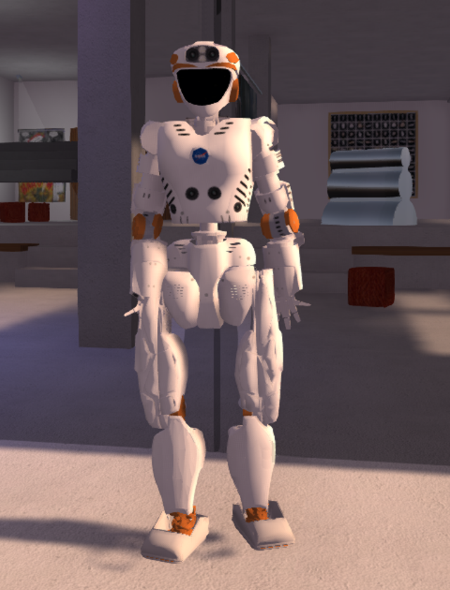

See this blog post for more information, images and a link to download the Valkyrie avatar for use in OpenSimulator...
http://blog.inf.ed.ac.uk/atate/valkyrie-avatar/
http://vue.ed.ac.uk/resources/valkyrie/

Prof. Tate’s research is in AI planning especially involving collaboration between people, systems and robots. He created the MSc level AI Planning MOOC (Massive Open Online Course). He is coordinator for the Virtual University of Edinburgh (Vue) and is the School of Informatics distance education coordinator. His virtual world avatar is “Ai Austin”.
