Coalition Task Support using I-X and <I-N-C-A>
Austin Tate
Artificial Intelligence Applications Institute, University of Edinburgh,
Appleton Tower, Crichton Street, Edinburgh EH8 9LE, UK
a.tate@ed.ac.uk
http://www.aiai.ed.ac.uk/project/ix/

Abstract. I-X is a research programme with a number of different aspects intended to create a well-founded approach to allow humans and computer systems to cooperate in the creation or modification of some product such as a design, physical entity or plan - i.e. it supports cooperative synthesis tasks. The I-X approach involves the use of shared models for task-directed cooperation between human and computer agents who are jointly exploring (via some, perhaps dynamically determined, process) a range of alternative options for the synthesis of an artifact such as a design or a plan (termed a product). The <I-N-C-A> (Issues - Nodes - Constraints - Annotations) ontology is used to represent a specific artifact as a set of constraints on the space of all possible artifacts in an application domain. It can be used to describe the requirements or specification to be achieved and the emerging description of the artifact itself. It can also describe the (perhaps dynamically generated) processes involved. I-X and |<I-N-C-A> have been applied to Coalition Task Support.

1 Introduction
I-X is a research programme with a number of different aspects intended to create a well-founded approach to allow humans and computer systems to cooperate in the creation or modification of some product or products such as documents, plans, designs or physical entities - i.e., it supports mixed-initiative synthesis tasks.

The I-X research draws on earlier work on Nonlin (Tate, 1977), O-Plan (Currie and Tate, 1991; Tate, 1995; Tate et. al., 1998; Tate et. al., 2000b, Levine et. al. 2000), Optimum-AIV (Aarup, 1994, Tate, 1996b), <I-N-OVA> (Tate, 1996; 2000a) and the Enterprise Project (Fraser and Tate, 1995; Uschold, et. al., 1998; Stader, 1996) but seeks to make the framework generic and to clarify terminology, simplify the approach taken, and increase re-usability and applicability of the core ideas.

The I-X research programme includes the following threads or work areas:

- I-Core, which is the core modular systems integration architecture.

- <I-N-C-A>, which is an underlying ontology for synthesised artifacts.

- I-P², which are I-X Process Panels used to support user tasks and cooperation.

- I-Plan, which is the I-X Planning System. This is also used within I-P2 and other applications as it provides generic facilities for supporting planning, process refinement, dynamic response to changing needs, etc.

- I-DE, which is the I-X Domain Editor. This is itself an I-X application but is also used to create and maintain the domain models, including especially the process models and activity specifications used throughout I-X systems.

- I-Views, which are viewers for processes and products, and which are employed in other applications of I-X. I-Views can be for a wide range of modalities of interface and types of user.

- I-Faces, which are underlying support utilities to allow for the creation of user interfaces, inter-agent communications and repository access.

- I-X Applications of the above threads in a variety of areas depending on our current collaborations. These include:
  - Coalition Operations (CoAX, CoSAR-TS)
  - Emergency and Unusual Procedure Assistance (I-Rescue)
  - Help Desk Support (I-Help)
  - Multi-Perspective Knowledge Modelling and Management (I-AKT)
  - Natural Language Presentations of Procedures and Plans (I-Tell)
  - Collaborative meeting and task support (I-Room, CoAKTinG).

- I-X Technology Transfer, including work on standards committees.

2 I-X Approach
The I-X approach involves the use of shared models for task-directed cooperation between human and computer agents who are jointly exploring (via some predefined or dynamically created process) a range of alternative options for the synthesis of one or more artifacts such as a design or a plan (termed a product).

An I-X system or agent has two cycles:

- Handle Issues (leading to the addition of Nodes especially, but also potentially further Issues, Constraints and Annotations)
- Respect Domain Constraints

An I-X system or agent carries out a (perhaps dynamically determined) process that leads to the production of (one or more alternative options for) a synthesised artifact.

I-X also involves a modular systems integration architecture that strongly parallels and supports the abstract view described. This is a Model - Viewer - Controller style of architecture. Plug-in components for Issue Handlers, Constraint Managers, I/O Handlers and Viewers allow for specific I-X systems to be created using this abstract architecture. More detail is available at the I-X web site - http://i-x.info.

3 <I-N-C-A> Ontology
<I-N-C-A> (Issues - Nodes - Constraints - Annotations) is the basis of the ontology that underpins the I-X approach, and provides the framework for the representation used to describe processes and process products within I-X systems and agents.

The forerunner of <I-N-C-A, <I-N-OVA> (Tate, 1996), when first designed, was intended to act as a bridge to improve dialogue between a number of communities working on formal planning theories, practical planning systems and systems engineering process management methodologies. It was intended to support new work then emerging on automatic manipulation of plans, human communication about plans, principled and reliable acquisition of plan information, and formal reasoning about plans. It has since been utilised as the basis for a number of research efforts, practical applications and emerging international standards for plan and process representations. For some of the history and relationships between earlier work in AI on plan representations, work from the process and design communities and the standards bodies, and the part that <I-N-OVA> played in this see Tate (1998).

At various stages of the development of the I-X research the typography for rendering <I-N-C-A> has varied as the components have received clarification. <I-N-CA> originally stood for Issues, Nodes, Critical and Auxiliary Constraints. The aspect of separating critical (shared communications) constraints from auxiliary (separately managed) constraints is still important within the I-X architecture, but is now considered a part of managing the "C" (constraints) component. The annotations were always present in the ontology and can be attached to all components, but the top level annotations capturing the rationale behind the synthesised product or the process/plan being described has required more prominence as the work has continued and as mixed-initiative and human communications aspects have become more important. Hence, the rendering <I-N-C-A> with the extra hyphen now stands for Issues, Nodes, Constraints and Annotations.

In <I-N-C-A>, both processes and process products are abstractly considered to be made up of a set of "Issues" which are associated with the processes or process products to represent potential requirements, questions raised as a result of analysis or critiquing, etc. They also contain "Nodes" (activities in a process, or parts of a physical product) which may have parts called sub-nodes making up a hierarchical description of the process or product. The nodes are related by a set of detailed "Constraints" of various kinds. Finally there can be "Annotations" related to the processes or products, which provide rationale, information and other useful descriptions. The I-X systems integration approach is based on the <I-N-C-A> Model of Synthesised Artifacts that provides it with a simple abstraction that provides an extremely flexible, extendable and intelligible representation of the processes and process products in I-X. It is well suited to communication between human and system agents engaged in some common task, each possibly taking the initiative over which parts they can handle at various stages.

3.1 Issues
The issues in the representation may state the outstanding questions to be handled and can represent unsatisfied objectives, questions raised as a result of analysis, etc. The I constraints can be thought of as implying potential further constraints which may have to be added into the design in future in order to address the outstanding issues. In work on I-X until recently, the issues had a task or activity orientation to them, being mostly concerned with actionable items referring to the process underway - i.e., actions in the process space. This is now not felt to be appropriate, and we are adopting the gIBIS orientation of expressing these issues as questions to be considered (Selvin, 1999; Conklin, 2003). This is advocated by the Questions - Options- Criteria approach (MacLean et. al., 1991) - itself used for rationale capture for plans and plan scheme libraries in our earlier work (Polyak and Tate, 1998; 1999) and similar to the mapping approaches used in Compendium (Selvin et. al. 2001).

3.2 Nodes
The nodes in the specifications describe components that are to be included in the design. Nodes can themselves be artifacts that can have their own structure with sub-nodes and other <I-N-C-A> described refinements associated with them.

The node constraints (these are of the form "include node") in the <I-N-C-A> model set the space within which an artifact may be further constrained. The "I" (issues) and "C" constraints restrict the artifacts within that space which are of interest.

Others have recognised the special nature of the inclusion of nodes (or activities) into a synthesised artifacts (or plan) compared to all the other constraints that may be described. In the planning domain, Khambhampati and Srivastava (1996) differentiate Plan Modification Operators into "progressive refinements" which can introduce new actions into the plan, and "non-progressive refinements" which just partition the search space with existing sets of actions in the plan. They call the former genuine planning refinement operators, and think of the latter as providing the scheduling component.

3.3 Constraints
The constraints restrict the relationships between the nodes to describe only those artifacts within the design space that meet the requirements. The constraints may be split into "critical constraints" and "auxiliary constraints" depending on whether some constraint managers (solvers) can return them as "maybe" answers to indicate that the constraint being added to the model is okay so long as other critical constraints are imposed by other constraint managers. The maybe answer is expressed as a disjunction of conjunctions of such critical or shared constraints. More details on the "yes/no/maybe" constraint management approach used in I-X and the earlier O-Plan systems are available in Tate (1995).

The choice of which constraints are considered critical and which are considered as auxiliary is itself a decision for an application of I-X and specific decisions on how to split the management of constraints within such an application. It is not pre-determined for all applications. A temporal activity-based planner would normally have object/variable constraints (equality and inequality of objects) and some temporal constraints (maybe just the simple before{time-point1, time-point-2} constraint) as the critical constraints. But, in a 3D design or a configuration application object/variable and some other critical constraints (possibly spatial constraints) might be chosen. It depends on the nature of what is communicated between constraint managers in the application of the I-X architecture.

3.4 Annotations
The annotations add additional human-centric information or design and decision rationale to the information describing the artifact.

3.5 Observation
If we consider the process of planning as a large constraint satisfaction task, we may try to model this as a Constraint Satisfaction Problem (CSP) represented by a set of variables to which we have to give a consistent assignment of values. In this case we can note that the addition of new nodes ("include node" constraints in <I-N-C-A>) is the only constraint that can add variables dynamically to the CSP. The Issue (I) constraints may be separated into two kinds: those that may (directly or indirectly) add nodes to the product and those that cannot. The "I" constraints that lead to the inclusion of new nodes are of a different nature in the process to those that cannot.

4 Putting <I-N-C-A> to Use
<I-N-C-A> models are intended to support a number of different uses:

- for automatic and mixed-initiative generation and manipulation of plans and other synthesised artifacts and to act as an ontology to underpin such use;
- as a common basis for human and system communication about plans and other synthesised artifacts;
- as a target for principled and reliable acquisition of knowledge about synthesised artifacts such as plans, process models and process product information;
- to support formal reasoning about plans and other synthesised artifacts.

These cover both formal and practical requirements and encompass the requirements for use by both human and computer-based planning and design systems.

5 I-X Process Panels
We "deliver" useful functionality based on the <I-N-C-A> ontology via I-X Process Panels (I-P2). These support a user or collaborative users in selecting and carrying out "processes" and creating or modifying "process products". The aim of an I-X Process Panel (I-P2) is to act as an intelligent workflow support, reporting and messaging "catch all" for its user. It can act in conjunction with other panels for other users if desired.

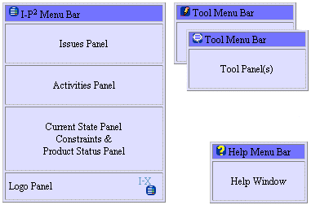

Fig. 1. Anatomy of an I-X Process Panel

An I-X Process Panel:

- Can take requests to:
  - Handle an issue
  - Perform an activity
  - Add a constraint
  - Support an annotation

- Deals with these via:
  - Manual (user) activity
  - Internal capabilities
  - External capabilities (invoke or query/answer)
  - Reroute or delegate to other panels or agents (pass)
  - Plan and execute a composite of these capabilities (plan or expand)

- Receives reports and messages and, where possible, interprets them to:
  - Understand current status of issues, activities, constraints and annotations
  - Understand current world state, especially status of process products
  - Help control the situation
  - Improve annotations

- Copes with partial knowledge and can operate even where little or no pre-built knowledge of the domain is available.
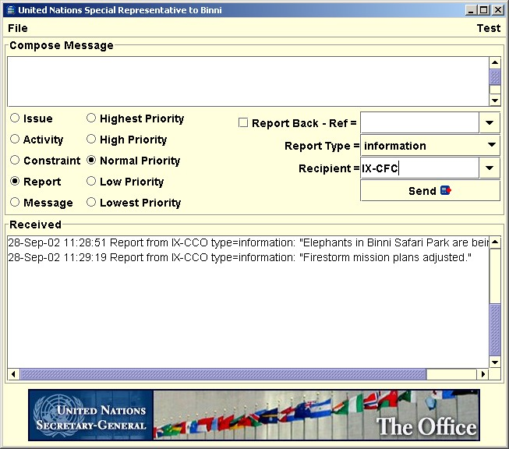
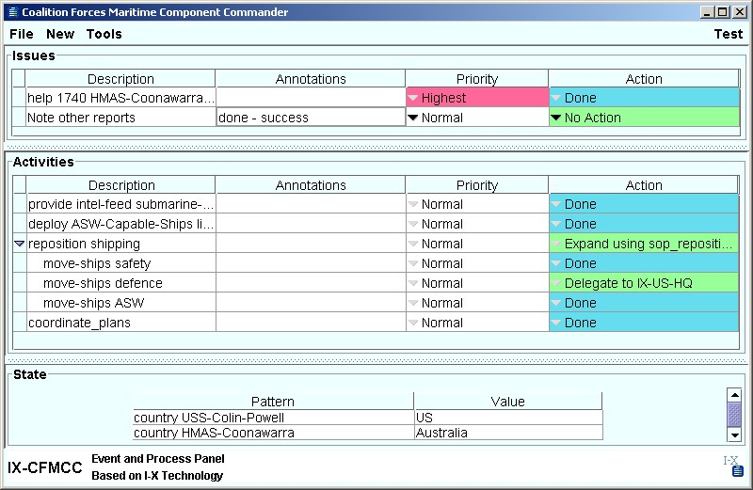
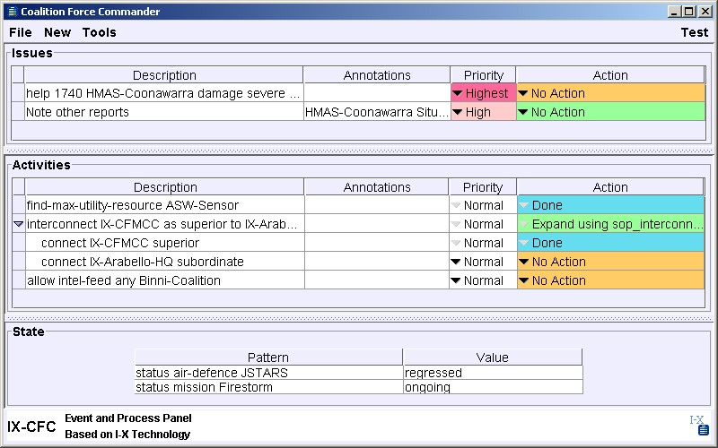

Fig. 1. CoAX I-X Process Panels

6 Coalition Task Support
I-X and I-X Process Panels (I-P2) concepts have been demonstrated in a number realistic scenarios such as in Air Campaign Planning (Tate et. al. 1998), Military Operations in Urban Terrain (Tate, et. al., 2000b), the Coalition Agents eXperiment - CoAX (Allsop et. al., 2001; 2002), and Coalition Search and Rescue (CoSAR-TS Team, 2003). They are being considered for use in a number of future joint and multi-national forces experiments and demonstrations.

7 Summary
I-X is aimed at supporting a range of collaborative mixed-initiative synthesis tasks - such as planning, design and configuration. It is intended to simplify and make more generic the component boundaries and naming conventions used in the construction of such systems and seeks to make the concepts more re-usable for a range of such tasks.

I-X is based on the <I-N-C-A> constraint ontology - a powerful and extremely flexible representation of the products of the synthesis process that an I-X system supports. This represents a product as a set of constraints on the space of all possible products within the model of the domain that the I-X system has. This ontology relates well to emerging standards for process representation and interchange (e.g. in PIF, NIST PSL, DARPA SPAR).

Both processes and process products are abstractly considered to be made up of a set of "Issues" which are associated with the processes or process products and may represent outstanding questions with respect to the products, unsatisfied requirements, problems raised as a result of analysis or critiquing, etc. They also contain "Nodes" (activities in a process, or parts of a process product) which may have parts called sub-nodes making up a hierarchical description of the process or product. The nodes are related by a set of detailed "Constraints" of various kinds. Finally there can be "Annotations" related to the processes or products, which provide rationale, information and other useful descriptions.

I-X and <I-N-C-A> have been utilized in a number of coalition cooperative task support scenarios in which the systems have to respond to dynamic events and changes of relationships between the agents involved.

Acknowledgements
Thanks to my co-workers on the I-X, CoAKTinG and CoSAR-TS projects at Edinburgh - especially Stuart Aitken, Jessica Chen-Burger, Clauirton de Siebra, Jeff Dalton, John Levine, Natasha Lino, Stephen Potter and Jussi Stader for discussions on the topic of this paper.

This material is based on research within the I-X and CoSAR-TS projects sponsored by the Defense Advanced Research Projects Agency (DARPA) and US Air Force Research Laboratory under agreement number F30602-03-2-0014 and under the Advanced Knowledge Technologies (AKT) Interdisciplinary Research Collaboration (IRC) and its Collaborative Advanced Knowledge Technologies in the Grid (CoAKTinG) project, which is sponsored by the UK Engineering and Physical Sciences Research Council under grant number GR/N15764/01. The AKT IRC comprises the Universities of Aberdeen, Edinburgh, Sheffield, Southampton and the Open University.

The U.S. Government, the University of Edinburgh, the AKT IRC research partners and sponsors are authorized to reproduce and distribute reprints and on-line copies for their purposes notwithstanding any copyright annotation hereon. The views and conclusions contained herein are those of the authors and should not be interpreted as necessarily representing the official policies or endorsements, either express or implied, of other parties.

References

Aarup, M., Arentoft, M.M., Parrod, Y., Stokes, I., Vadon, H. and Stader, J. (1994) Optimum-AIV: A Knowledge-Based Planning and Scheduling System for Spacecraft AIV, in Intelligent Scheduling (eds. Zweben, M. and Fox, M.S.), pp. 451-469, Morgan Kaufmann.

Allsopp, D.N., Beautement, P., Bradshaw, J.M., Durfee, E.H., Kirton, M., Knoblock, C.A., Suri, N. and Tate, A. and Thompson, C.W. (2002) Coalition Agents Experiment: Multi-Agent Co-operation in an International Coalition Setting, Special Issue on Knowledge Systems for Coalition Operations (KSCO), IEEE Intelligent Systems, Vol. 17 No. 3 pp. 26-35. May/June 2002.

Binni Web Site (2003), http://binni.org

Conklin, J. and Begeman, M. L. (1988). gIBIS: A hypertext tool for exploratory policy discussion. ACM Transactions on Office Information Systems, 4(6), 303-331.

Conklin, J. (2003) Dialog Mapping: Reflections on an Industrial Strength Case Study. In: P.A. Kirschner, S.J. Buckingham Shum and C.S. Carr (Eds.), Visualizing Argumentation: Software Tools for Collaborative and Educational Sense-Making. Springer-Verlag: London, ISBN 1-85233-6641-1, pp. 117-136. See www.VisualizingArgumentation.info

CoSAR-TS Team (2003) Coalition Search and Rescue Task Support Project Web Site. http://www.aiai.ed.ac.uk/project/cosar-ts/

Currie, K.W. and Tate, A. (1991) O-Plan: the Open Planning Architecture, Artificial Intelligence 52(1), Autumn 1991, North-Holland.

Fraser, J. and Tate, A. (1995) The Enterprise Tool Set - An Open Enterprise Architecture, Proceedings of the Workshop on Intelligent Manufacturing Systems, International Joint Conference on Artificial Intelligence (IJCAI-95), Montreal, Canada, August 1995.

Khambhampati, S. and Srivastava, B. (1996) Unifying Classical Planning Approaches, Arizona State University ASU CSE TR 96-006, July 1996.

Kunz, W. and Rittel, H.W.J (1970) Issues as Elements of Information Systems, Institute of Urban & Regional Development, University of California, Berkeley, CA, USA, Working Paper WP-131, July 1970. Available as http://www-iurd.ced.berkeley.edu/pub/abstract_wp131.htm

Levine, J., Tate, A. and Dalton, J. (2000) O-P3: Supporting the Planning Process using Open Planning Process Panels, IEEE Intelligent Systems, Vol. 15, No. 6, November/December 2000.

MacLean, A., Young, R., Bellotti, V. and Moran, T. (1991) Design space analysis: Bridging from theory to practice via design rationale. In Proceedings of Esprit '91, pages 720-730, Brussels, November 1991.

Polyak, S. and Tate, A. (1998) Rationale in Planning: Causality, Dependencies and Decisions, Knowledge Engineering Review, Vol.13(3), pp. 247-262, September, 1998, Cambridge University Press. See http://www.aiai.ed.ac.uk/project/oplan/documents/1998/98-rationale.pdf

Polyak, S. and Tate, A. (1999) A Common Process Ontology for Process-Centred Organisations, Knowledge based Systems, 2000. Earlier version by S. Polyak published as University of Edinburgh Department of Artificial Intelligence Research paper 930, 1998. See http://www.aiai.ed.ac.uk/project/oplan/documents/1999/99-sebpc-cpm.pdf

Schlenoff, C., Gruninger, M., Tissot, F., Valois, L., and Lubell, J. (1999) The Process Specification Language (PSL): Overview and Version 1.0 Specification, NIST Internal Report (NISTIR) 6459, National Institute of Standards and Technology, Gaithersburg, MD, USA

Selvin, A.M. (1999) Supporting Collaborative Analysis and Design with Hypertext Functionality, Journal of Digital information, Volume 1 Issue 4. See http://jodi.ecs.soton.ac.uk/Articles/v01/i04/Selvin/

Selvin, A.M, Buckingham Shum, S.J., Sierhuis, M., Conklin, J., Zimmermann, B., Palus, C., Drath, W., Horth, D., Domingue, J., Motta, E. and Li, G. (2001) Compendium: Making Meetings into Knowledge Events, Knowledge Technologies 2001, Austin TX, USA, March 4-7, 2001. See
http://www2.gca.org/ knowledgetechnologies/2001/proceedings/Conklin&Selvin%20Slides.pdf

Stader, J. (1996) Results of the Enterprise Project. In Proceedings of Expert Systems '96, the 16th Annual Conference of the British Computer Society Specialist Group on Expert Systems, Cambridge, UK, December 1996. See
http://www.aiai.ed.ac.uk/project/enterprise/96-es96-enterprise.ps.gz

Tate, A. (1977) Generating Project Networks, Proceedings of the International Joint Conference on Artificial Intelligence (IJCAI-77), pp. 888-893, Cambridge, MA, USA, Morgan Kaufmann.

Tate, A. (1994) Mixed Initiative Planning in O-Plan2, Proceedings of ARPA/Rome Laboratory Planning Initiative (ARPI) Workshop, Tucson Arizona, 22nd - 24th February, 1994, Morgan Kaufmann. See http://www.aiai.ed.ac.uk/~oplan/documents/1994/94-arpi-mixed-initiative.pdf

Tate, A. (1995) Integrating Constraint Management into an AI Planner, Journal of Artificial Intelligence in Engineering, Vol. 9, No.3, pp. 221-228,1995.

Tate, A. (1996a) The <I-N-OVA> Constraint Model of Plans, Proceedings of the Third International Conference on Artificial Intelligence Planning Systems, (ed. Drabble, B.), pp. 221-228, Edinburgh, UK, May 1996, AAAI Press.

Tate, A. (1996b) Responsive Planning and Scheduling Using AI Planning Techniques - Optimum-AIV, In Trends & Controversies - AI Planning Systems in the Real World, IEEE Expert: Intelligent Systems & their Applications, Vol. 11 No. 6, pp. 4-12, December 1996

Tate, A. (1998) Roots of SPAR, in Special Issue on Ontologies, Knowledge Engineering Review, Vol.13(1), March, 1998, Cambridge University Press.

Tate, A. (2000a) <I-N-OVA> and <I-N-CA> - Representing Plans and other Synthesized Artifacts as a Set of Constraints, AAAI-2000 Workshop on Representational Issues for Real-World Planning Systems, at the National Conference of the American Association of Artificial Intelligence (AAAI-2000), Austin, Texas, USA, August 2000.

Tate, A. (2000b) Intelligible AI Planning, in Proceedings of the Twentieth British Computer Society Special Group on Expert Systems International Conference on Knowledge Based Systems and Applied Artificial Intelligence, Cambridge, UK, December 2000.

Tate, A., Dalton, J. and Levine, J. (1998) Generation of Multiple Qualitatively Different Plan Options, Fourth International Conference on AI Planning Systems (AIPS-98), Pittsburgh, PA, USA, June 1998.

Tate, A., Dalton, J. and Levine, J. (2000a) O-Plan: a Web-based AI Planning Agent, AAAI-2000 Intelligent Systems Demonstrator, in Proceedings of the National Conference of the American Association of Artificial Intelligence (AAAI-2000), Austin, Texas, USA, August 2000.

Tate, A., Dalton, J., Jarvis, P. and Levine, J. (2000b) Using AI Planning Technology for Army Small Unit Operations, Poster Paper in the Proceedings of the Artificial Intelligence Planning and Scheduling Systems Conference (AIPS-2000), Breckenridge, Colorado, USA, April 2000.

Tate, A., Levine, J., Dalton, J. and Nixon, A. (2003) Task Achieving Agents on the World Wide Web, in Spinning the Semantic Web, Fensel, D., Hendler, J., Liebermann, H. and Wahlster, W. (eds.), MIT Press, 2003.

Uschold, M., King, M., Moralee, S. and Zorgios, Y. (1998) The Enterprise Ontology, in Special Issue on Ontologies, Knowledge Engineering Review, Vol.13(1), March, 1998, Cambridge University Press.

