Intelligent Agents for Coalition Search and Rescue Task Support
Austin Tate, Jeff Dalton, Clauirton de Siebra, Stuart Aitken
Artificial Intelligence Applications Institute (AIAI), University of Edinburgh, Edinburgh EH8 9LE, UK
{a.tate, j.dalton, c.siebra, s.aitken}@ed.ac.uk
Jeffrey M. Bradshaw, Andrzej Uszok
Institute for Human and Machine Cognition (IHMC), 40 S. Alcaniz, Pensacola, FL 32501, USA
{auszok, jbradshaw}@ihmc.us
http://www.aiai.ed.ac.uk/project/cosar-ts/demo/isd/

Abstract
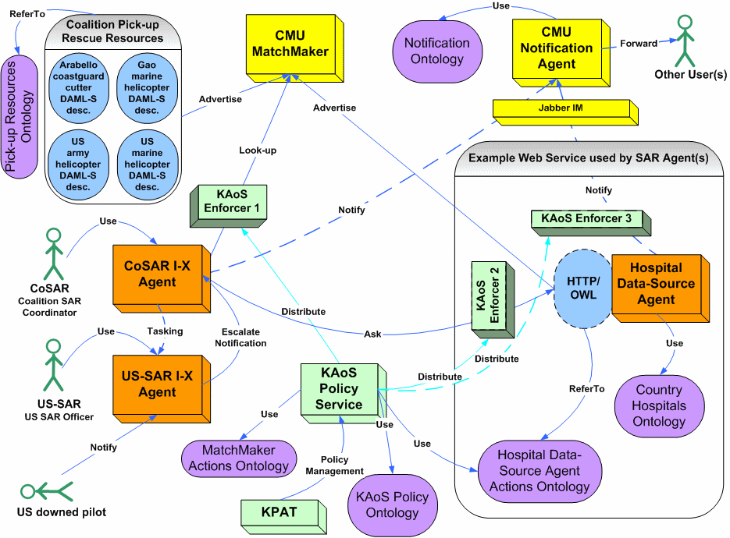
The Coalition Search and Rescue Task Support demonstration shows cooperative agents supporting a highly dynamic mission in which AI task planning, inter-agent collaboration, workflow enactment, policy-managed communications, semantic web queries, semantic web services matchmaking and knowledge-based notifications are employed.
Introduction
The Coalition Search and Rescue Task Support (CoSAR-TS) project is integrating AIAI’s I-X planning and collaboration technology, IHMC’s KAoS policy and domain management agent services, and semantic web services of various kinds. Search and rescue operations by nature require the kind of rapid dynamic composition of available policy-constrained services making it a good use case for Semantic Web technologies. Other participants in the application include BBN Technologies, SPAWAR, AFRL, and Carnegie Mellon University.
CoSAR-TS Scenario
The scenario is set in the Binni domain used for multi-national research in Command and Control (Rathmell, 1999). It begins with an event that reports a downed airman in the Red Sea between the coastlines of two fictional nations: Binni (to the West) and Arabello (to the East). In this initial scenario it is assumed that excellent location knowledge is available, and that there are no local threats to counter or avoid in the rescue. The airman reports his own injuries via his suit sensors. Next is an investigation of the facilities available to rescue the airman. There will be three possibilities: a US ship-borne helicopter; a Gaoan helicopter from a land base in Binni; or a patrol boat situated off the Arabello coastline. Finally, there is a process to establish available medical facilities for the specialized injury reported using the information provided about the countries in the region. Arabello’s hospital is best placed to provide the facilities, due to the fact that it has the necessary treatment facilities for burns. But the selection of the rescue resource is policy-constrained since no Gaoan helicopters may enter Arabello airspace.

Figure 1: CoSAR-TS Components

Figure 1 shows the agents used in the demonstration, representing the roles and functions of the Coalition SAR coordinator, US SAR officer, hospital information provider, SAR resource provider and a Notification Agent. The Coalition SAR Coordinator and US SAR Officer each has an I-X process panel, which can be used for messaging concerning collaborative activity, and is also used to select, refine and execute a suitable standard operating procedure or plan. A query is made on a BBN Technologies semantic web service of OWL-encoded facts about country medical infrastructure. The selection of a SAR resource is made using the CMU Semantic Matchmaker to find a suitable service. These lookups obey policies set by the IHMC KAoS Policy Administration Tool (KPAT). Finally, the CMU Notification Agent uses knowledge of the recipients to make notifications to hospital administrators or pilots.
I-X Technology
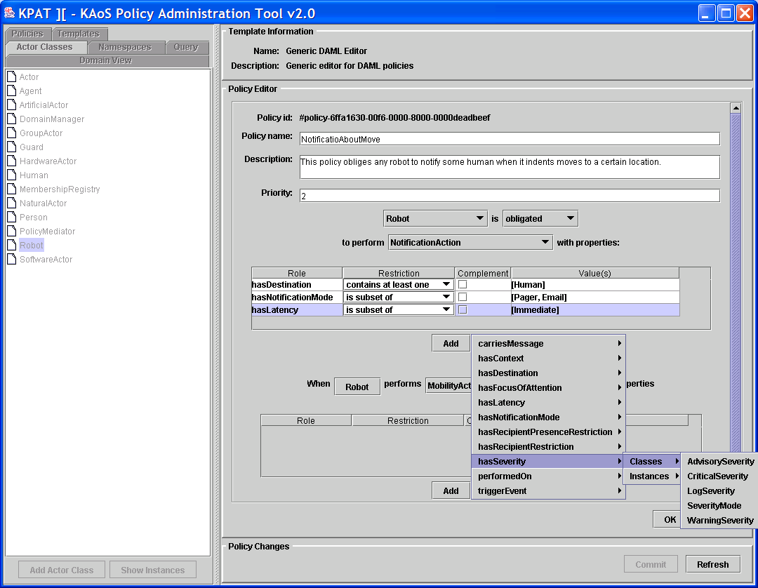
I-X Process Panels (http://i-x.info - Tate, 2003) can provide task support by reasoning about and exchanging with other agents and services any combination of Issues, Activities, Constraints and Annotations (in the <I-N-C-A> ontology). I-X can therefore provide collaborative task support and exchange of structured messages related to plans, activity and the results of such activity. These types of information can be exchanged with other I-X panels and with other tools using OWL, RDF or other languages.
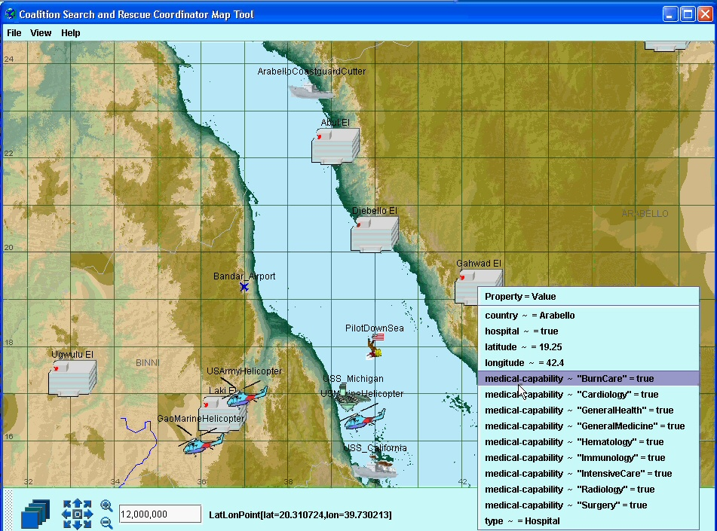
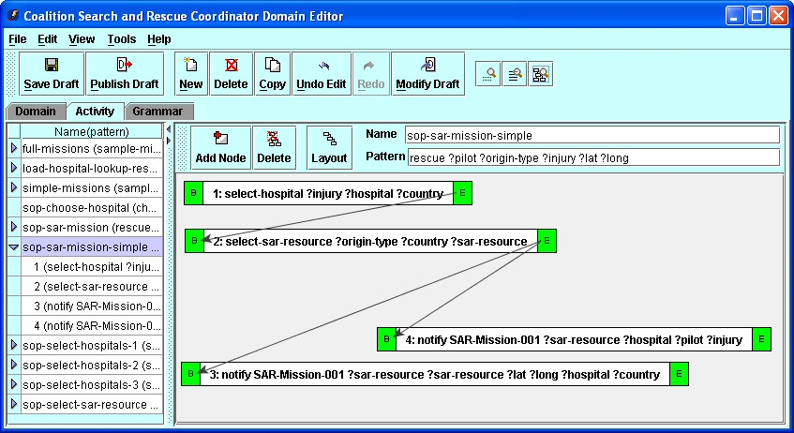
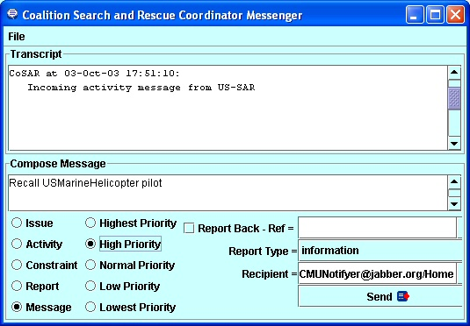
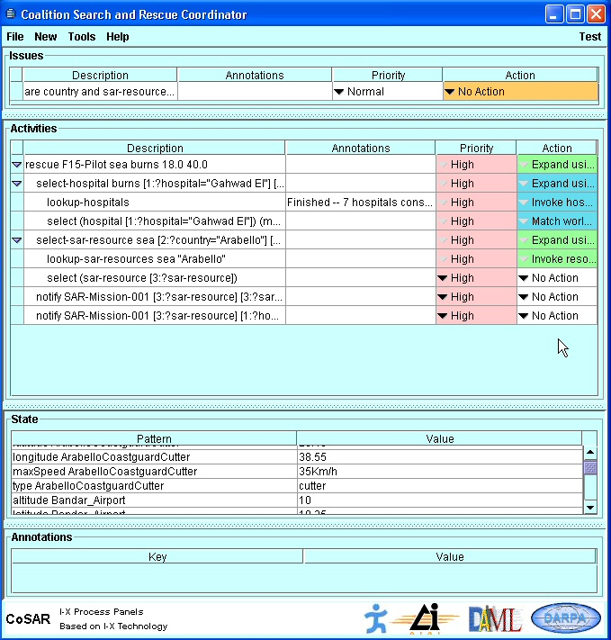
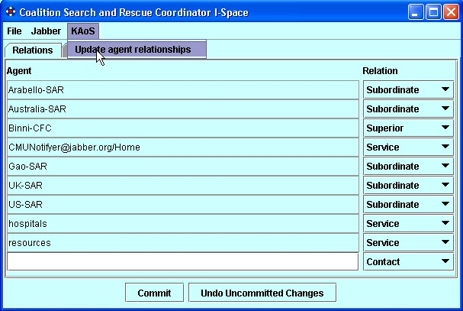
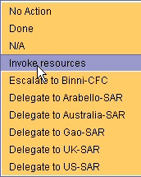
Process Panel
Domain Editor
Messenger
I-Space
Map Tool

Figure 2: I-X Process Panel and Associated Tools

Figure 2 shows an I-X Process Panel (I-P²) and associated I-X Tools. I-X can make use of multiple communications methods ranging from simple XML instant messaging (e.g. via Jabber) to sophisticated policy constrained agent communications environments (e.g. CoABS Grid, KAoS). The I-Space tool maintains agent relationships. The relationships can be obtained from agent services such as KAoS. I-X Process Panels can also link to semantic web information and web services though an I-Q query adaptor.

I-X includes a process editor for creating process models (I-DE) to populate the domain model and an AI planner (I-Plan) that can compose a suitable plan for the given tasks when provided with a library of standard operating procedures or processes, and knowledge of other agents or web services that it may use. I-Plan can support hierarchical plan creation, precondition achievement, consistent binding of multiple variables, temporal constraint checking, etc.
KAoS Technology
Figure 3 shows the KAoS Policy Administration Tool (http://www.ihmc.us/research/projects/KAoS/ - Uszok et al. 2003). Through it, policies constraining usage of resources and agents’ actions are inserted into the system. The policies are expressed using OWL. This allows the use of Description Logic reasoning algorithms to perform sophisticated queries and analysis of policies; supported by Stanford University’s Java Theorem Prover (JTP) inferencing engine. Loading relevant application specific ontologies can dynamically extend the KAoS Services. The layer of guards and enforcers integrated with the application facilitates the enforcement of the policies.

Figure 3: KAoS Policy Administration Tool
Acknowledgements

This material is based on research sponsored by the Defense Advanced Research Projects Agency (DARPA) and US Air Force Research Laboratory under agreement numbers F30602-00-2-0577 and F30602-03-2-0014. The U.S. Government, IHMC, and the University of Edinburgh are authorized to reproduce and distribute reprints and on-line copies for their purposes notwithstanding any copyright annotation hereon. The views and conclusions contained herein are those of the authors and should not be interpreted as necessarily representing the official policies or endorsements, either expressed or implied, of other parties.
References
Rathmell, R.A. (1999) A Coalition Force Scenario 'Binni - Gateway to the Golden Bowl of Africa', in Proceedings of the International Workshop on Knowledge-Based Planning for Coalition Forces, (ed. Tate, A.) pp. 115-125, Edinburgh, Scotland, 10-11 May 1999.

Tate, A. (2003). Coalition Task Support using I-X and <I-N-C-A>. Proceedings of the Third International Central and Eastern European Conference on Multi-Agent Systems (CEEMAS 2003), 16-18 June, Prague, Czech Republic, LNAI 2691. (pp. 7-16). Berlin: Springer.

Uszok, A., Bradshaw, J. M., Jeffers, R., Suri, N., Hayes, P., Breedy, M. R., Bunch, L., Johnson, M., Kulkarni, S., & Lott, J. (2003). KAoS policy and domain services: Toward a description-logic approach to policy representation, deconfliction, and enforcement. Proceedings of Policy 2003. Como, Italy.

