I–X: Collaborative Task Support and e-Response
Rather than seeking to automate the tasks performed by humans, the trend in modern AI research and application development is towards providing support to human agents in the workplace. The impetus for this lies in an acknowledgement of the differing capabilities of humans and computers, and its aim is to engineer environments where these capabilities will complement each other to greatest effect. Another influence is the dramatic shift in work practices in recent years with the rise of the internet and the WWW (and with the Semantic Web on the horizon), ensuring that knowledge management has become central to the philosophy of the modern organisation.
The I-X programme at the Artificial Intelligence Applications Institute (AIAI), part of the School of Informatics within the University of Edinburgh, is typical of this type of modern AI project. Its overall aim is to create an enabling environment for mixed-initiative (i.e., involving both human and computer agents) synthesis tasks. The definition of a ‘synthesis task’, as it is considered here, is general enough to embrace tasks as diverse as designing an aircraft engine, devising a marketing strategy and writing a joint report. Such tasks occur regularly in organisations and usually require some degree of creativity, something that is difficult to emulate on computer. (This is not to say that computers do not have a role to play in the task – for instance in simulating design concepts.)
I–X draws on (and is a natural successor to) several decades of AI experience at Edinburgh in planning, scheduling and, more recently, process, workflow and activity management. Born of this experience, and lying at the conceptual heart of the programme, is a unifying upper ontology for a shared representation of a synthesis task, whatever the precise nature of the task or its domain may be. This conceptualisation, the <I-N-C-A> ontology, is based on the notion of both the processes governing and the products emerging from the task being composed of abstract ‘nodes’, related by a series of constraints, and about which issues are cyclically generated and resolved so as to refine the set of nodes and their relationships. This model allows flexibility in the extent and nature of the formalisation of the representation. So, while an informal approach to representing, say, constraints might suffice when coordinating joint memorandum-writing activities (“finish by next Friday”), a more formal scheme might be imposed for a design task where precision is required or automated constraint-solver agents are to be invoked (“has-orientation(fin-9102, horizontal)”).
As well as encouraging a well-founded encapsulation of the task, the model also provides the basis for a systems architecture and communication framework, allowing the concrete realisation of I–X systems. Figure 1 depicts the manner in which the I-X tools serve to construct a task-solving environment.
The Collaborative Advanced Knowledge Technologies in the Grid (CoAKTinG) project, funded by the UK e-Science Programme, is one current project where I-X technology is being put to use. The aim of CoAKTinG is to assist e-Scientists collaborate remotely by creating a mediated conceptual space within which to situate their work. This is realised by adopting concepts from AI and knowledge management – ontologies, issue-based information systems, presence visualisations and so on – and embodying these in a set of complementary tools, including the I-X tools, developed by the project partners (along with AIAI, the Knowledge Media Institute at The Open University and the Intelligence, Agents, Multimedia group at the University of Southampton). One CoAKTinG demonstration scenario, termed e-Response, surrounds an evolving environmental emergency: an oil spill is threatening a sea-bird reserve. The response team (whose members are together assumed to have a wide-ranging scientific background) has to generate a plan for responding to this emergency – the creation of this plan is the synthesis task here.
In constructing their plan, the members of the team follow – individually and as a group – specific response procedures. While some of these may be extemporised and contingent on circumstances, others may be instances of ‘standard operating procedures’, generic approaches to archetypal activities, which can be downloaded from a central web-store. In addition to the human agents in this environment, automated agents exist to provide tide data and weather forecasts, simulate the progress of the oil slick, poll centralised data stores for details of available human expertise in specific fields and so on. The interactions are governed by the activities, issues and constraints that arise, and mediated by the I-X interfaces of the team members, which present to them the current state of the collaboration from their individual perspectives, and allow them to decompose activities, refine elements of the plan, delegate issues, invoke the automated agents etc, all serving to facilitate the team’s task.
Stephen Potter, Austin Tate and Jeff Dalton,
AIAI, Informatics,
The University of Edinburgh,
Edinburgh, UK
E-mail: stephenp@inf.ed.ac.uk
Links: I-X: http://i-x.info; CoAKTinG: http://www.aktors.org/coakting/; e-Response: http://e-response.org.

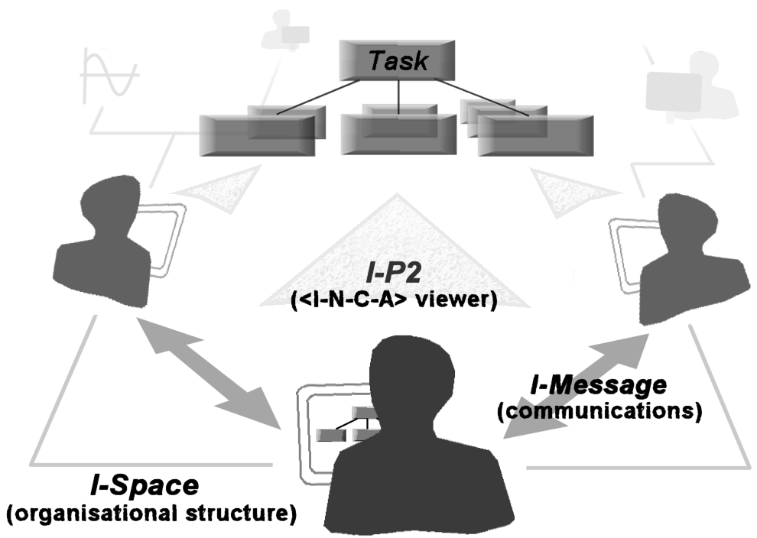
Figure 1. The I-X environment: the I-P2 (Process Panel) tool visualises the current task for a user; the I-Space tool establishes organisational relationships between agents, dictating the sort of appropriate interactions among them; the I-MessageTool allows messages of variable formality to be sent. In addition, various editor tools allow human agents to express and formalise <I-N-C-A> entities, and task-specific tools can be ‘plugged in’ to provide additional visualisations, editors and solvers.

