Collaborative Tools in the Semantic Grid

Michelle Bachler,
Simon Buckingham Shum,
Marc Eisenstadt,
Jiri Komzak
KMI,
The Open University, UK
Jessica Chen-Burger,
Jeff Dalton,
Stephen Potter,
Austin Tate
AIAI,
University of Edinburgh, UK
David De Roure, Danius Michaelides, Kevin Page,
Nigel Shadbolt
ECS,
University of Southampton, UK

Abstract
The CoAKTinG project aims to advance the state of the art in collaborative mediated spaces for distributed e-Science. The project is integrating several knowledge based and hypertext tools into existing collaborative environments, and through use of a shared ontology to exchange structure, promotes enhanced process tracking and navigation of resources before, after, and while a meeting occurs. This paper provides an overview of the CoAKTinG tools, the ontology that connects them, and current research activities.

1. Introduction
The CoAKTinG project [1] aims to advance the state of the art in collaborative mediated spaces for distributed e-Science through the novel application of advanced knowledge technologies. It comprises four tools: instant messaging and presence notification (BuddySpace), graphical meeting and group memory capture (Compendium), intelligent 'to-do' lists (Process Panels) and meeting capture and replay. These are integrated into existing collaborative environments (such as the Access Grid [2]), and through use of a shared ontology to exchange structure, promotes enhanced process tracking and navigation of resources before, after, and while a meeting occurs.
Section 2 provides an overview of the tools, Section 3 describes the ontology that interconnects them, and Section 4 gives a glimpse of current work using the tools.

2. Tools

2.3 BuddySpace

BuddySpace is an Instant Message client (based on the Jabber protocol) with features that enhance presence awareness. Specifically, it introduces the graphical visualisation of people and the presence on a image or map, as can bee seen in the figure. This allows for multiple views of collaborative workgroups and the immediacy or “at a glance” nature gives users a snapshot of a virtual organisation. In a meeting, the instant message capabilities of Buddyspace naturally provide a “back-channel” to the meeting, for example, conveying URLs of documents discussed or as a non-disrupting communication. For distributed meetings, such Access Grid meetings, the presence of individuals gives an extra indication of co-location (especially if the videoconferencing technology is failing). The back-channel can also be used for meeting control tasks, such as queuing of speakers and voting on issues.
Figure 1: BuddySpace showing a virtual organisation and presence indicators
For meeting capture purposes, logs of the channel conversations are made. Individual messages are timestamped and possibly examined to see if they control meeting specific messages.

2.2 Compendium
Compendium, first developed in 1993 as an approach to aid cross-functional business process redesign (BPR) teams, has been applied in several dozen projects in both industry and academic settings [5]. Its origins lie in the problem of creating shared understanding between the team members, typical of those attending teams working over weeks or months to design business processes: keeping track of the plethora of ideas, issues, and conceptual interrelationships without needing to sift through piles of easel sheets, surfacing and tracking design rationale, and staying on track and “boughtin” to the project’s overall structure and goals [8]. The key feature of the early approach was the combination of an Issue-Based Information System (IBIS) concept-mapping tool [6], which supported informal and exploratory conversation and facilitation, with a structured modelling approach [7]. This allowed teams to move along the spectra of formal to informal representation, and prescribed to spontaneous approaches, as their needs dictated. It also let them incrementally formalise data [10] over the life of the project. As the approach was tested and refined over the course of several years, additional modelling methods were added, plus tools to transform Compendium’s hypertext models into established organisational document forms, and vice-versa [9].
In our experience, Compendium introduces a distinctive element to the design space of knowledge technologies, namely, making meetings into true events for group knowledge creation which leave a trace - a structured, collectively owned, searchable group memory that is generated in real time as a product of a meeting. Effective, on-the-fly construction of knowledge resources does not come ”for free” - the lower the effort invested at the capture stage (e.g. simply video recording all meetings, or taking conventional minutes), the more work is required for collective reuse and computational support. Naturally, we want quality knowledge resources for minimal effort, and while smart analysis technologies will continue to push the boundaries, there are pragmatic factors to consider: what is possible now? Compendium tackles the capture bottleneck that any knowledge construction effort must confront, by investing effort in real time quality capture by a facilitator, mediated and validated by those at the meeting.
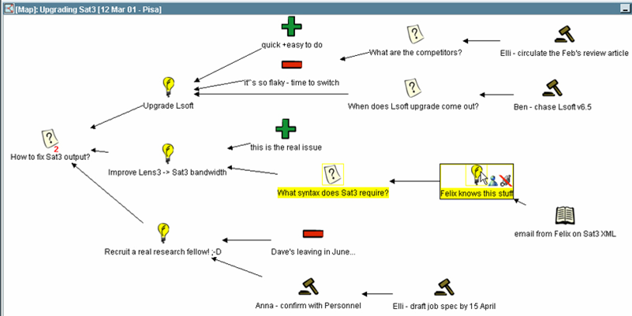
Figure 2: A Compendium map showing various node types and links

2.3 Process panels
I-X is a suite of tools[12] whose function is to aid in processes which create or modify one or more "product" (such as a document, a physical entity or even some desired changes in the world state). The main interface is the I-X Process Panel (I-P2) which, in its simplest form, acts like an intelligent "to do" list. The panel shows users their current issues and activities, on which Standard Operating Procedures can be applied to manage complex and long-running processes. I-X also has a collaborative element to it, in that issues and activities can be passed between different process panels to enact a workflow across an organisation. Web services can be called to automatically enact steps of the processes involved. Progress and completion reporting between panels and external services is possible. The underlying model on which I-X is based is the <I-N-C-A> Constraints Model[11]. In a meeting scenario, actions raised in a meeting have a direct mapping to <I-N-C-A> activities. Actions created in a meeting specific I-X panel are passed onto the relevant user panel's for individuals, which, on completion report back.
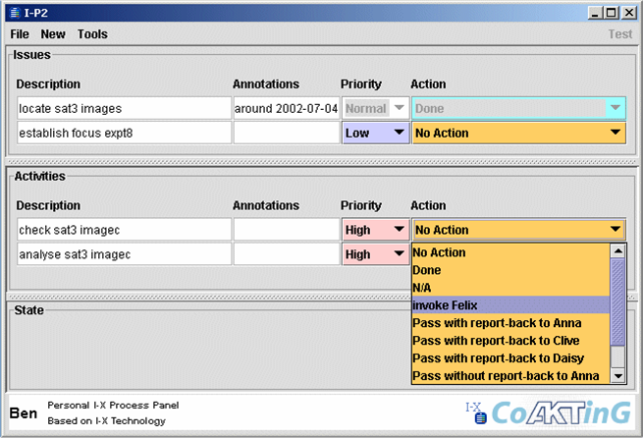
Figure 3: An I-X Process Panel showing pending issues and activities

2.4 Meeting Replay
Once a meeting has taken place it can be useful to revisit the ideas and topics discussed. Traditionally, formal minutes are taken to record the salient points, but often these are too brief to be more than a simple aide memoire; in the typical CoAKTinG scenario (such as an Access Grid node) full audio and video logs are available, but conversely these are too verbose to be of practical use. We require the ability to select high-level points of reference from the meeting, then “zoom in” to view detailed records. e.g. a user sees from Compendium notes that a decision was made, but to understand the subtle reasoning behind that outcome wishes to view the video of discussion between participants. Each meeting is described using RDF conforming to the OWL meeting ontology; this represents resources such as: the meeting time, location, attendees, audio/video recordings, any presentations given (and associated web viewable versions), and argumentation annotation from Compendium. The Event / has-sub-event structure held within the RDF is mapped onto a more conventional time-line, which is automatically published using HTML and Javascript on a web site (see figure). The user can navigate the meeting using the video timeline, or jump to a different point in the meeting by selecting a particular event, such as a slide being presented, or a Compendium node being created. By using the shared AKT reference ontology, we can also link to further information about resources held in other knowledge bases, e.g. when a person is referenced we link to information about them in the populated AKT triple store. We populate the timeline with any temporally annotated information about the meeting that would aid the user in navigation. In CoAKTinG we have experimented with:
- Agenda item
- Slide exhibits
- Compendium node
- Speaker identification
- I-X activity(action item) creation
- Buddyspace chat
By providing all available information we hope to cater for the many activities and contexts of the user, in a seamful [4] manner.
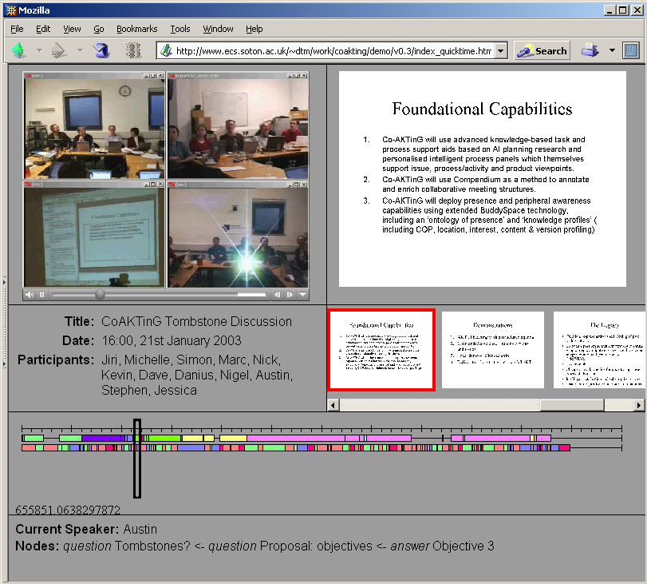
Figure 4: The meeting replay tool
We can categorise the information presented in the entire meeting replay in terms of the dimensions “structured” and “detailed”, as shown in the figure. Video, for example, is high in detail, in that it captures the entire audio and visuals of the meeting. Structurally, it is relatively low, since although there is implicit structure (image frames and audio samples) these do not directly contribute to navigating the structure of the meeting. Video processing could applied to segment the video into scenes but structurally this would not provide much more than Speaker Identification. The Agenda, conversely, is high in meeting structure, but relatively low in the details. Compendium captures a moderate level of detail in a highly structured representation.
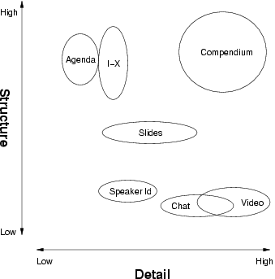
Figure 5: Detail and structure of recorded sources

3. Ontology
The Advanced Knowledge Technologies (AKT) project, with which CoAKTinG is affiliated, has developed a reference ontology [3] to describe the domain of computer science research in the UK, exemplified by the CS AKTive Space semantic web application. Within this domain, its vocabulary is able to express relationships between entities such as individuals, projects, activities, locations, documents and publications. For purposes of capturing meeting specific information, the reference ontology is already suitable for encapsulating:
- the meeting event itself
- meeting attendees
- projects which are the subject matter of the meeting
- documents associated with the meeting, including multimedia
For activities such as meetings, which we wish to index and navigate temporally, the way in which the ontology represents time is of particular relevance. The reference ontology contains the notion of an Event, which is a Temporal-Thing that can define a duration, start and end times, a location and agents involved in the event. More importantly, each Event can express a has-sub-event relationship with any number of other Events, and it is with this property that we build up our temporal meeting structure. Within the ontology there are also many Event sub-classes, such as Giving-a-Talk, Sending-an-Email, Book-Publishing, and Meeting-Taking-Place.
While the reference ontology provides a foundation for describing meeting related resources, the CoAKTinG meeting ontology (figure 6) extends the OWL version of AKT reference ontology to better encompass concepts needed to represent collaborative spaces and activities, including:
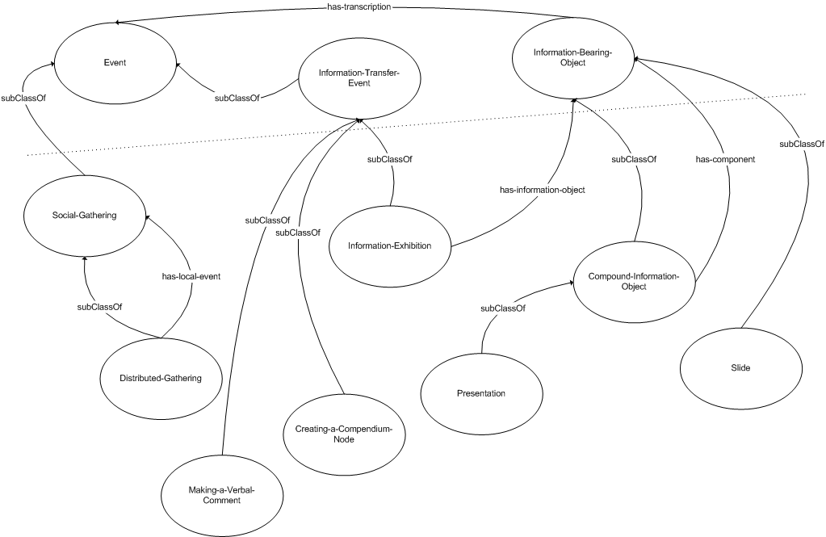
Figure 6: A simplified representation of the meeting ontology
- time properties sufficient for multimedia synchronisation
- distributed gatherings to represent meetings which simultaneously take place in several spaces, both real and virtual exhibition of information bearing objects; e.g. showing a slide as part of a presentation
- compound information objects; e.g. to describe a presentation consisting of several multimedia documents
- rendering of information objects; e.g. JPEG image of a slide Figure 4: A simplified representation of the meeting ontology
- transcription of events; e.g. a video recording of a presentation, minutes of a meeting
- annotation of events; e.g. making a verbal comment, creating a Compendium node
When a meeting takes place we “mark up” the event with metadata - details such as those listed above - to build a structured description of the activities that occur. Through use of an ontology shared and understood by several different tools, we can lower the workload needed to provide usable and useful structure.

4. Case Studies

4.1 e-Response
One CoAKTinG demonstration scenario, termed e-Response, surrounds an evolving environmental emergency: an oil spill is threatening a sea-bird reserve. The response team (whose members are together assumed to have a wide-ranging scientific background) has to generate a plan for responding to this emergency – the creation of this plan is the synthesis task here.
In constructing their plan, the members of the team follow – individually and as a group – specific response procedures. While some of these may be extemporised and contingent on circumstances, others may be instances of ‘standard operating procedures’, generic approaches to archetypal activities, which can be downloaded from a central web-store. In addition to the human agents in this environment, automated agents exist to provide tide data and weather forecasts, simulate the progress of the oil slick, poll centralised data stores for details of available human expertise in specific fields and so on. The interactions are governed by the activities, issues and constraints that arise, and mediated by the I-X interfaces of the team members, which present to them the current state of the collaboration from their individual perspectives, and allow them to decompose activities, refine elements of the plan, delegate issues, invoke the automated agents etc, all serving to facilitate the team’s task.

4.2 CombeChem
The CombeChem project aims to enhance structure property correlation and prediction by increasing the amount of knowledge about materials via synthesis and analysis of large compound libraries. Automation of the measurement and analysis is required in order to do this efficiently and reliably while ensuring that wide dissemination of the information occurs together with all the necessary associated background (raw) data that is needed to specify the provenance of the material. The project aims for a complete end-to-end connection between the laboratory bench and the intellectual chemical knowledge that is published as a result of the investigation; this necessitates that all steps in the process are enhanced by a suitable digital environment. Comb-e-Chem has achieved many parts of this ambitious programme, e.g. the smart laboratory (smarttea.org), grid-enabled instrumentation, data tracking for analysis, methodology for publication@source, process and role based security and high throughput computation.
The CoAKTinG tools provide support for the e-Science process in Comb-e-Chem and they also enable the digitisation of ‘missing links’ in the processing chain which form part of the typical collaborative scientific processes that we are attempting to enhance using the grid infrastructure: support of the experimental process, tracking and awareness of people and machine states, capturing of the discussions about data as well as the traditional metadata, and enriched meta-data regarding these components to support interlinking.
The BuddySpace systems can be adapted to show and track the interactions between the staff and equipment using the National Crystallographic Service (NCS), providing information to their users about the state of the service. Compendium provides the harness to ensure more adequate capture of the discussions in analysis, while Process Panels provide the means to initiate and track key tasks and issues. Additionally the ideas from CoAKTinG provide different techniques to achieve the necessary multi-user interaction in real time over the network and give Comb-e-Chem the opportunity to implement the ‘video interaction’ collaboration part of Comb-e-Chem using event based ontologies to annotate real time streaming media and content.
These various components are valuable complements to Comb-e-Chem individually but jointly are even more powerful. For example, Process Panels can exploit the presence information derived from BuddySpace with respect to instrument status and operator availability to offer more informed task delegation options. This completes the chain of digital support and capture, maximising the potential for re-use of the digital information in support of the scientific process.
The following figure illustrates one particular aspect of the deep integration – the application of the Process Panel tool to the laboratory, building on the process capture work of Comb-e-Chem’s Smart Tea team.
Figure 6 shows a screen capture of an I-X Process Panel and its Map Tool resulting from our initial experiment. The Map Tool depicts a real Chemistry lab where both fixed and mobile entities are represented. The positions of mobile entities such as movable equipment and technicians are updated automatically through the (World) State sub-panel. By sharing information with BuddySpace, (dynamic) properties of devices are also described in the same panel. At this particular point in time, it shows Technician-2 is in front of the Rotary Evaporator and about to carry out the sub-process “Remove solvent from the-mixture using Vacuo results in Compound”, having completed the previous steps in this process. In our investigation, the process decomposition facility of the I-X Activity sub-panel supports views of different levels of abstraction that fits nicely with different chemists’ (and labs’) practice. Activities, issues, annotations and constraints may be recorded directly or via Compendium where in-depth discussion has taken place. Static and dynamic process editing provide great flexibility as processes are modifiable at run-time in response to unexpected changes. The ability to store, retrieve and refine process models is important in the Chemistry domain where existing processes are constantly reviewed and modified to discover or synthesise new chemical compounds. This facility alone makes I-X a valuable back-end component for integration with the existing Comb-e-Chem Grid.
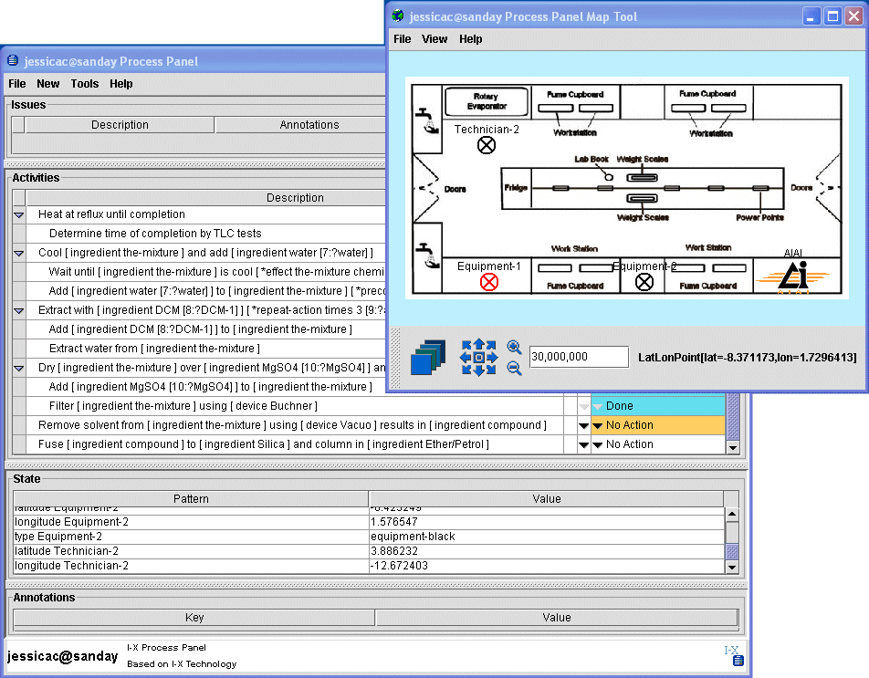
Figure 6: I-X Process Panel configured for e-Chemists

5. Conclusions
This paper has introduced the tools that have been developed by the CoAKTinG project and identified how they are typically used in meetings, and also shown how they are being explored in scenarios such as e-Response and CombeChem.

Acknowledgments
This work is funded by the UK Engineering and Physcal Sciences Research Council under grant number GR/R85143/01, in association with the Advanced Knowledge Technologies Interdisciplinary Research Collaboration. The AKT IRC research partners and sponsors are authorized to reproduce and distribute reprints and on-line copies for their purposes notwithstanding any copyright annotation hereon. The views and conclusions contained herein are those of the authors and should not be interpreted as necessarily representing the official policies or endorsements, either expressed or implied, of other parties. We are grateful to members of the CombeChem team for their assistance with one of the case studies: Jeremy Frey, Gareth Hughes, Hugo Mills, monica schraefel and Graham Smith.

REFERENCES
[1] The CoAKTinG project. http://www.aktors.org/coakting/.
[2] The Access Grid. http://www.accessgrid.org/.
[3] The AKT Reference Ontology. http://www.aktors.org/ontology/.
[4] Matthew Chalmers, Ian MacColl, and Marek Bell. Seamful design: Showing the seams in wearable computing. In Proceedings of IEE Eurowearable 2003, pages 11–172, Birmingham, UK, 2003.
[5] J. Conklin, A. Selvin, S. Buckingham Shum, and M. Sierhuis. Facilitated Hypertext for Collective Sensemaking: 15 Years on from gIBIS. In Proceedings The Twelfth ACM Conference on Hypertext and Hypermedia (Hypertext ’01), pages 123–124, 2001.
[6] J. Conklin and K. C. Burgess Yakemovic. A Process-Oriented Approach to Design Rationale. Human-Computer Interaction, 6(3&4):357–391, 1991.
[7] A. Selvin. Supporting Collaborative Analysis and Design with Hypertext Functionality. Journal of Digital Information, 1(4), 1999.
[8] A. Selvin and M. Sierhuis. Towards a Framework for Collaborative Modelling and Simulation. In Workshop on Strategies for Collaborative Modelling and Simulation, CSCW’96: ACM Conference on Computer-Supported Cooperative Work, Boston, MA, USA, 1996.
[9] A.M. Selvin and S.J. Buckingham Shum. Repurposing Requirements: Improving Collaborative Sensemaking over the Lifecycle. In Profess’99: International Conference on Product Focused Software Process Improvement, Oulu, Finland, pages 539–559, June 1999.
[10] F.M. Shipman and R. McCall. Supporting Knowledge-Base Evolution with Incremental Formalization. In Proc. ACM CHI’94: Human Factors in Computing Systems, Boston, Mass., pages 285–291. ACM Press: New York, 1994.
[11] A. Tate. <I-N-C-A>: an Ontology for Mixed-initiative Synthesis Tasks. In Proceedings of the Workshop on Mixed-Initiative Intelligent Systems (MIIS) at the International Joint Conference on Artificial Intelligence (IJCAI-03), Acapulco, Mexico, august 2003.
[12] A. Tate, J. Dalton, and J J. Stader. I-P2 - Intelligent Process Panels to Support Coalition Operations. In Proceedings of the Second International Conference on Knowledge Systems for Coalition Operations (KSCO-2002), Toulouse, France, april 2002.

