Activity-oriented Instant Messaging

for Coalition Operations

Austin Tate, Jeff Dalton and Stephen Potter

Artificial Intelligence Applications Institute (AIAI), University of Edinburgh

{a.tate,j.dalton,s.potter}@ed.ac.uk
Abstract. I-X Process Panels are used to support users who are carrying out processes and responding to events in a cooperative working environment. The panels support the tracking of personal or group issues, the planning and execution of activities and the checking of constraints. Panels can be connected to other panels, and also to a range of services, agents and other cooperative working support tools to form part of a framework for activity and process support in an organization. The dynamically changing context in which a user operates is reflected in the options presented. Actual usage in a multi-national coalition operations setting indicated the value of adopting an “instant messaging” style of use. An augmented activity-orientated “intelligent messaging” approach is taken in which artificial intelligence planning technology can be deployed in a natural way.
1 Introduction
I-X is a research programme with a number of different aspects intended to allow humans and computer systems to cooperate in the creation or modification of some product or products such as documents, plans, designs or physical entities - i.e., it supports mixed-initiative synthesis tasks (Tate, 2003).
The I-X research draws on earlier work on Nonlin (Tate, 1977), O-Plan (Currie and Tate, 1991; Tate, 1995; Tate et al., 1998; Tate et al., 2000b, Levine et al. 2000), Optimum-AIV (Aarup, 1994, Tate, 1996b), <I-N-OVA> (Tate, 1996; 2000a) and the Enterprise Project (Fraser and Tate, 1995; Stader, 1996) but seeks to make the framework generic and to clarify terminology, simplify the approach taken, and increase re-usability and applicability of the core ideas.
I-X Process Panels (I-P²) are used to support individual users who are carrying out processes and responding to events in a cooperative working environment. The panels support the tracking of personal or group issues, the planning and execution of activities and the checking of constraints. Panels can be connected both to other panels, and also to a range of services, agents and other co-operative working support tools to form part of a framework for activity and process support in an organization.
I-X Process Panels can communicate between themselves and the other services or agents they know about via any of a range of communications strategies which vary from simple direct internet ports, custom name server and brokering systems through to comprehensive, secure, agent communications routes such as the CoABS Grid (Kahn and Della Torre Cicalese, 2001) and KAoS (Bradshaw et al., 2003).
I-X Process Panels and their predecessors, the Open Planning Process Panels (O-P³) (Levine et al., 2000), have been used in a number of prototype and deployed applications:
- Air Campaign Planning (Tate et al., 1998)
- Noncombatant Evacuation Operations (Tate, et al., 2000b)
- US Army Small Unit Operations (Tate et al., 2000a)
- Coalition and Multi-national Forces Command and Control (Allsopp et al., 2002; Wark et al. 2003)
- Search & Rescue Coordination (CoSAR-TS, 2003; Tate et al., 2004; Siebra and Tate, 2003)
- Help Desks
- Unmanned Autonomous Vehicle Command and Control
- Cooperative working between e-Scientists (Buckingham Shum et al., 2002)
2 I-X Approach
The I-X approach involves the use of shared models for task-directed collaboration between human and computer agents who are jointly exploring (via some, perhaps dynamically determined, process) a range of alternative options for the synthesis of an artifact such as a design or a plan (termed a product). The <I-N-C-A> (Issues - Nodes - Constraints - Annotations) ontology (Tate, 2003) is used to represent a specific artifact as a set of constraints on the space of all possible artifacts in an application domain. It can be used to describe the requirements or specification to be achieved and the emerging description of the artifact itself. It can also describe the (perhaps dynamically generated) processes involved.
I-X also involves a modular systems integration architecture that strongly parallels the underlying <I-N-C-A> ontology. It provides a “Model – Viewer – Controller” style of architecture. Plug-in components for Issue Handlers, Activity Performers, Constraint Managers, Process or Product Viewers, and Input/Output allow for specific I-X systems to be created.
3 I-X Process Panels
We “deliver” useful functionality based on the I-X and <I-N-C-A> ontology via I-X Process Panels (I-P²) and associated Tools as shown in figures 1 and 2. These support a user or collaborative users in selecting and carrying out “processes” and creating or modifying “process products”. An I-X Process Panel can be seen, at its simplest, as an intelligent ‘to-do’ list for its user. However, and especially when used in conjunction with other users’ panels, it can become a workflow, reporting and messaging ‘catch all’, allowing the coordination of activity, and hence facilitating more successful and efficient collaborations. I-X Process Panels thus provide a user interface to support user tasks and cooperation.
A panel corresponds to its user’s ‘view’ onto the current activity, through the presentation of the current items (from the user’s perspective) of each of the four sets of entities comprising the <I-N-C-A> model. The contents of these sets, along with the current context and state of the collaboration, are used to generate dynamically the support options the tool provides. For example, associated with a particular activity node might be suggestions for performing it using known procedural expansions, for invoking an agent offering a corresponding capability, or for delegating the activity to some other agent in the environment.
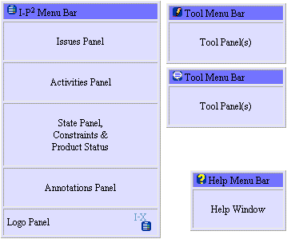

Fig. 1. Anatomy of an I-X Process Panel
An I-X Process Panel:
- Takes requests to:
  - Handle an issue
  - Perform an activity
  - Add a constraint
  - Note an annotation
- Deals with these via:
  - Manual (user) activity
  - Internal capabilities (perform)
  - External capabilities (invoke or query/answer)
  - Reroute or delegate to other panels or agents (pass)
  - Plan and execute a composite of these capabilities (plan or expand)
- Receives “progress” or “completion” reports and other event-related messages and, where possible, interprets them to:
  - Understand current status of issues, activities and constraints
  - Understand current world state, especially status of various attributes of process products
  - Help control the situation
  - Improve annotations
An I-X Process Panel can cope with partial knowledge and can operate even where little or no pre-built knowledge of the domain or knowledge of relationships to other panels or services is available – effectively becoming a simple “to-do” list aid in that case.
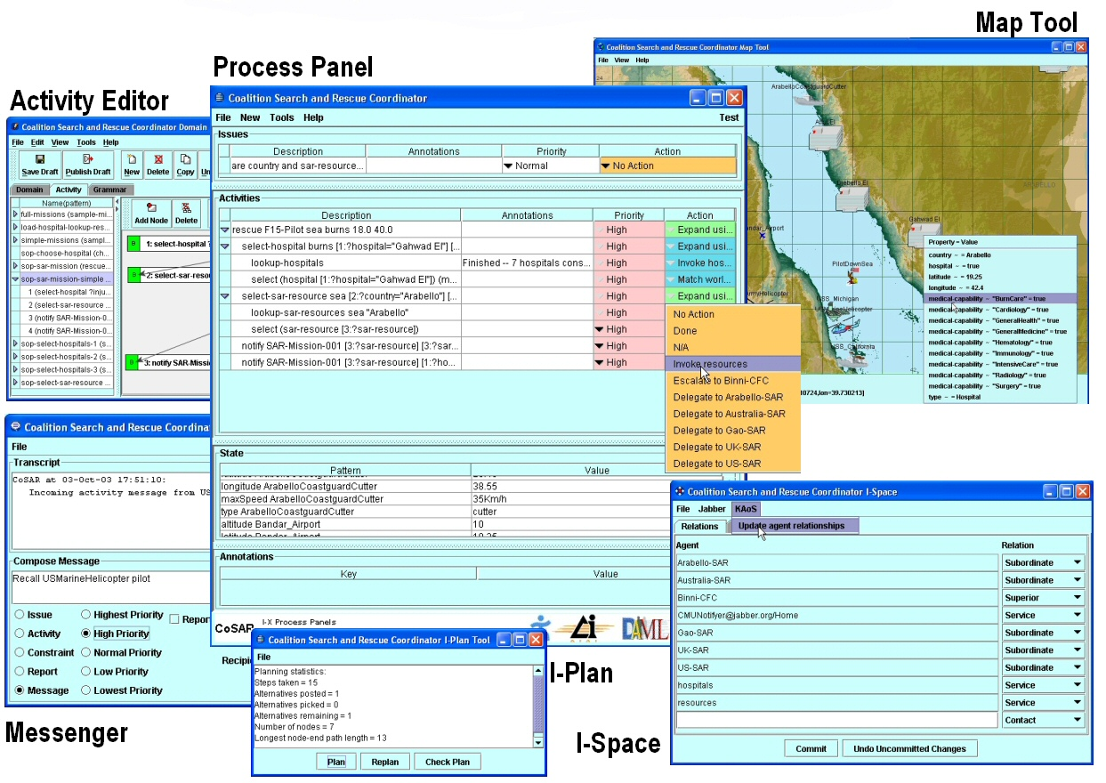
Fig. 2. I-X Process Panel and Tools
Trial use of I-X/I-P² in 2001 by users at the Navy Warfare Development Command (NWDC) at Newport, Rhode Island during the testing of advanced technologies appropriate for deployment in a large-scale training exercise called “Millennium Challenge” led to a major change in the direction for our systems development. Prior to that we had provided a test interface panel, which allowed us to send testing messages both to a local panel (the user’s own panel – labeled as “me”) and to any other named panel accessible via the communications method that was in use. NWDC was using I-P² alongside an Instant Messaging tool to log communications between countries and commands in a coalition. Both the simple Instant Messenger and I-P² were running over the CoABS Grid and KAoS to show how useful agent technology could be employed over secure channels. It quickly became clear that the messages being passed back and forth often related to entities that the process panels could handle – such as issues, activities and various types of preferences and constraints related to these. The test panel was quickly turned into an Instant Messaging style of interface, as shown in figure 3, in which simple text format “chat” was still possible, but the interface encouraged the use of more structured forms of messaging when this was natural. So it became easy to express and transmit the structured items related to task support. It then became easier to explain what the I-X Process Panels offered by referring to them as providing “augmented” instant messaging where process, activity and task support along with accompanying progress and completion reporting was desirable.
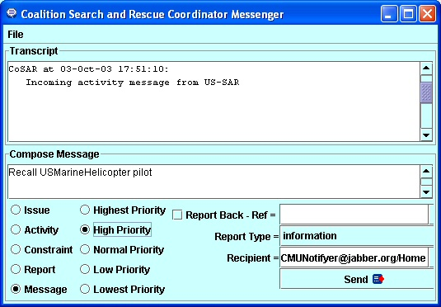

Fig. 3. Instant Messaging style interface for message creation
Since that time, this has been the preferred interface for I-X Process Panels and we have adopted this “intelligible messaging” style of interface. As I-X Process Panels have further developed and been used in more cooperative and human-centric applications (such as in support of scientific meeting and group work – Buckingham Shum et al., 2002), this style of interface has been further refined and made more central to our approach. We have also incorporated the use of a Jabber (Jabber, 2003) communications strategy, which provides for Instant Messaging using XML content. This has allowed for simpler and larger scale “out of the box” deployments of the I-X Process Panels.
4 I-Plan
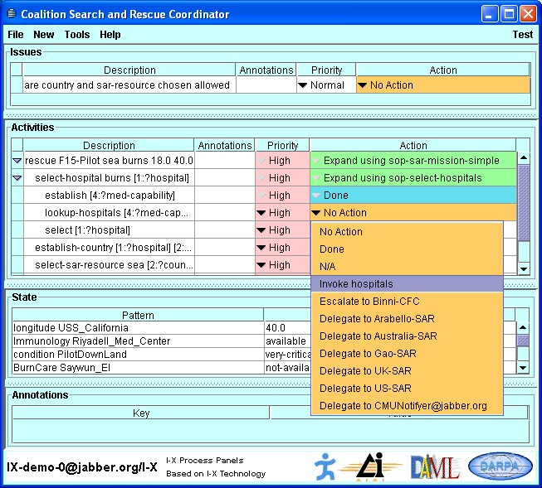
The facilities available in the I-X Process Panels) provide context sensitive options for the handing of issues (such as the achievements of stated objectives), the performance of activities, and the satisfaction of constraints. A simple AI Planner (I-Plan, shown in figure 4) is available as a tool to propose alternative ways in which activities on the panel can be expanded.

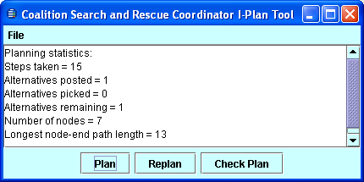

Fig. 4. Context-sensitive “Action” menu and I-Plan Tool
For any activity on the panel, an “Action” column shows its current status and the available options to perform the activity. Colours (which may not be discernable in figure 4) indicate the readiness of the item for current execution:
- White indicates that the item is not currently ready for execution (i.e., some temporal ordering, preconditions or other constraints might not be met).
- Orange indicates that the action is ready to perform and that all preconditions and constraints are met.
- Green indicates that the item is currently being performed.
- Blue indicates successful completion.
- Red indicates a failure for which failure recovery planning steps might be initiated.
The set of “Actions” available to perform any item on the panel is available through a menu. This is dynamically generated and context-sensitive – reflecting the knowledge of the capabilities of other panels and services available. It also draws on the inbuilt planner – I-Plan – to select from any known plans or “Standard Operating Procedures (“plan schemas”) that match the item.
I-Plan can perform hierarchical partial-order composition of plans from a library of plan schemas or Standard Operating Procedures. This library can be augmented during planning either with a simple “activity details” interface to add in specific ways to expand a given activity (intended for use by users familiar with the application domain but not AI planning techniques) or with a more comprehensive graphical domain editor (see section on I-DE). Grammars and lexicons for the activities in the domain and the objects manipulated by them are built automatically during domain editing to assist the user.
Future developments of I-Plan will provide more assistance with a “How do I do this?” option under the Action menu which will be able to account for other concurrent items on the panel, and account for mutual satisfaction of open variables, unsatisfied world state conditions and other constraints. I-Plan will also be extended to provide a plan repair capability should activities fail during execution, or the environment dynamically change in unforeseen ways.
5 Other I-X Tools
There are other tools in the I-X suite include messaging tools and various information viewers (e.g. map, 3D VRML and PDA interfaces) and editors, along with three specific tools: I-DE, I-Q and I-Space:
- I-DE (I-X Domain Editor) allows the creation, maintenance and, ultimately, the publication of Standard Operating Procedures (SOPs), generic approaches to archetypal activities.
- I-Q (I-Query) is a generic I-X agent shell which, when embodied with the appropriate mechanisms, provides an agent with the capability of interacting with a query service of some kind. It usually responds by adding facts or constraints into the current state of the panel. A typical application, for instance, is for the retrieval of information from some external source such as the semantic web - e.g. to retrieve hospital medical capabilities.
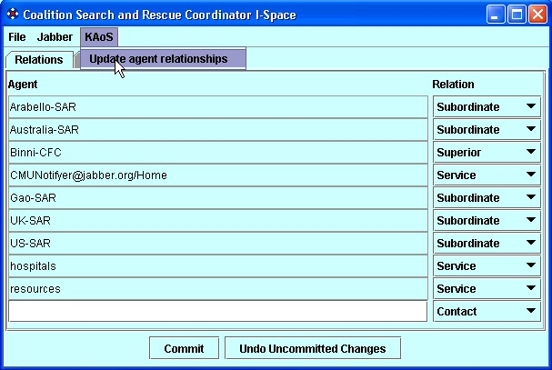
- I-Space is used to maintain organizational relationships with other agents in the environment. The nature of the relationship (for instance, supervisor-supervisee) will influence the nature of the activity-based interactions between these agents; the choices available to an agent will depend (amongst other things) both on its position in the organizational scheme of things and on its awareness of the capabilities and dynamic status (e.g. the current ‘presence’) of other agents. Exchange of agent and organization relationships with tools such as the KAoS Policy Administration Tool (KPAT) is possible.

Fig. 5. I-Space Organizational Relationships Tool
6 I-X Message Formats, Reports and Current State
There are a number of messages that are used within the I-X Process Panels and that can be passed between panels and other services and agents.
- Issues, Activities, Constraints and Annotations
- Current state information (world state constraints)
- Plans (composites of Issues, Activities, Constraints and Annotations)
- Reports on progress or completion of nominated activities
- Text-orientated “chat” messages.
The first 3 relate to the core underlying ontology on which I-X is based. The other two message types provide status and other contextual information.
Activities (and other panel items) can be passed from one panel to another (or to capable services or other agents). These can pass back “progress” and “completion” (success/fail) reports to the original sender of the item. This provides a way to monitor activity progress, receive back milestone reports, and check off the completion of activities.
Information on the current state of the environment can be passed to panels via “world state” constraints. These might come from sensors directly, or from some analysis or reporting system.
A specific type of current state we have found useful is the presence or status information maintained by instant messaging systems, so one can tell if another agent, panel or person is active and available for communications. Jabber (Jabber, 2003) for example maintains such information and makes it available for registered users/addresses of interest (kept in “buddy lists”) to any client. This information comes in as current state/constraint information to a process panel.
Incoming completion reports and information about the current state sent as constraints can trigger later activities to be executable as temporal or other constraints are satisfied. As an example, incoming presence or location information about a person might be sent between users. This would appear on the state panel for the receiver, and could trigger activities awaiting specific status or presence (e.g. waiting for a user to come on-line).
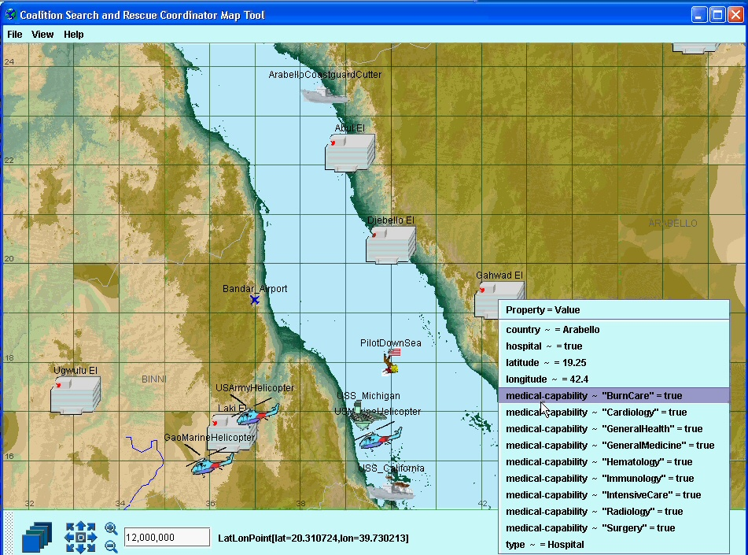
I-X also allows custom state viewers to be added to augment or replace the simple tabular current state view in a normal I-P² panel. An example of a viewer for such state information could be the BBN OpenMap™ tool (BBN, 2003). Changes to information in any viewer, or coming in via messages from outside of panels, are synchronized.
Fig. 6. Custom State Viewer – Map View
7 <I-N-C-A> Ontology
<I-N-C-A> (Issues - Nodes - Constraints - Annotations) is the basis of the ontology that underpins the I-X approach. It provides the framework for the representation used to describe processes and process products within I-X Process Panels and the structure for the main types of activity-orientated I-X Messages. <I-N-C-A> is a conceptual model that can be shared between human users and system components cooperating to carry out shared tasks.
In <I-N-C-A>, both processes and process products are abstractly considered to be made up of a set of "Issues" which are associated with the processes or process products to represent potential requirements, questions raised as a result of analysis or critiquing, etc. They also contain "Nodes" (activities in a process, or parts of a physical product) which may have parts called sub-nodes making up a hierarchical description of the process or product. The nodes are related by a set of detailed "Constraints" of various kinds. Finally there can be "Annotations" related to the processes or products, which provide rationale, information and other useful descriptions. The I-X systems integration approach is based on the <I-N-C-A> Model of Synthesized Artifacts that provides it with a simple abstraction that provides an extremely flexible, extendable and intelligible representation of the processes and process products in I-X. It is well suited to communication between human and system agents engaged in some common task, each possibly taking the initiative over which parts they can handle at various stages.
The forerunner of <I-N-C-A> was <I-N-OVA> (Tate, 1996). <I-N-C-A> generalizes the activity/plan orientated <I-N-OVA> ontology. When first designed, <I-N-OVA> was intended to act as a bridge to improve dialogue between a number of communities working on formal planning theories, practical planning systems and systems engineering process management methodologies. It was intended to support new work then emerging on automatic manipulation of plans, human communication about plans, principled and reliable acquisition of plan information, and formal reasoning about plans. It has since been utilized as the basis for a number of research efforts, practical applications and emerging international standards for plan and process representations. For some of the history and relationships between earlier work in AI on plan representations, work from the process and design communities and the standards bodies, and the part that <I-N-OVA> played in this see Tate (1998).
At various stages of the development of the I-X research the typography for rendering <I-N-C-A> has varied as the components have received clarification and as we have striven for greater generality. <I-N-CA> originally stood for Issues, Nodes, Critical and Auxiliary Constraints. The aspect of separating critical (shared communications) constraints from auxiliary (separately managed) constraints is still important within the I-X architecture, but is now considered a part of managing the "C" (constraints) component. The annotations were always present in the ontology and can be attached to all components, but the top level annotations that capture the rationale behind the synthesized product or the process/plan being described have required more prominence as the work has continued and as mixed-initiative and human communications aspects have become more important. Hence, the rendering <I-N-C-A> with the extra hyphen now stands for Issues, Nodes, Constraints and Annotations.
Issues
The issues in the representation may state the outstanding questions to be handled and can represent unsatisfied objectives, questions raised as a result of analysis, etc. The I constraints can be thought of as implying potential further constraints which may have to be added into the design in future in order to address the outstanding issues. In work on I-X until recently, the issues had a task or activity orientation to them, being mostly concerned with actionable items referring to the process underway - i.e., actions in the process space. This is now not felt to be appropriate, and we are adopting the gIBIS (Conklin and Begeman, 1988) orientation of expressing these issues as any of a number of specific types of question to be considered (Selvin, 1999; Conklin, 2003). The types of questions advocated are:
- Deontic questions - What should we do?
- Instrumental questions - How should we do it?
- Criterial questions - What are the criteria?
- Meaning or conceptual questions - What does X mean?
- Factual questions - What is X? or Is X true?
- Background questions - What is the background to this project?
- Stakeholder questions - Who are the stakeholders of this project?
- Miscellaneous questions - To act as a catch all.
The first 5 of these are likely to be the most common in our task support environment. This is similar to the Questions - Options- Criteria approach (MacLean et al., 1991) - itself used for rationale capture for plans and plan schema libraries in our earlier work (Polyak and Tate, 1998; 1999) and similar to the mapping approaches used in Compendium (Selvin et al. 2001). Compendium can in fact exchange its set of issues, activities and some types of constraints and annotations with I-P² (Buckingham Shum et al., 2002; Chen-Burger and Tate, 2003).
Nodes
The nodes in the specifications describe components that are to be included in the design. Nodes can themselves be artifacts that can have their own structure with sub-nodes and other <I-N-C-A> described refinements associated with them.
The node constraints (these are of the form “include node”) in the <I-N-C-A> model set the space within which an artifact may be further constrained. The “I” (issues) and “C” constraints restrict the artifacts within that space which are of interest.
When <I-N-C-A> is being used to describe processes, the nodes are usually the individual activities or their sub-activities. They are usually characterized by a “pattern” composed of an initial verb followed by any number of parameter objects, noun phrases, and qualifiers or filler words describing the activity. E.g.,
(transport package-1 from location-a to location-b)
Others have recognized the special nature of the inclusion of nodes (or activities) into a synthesized artifact (or plan) compared to all the other constraints that may be described. In the planning domain, Khambhampati and Srivastava (1996) differentiate Plan Modification Operators into “progressive refinements” which can introduce new actions into the plan, and “non-progressive refinements” which just partition the search space with existing sets of actions in the plan. They call the former genuine planning refinement operators, and think of the latter as providing the scheduling component.
Constraints
The constraints restrict the relationships between the nodes to describe only those artifacts within the design space that meet the requirements. The constraints may be split into “critical constraints” and “auxiliary constraints” depending on whether some constraint managers (solvers) can return them as “maybe” answers to indicate that the constraint being added to the model is okay so long as other critical constraints are imposed by other constraint managers. The maybe answer is expressed as a disjunction of conjunctions of such critical or shared constraints. More details on the “yes/no/maybe” constraint management approach used in I-X and the earlier O-Plan systems are available in Tate (1995).
The choices of which constraints are considered critical and which are considered auxiliary is itself a decision for an application of I-X and specific decisions on how to split the management of constraints within such an application (not a complete sentence?). It is not pre-determined for all applications. A temporal activity-based planner would normally have object/variable constraints (equality and inequality of objects) and some temporal constraints (maybe just the simple “before” constraint: {before time-point1 time-point-2}) as the critical constraints. But, in a 3D design or a configuration application object/variable and some other critical constraints (possibly spatial constraints) might be chosen. It depends on the nature of what is communicated between constraint managers in the application of the I-X architecture.
Annotations
The annotations add additional human-centric information or design and decision rationale to the information describing the artifact.
8 Future Directions
Work to date on I-X and its applications in coalition command and control, search and rescue, help desks, etc. have indicated the value of adopting an “augmented” style of instant messaging paradigm which we call activity-orientated “intelligible messaging”. This provides a platform for making AI planning technology available in an immediately usable form.
There are many opportunities for extending the initial approach and technology included. A more comprehensive I-Plan planner is to be incorporated as project work allows, and this will use the O-Plan “repairing plans on-the-fly” repair technology (Drabble et al., 1997) to recover from failures. The incorporation of more capable constraint managers and optimization algorithms to propose options is possible within the design.
More sophisticated and robust communications strategies are being experimented with, including secure communications routes (e.g. in tunneled versions of the CoABS Grid), and logging of message traffic for quality control and audit purposes. We are particularly interested in the changes of process that might be triggered when the status of agents and panels alter (say moving from a synchronous on-line instant messaging mode of communication to an off-line store and forward messaging mode).
Ways to describe panels and user/service capabilities in an organization, the roles they play and the authorities they have to act for one another are being experimented with.
The current I-P² software is available for demonstrations and more technical details on I-X are available via http://www.aiai.ed.ac.uk/project/ix/ or http://i-x.info
Acknowledgements
Thanks to our co-workers on the I-X, CoSAR-TS and CoAKTinG projects at AIAI (Stuart Aitken, Yun-Heh Chen-Burger, Renia Jeffers, John Levine, Natasha Lino, Clauirton de Siebra, Jussi Stader and Gerhard Wickler), IHMC (Jeff Bradshaw, Maggie Breedy, Niranjan Suri and Andrzej Uszok) and the Open University (Simon Buckingham Shum and Marc Eisenstadt) for discussions on the topic of this paper.
This material is based on research within the I-X and CoSAR-TS projects sponsored by the Defense Advanced Research Projects Agency (DARPA) and US Air Force Research Laboratory under agreement number F30602-03-2-0014 and under the Advanced Knowledge Technologies (AKT) Interdisciplinary Research Collaboration (IRC) and its Collaborative Advanced Knowledge Technologies in the Grid (CoAKTinG) project, which is sponsored by the UK Engineering and Physical Sciences Research Council under grant number GR/N15764/01. The AKT IRC comprises the Universities of Aberdeen, Edinburgh, Sheffield, Southampton and the Open University.
The U.S. Government, the University of Edinburgh, the AKT IRC research partners and sponsors are authorized to reproduce and distribute reprints and on-line copies for their purposes notwithstanding any copyright annotation hereon. The views and conclusions contained herein are those of the authors and should not be interpreted as necessarily representing the official policies or endorsements, either expressed or implied, of other parties.
References
Aarup, M., Arentoft, M.M., Parrod, Y., Stokes, I., Vadon, H. and Stader, J. (1994) Optimum-AIV: A Knowledge-Based Planning and Scheduling System for Spacecraft AIV, in Intelligent Scheduling (eds. Zweben, M. and Fox, M.S.), pp. 451-469, Morgan Kaufmann.

Allsopp, D.N., Beautement, P., Bradshaw, J.M., Durfee, E.H., Kirton, M., Knoblock, C.A., Suri, N. and Tate, A. and Thompson, C.W. (2002) Coalition Agents Experiment: Multi-Agent Co-operation in an International Coalition Setting, Special Issue on Knowledge Systems for Coalition Operations (KSCO), IEEE Intelligent Systems, Vol. 17 No. 3 pp. 26-35. May/June 2002.

BBN (2003) OpenMap™ Open Systems mapping Technology - http://openmap.bbn.com

Bradshaw, J.M., Dutfield, S., Benoit, P. and Woolley, J.D. (1997) KAoS: Toward an industrial-strength generic agent architecture, In J. M. Bradshaw (Ed.), Software Agents, 1997, pp. 375-418, Cambridge, MA: AAAI Press/The MIT Press.

Buckingham Shum, S., De Roure, D., Eisenstadt, M., Shadbolt, N. and Tate, A. (2002) CoAKTinG: Collaborative Advanced Knowledge Technologies in the Grid, Proceedings of the Second Workshop on Advanced Collaborative Environments, Eleventh IEEE Int. Symposium on High Performance Distributed Computing (HPDC-11), July 24-26, 2002, Edinburgh, Scotland.

Chen-Burger, Y. and Tate, A. (2003) Concept Mapping Between Compendium and I-X, Informatics Report Series, University of Edinburgh, EDI-INF-RR-0166, May 2003.

Conklin, J. and Begeman, M. L. (1988). gIBIS: A hypertext tool for exploratory policy discussion. ACM Transactions on Office Information Systems, 4(6), 303-331.

Conklin, J. (2003) Dialog Mapping: Reflections on an Industrial Strength Case Study. In: P.A. Kirschner, S.J. Buckingham Shum and C.S. Carr (Eds.), Visualizing Argumentation: Software Tools for Collaborative and Educational Sense-Making. Springer-Verlag: London, ISBN 1-85233-6641-1, pp. 117-136.

CoSAR-TS Team (2003) Coalition Search and Rescue Task Support Web Site. http://www.aiai.ed.ac.uk/project/cosar-ts/

Currie, K.W. and Tate, A. (1991) O-Plan: the Open Planning Architecture, Artificial Intelligence 52(1), Autumn 1991, North-Holland.

Drabble, B., Dalton, J. and Tate, A. (1997) Repairing Plans on the Fly, in Proceedings of the NASA Workshop on Planning and Scheduling for Space, Oxnard CA, USA, October 1997.

Fraser, J. and Tate, A. (1995) The Enterprise Tool Set - An Open Enterprise Architecture, Proceedings of the Workshop on Intelligent Manufacturing Systems, International Joint Conference on Artificial Intelligence (IJCAI-95), Montreal, Canada, August 1995.

Jabber (2003) Jabber XML Instant Messaging, http://www.jabber.org.

Khambhampati, S. and Srivastava, B. (1996) Unifying Classical Planning Approaches, Arizona State University ASU CSE TR 96-006, July 1996.

Kahn, M.L. and Della Torre Cicalese, C. (2001) CoABS Grid Scalability Experiments, Autonomous Agents 2001 Conference, 2nd Int’l Workshop on Infrastructure for Agents, MAS, and Scalable MAS, May 29, 2001.

Levine, J., Tate, A. and Dalton, J. (2000) O-P3: Supporting the Planning Process using Open Planning Process Panels, IEEE Intelligent Systems, Vol. 15, No. 6, November/December 2000.
MacLean, A., Young, R., Bellotti, V. and Moran, T. (1991) Design space analysis: Bridging from theory to practice via design rationale. In Proceedings of Esprit '91, pages 720-730, Brussels, November 1991.

Polyak, S. and Tate, A. (1998) Rationale in Planning: Causality, Dependencies and Decisions, Knowledge Engineering Review, Vol.13 (3), pp. 247-262, September, 1998, Cambridge University Press. See http://www.aiai.ed.ac.uk/project/oplan/documents/1998/98-rationale.pdf

Polyak, S. and Tate, A. (1999) A Common Process Ontology for Process-Centred Organisations, Knowledge based Systems, 2000. Earlier version by S. Polyak published as University of Edinburgh Department of Artificial Intelligence Research paper 930, 1998. See http://www.aiai.ed.ac.uk/project/oplan/documents/1999/99-sebpc-cpm.pdf

Selvin, A.M. (1999) Supporting Collaborative Analysis and Design with Hypertext Functionality, Journal of Digital information, Volume 1 Issue 4.

Selvin, A.M, Buckingham Shum, S.J., Sierhuis, M., Conklin, J., Zimmermann, B., Palus, C., Drath, W., Horth, D., Domingue, J., Motta, E. and Li, G. (2001) Compendium: Making Meetings into Knowledge Events, Knowledge Technologies 2001, Austin TX, USA, March 4-7, 2001.

Siebra, C. and Tate, A. (2003) I-Rescue: A Coalition Based System to Support Disaster Relief Operations, The Third International Association of Science and Technology for Development (IASTED) International Conference on Artificial Intelligence and Applications (AIA-2003), Benalmadena, Spain, September 2003.

Stader, J. (1996) Results of the Enterprise Project. In Proceedings of Expert Systems '96, the 16th Annual Conference of the British Computer Society Specialist Group on Expert Systems, Cambridge, UK, December 1996.
http://www.aiai.ed.ac.uk/project/ftp/documents/1996/96-es96-enterprise.ps

Tate, A. (1977) Generating Project Networks, Proceedings of the International Joint Conference on Artificial Intelligence (IJCAI-77), pp. 888-893, Cambridge, MA, USA, Morgan Kaufmann.

Tate, A. (1994) Mixed Initiative Planning in O-Plan2, Proceedings of ARPA/Rome Laboratory Planning Initiative (ARPI) Workshop, Tucson Arizona, 22nd - 24th February, 1994, Morgan Kaufmann. See http://www.aiai.ed.ac.uk/~oplan/documents/1994/94-arpi-mixed-initiative.pdf

Tate, A. (1995) Integrating Constraint Management into an AI Planner, Journal of Artificial Intelligence in Engineering, Vol. 9, No.3, pp. 221-228,1995.

Tate, A. (1996a) The <I-N-OVA> Constraint Model of Plans, Proceedings of the Third International Conference on Artificial Intelligence Planning Systems, (ed. Drabble, B.), pp. 221-228, Edinburgh, UK, May 1996, AAAI Press.

Tate, A. (1996b) Responsive Planning and Scheduling Using AI Planning Techniques - Optimum-AIV, In Trends & Controversies - AI Planning Systems in the Real World, IEEE Expert: Intelligent Systems & their Applications, Vol. 11 No. 6, pp. 4-12, December 1996

Tate, A. (1998) Roots of SPAR, in Special Issue on Ontologies, Knowledge Engineering Review, Vol. 13(1), March, 1998, Cambridge University Press.

Tate, A. (2000a) <I-N-OVA> and <I-N-CA> - Representing Plans and other Synthesized Artifacts as a Set of Constraints, AAAI-2000 Workshop on Representational Issues for Real-World Planning Systems, at the National Conference of the American Association of Artificial Intelligence (AAAI-2000), Austin, Texas, USA, August 2000.

Tate, A. (2000b) Intelligible AI Planning, in Proceedings of the Twentieth British Computer Society Special Group on Expert Systems International Conference on Knowledge Based Systems and Applied Artificial Intelligence, Cambridge, UK, December 2000.

Tate, A., Dalton, J. and Levine, J. (1998) Generation of Multiple Qualitatively Different Plan Options, Fourth International Conference on AI Planning Systems (AIPS-98), Pittsburgh, PA, USA, June 1998.

Tate, A., Dalton, J. and Levine, J. (2000a) O-Plan: a Web-based AI Planning Agent, AAAI-2000 Intelligent Systems Demonstrator, in Proceedings of the National Conference of the American Association of Artificial Intelligence (AAAI-2000), Austin, Texas, USA, August 2000.

Tate, A., Dalton, J., Jarvis, P. and Levine, J. (2000b) Using AI Planning Technology for Army Small Unit Operations, Poster Paper in the Proceedings of the Artificial Intelligence Plan-ning and Scheduling Systems Conference (AIPS-2000), Breckenridge, Colorado, USA, April 2000.

Tate, A., Levine, J., Dalton, J. and Nixon, A. (2003) Task Achieving Agents on the World Wide Web, in Spinning the Semantic Web, Fensel, D., Hendler, J., Liebermann, H. and Wahlster, W. (eds.), MIT Press, 2003.

Tate, A., Dalton, J., Siebra, C., Aitken, S., Bradshaw, J.M. and Uszok, A. (2004) Intelligent Agents for Coalition Search and Rescue Task Support, Intelligent Systems Demonstrator, Nineteenth National Conference of the American Association of Artificial Intelligence, (AAAI-2004), San Jose, California, USA, July 2004.

Wark, S., Zschorn, A., Perugini, D., Tate, A., Beautement, P., Bradshaw, J.M. and Suri, N. (2003) Dynamic Agent Systems in the CoAX Binni 2002 Experiment, Special Session on Fusion by Distributed Cooperative Agents at the 6th International Conference on Information Fusion (Fusion 2003), Cairns, Australia, July, 2003.

