IEEE Intelligent Systems – 2010 - Submitted Paper

I-Room: A Virtual Space for Intelligent Interaction
Austin Tate, Yun-Heh Chen-Burger, Jeff Dalton, Stephen Potter, David Richardson, Jussi Stader, and Gerhard Wickler
University of Edinburgh
Ian Bankier
Glenkier Whiskies
Christopher Walton
Metaforic/Slam Games
Patrick Geoffrey Williams
EADS Innovation Works

The I-Room is a virtual environment intended to support a range of collaborative activities, especially those that involve sense making, deliberation and decision making.
The Internet is changing both our work and leisure activities at a fundamental level, allowing interactions that would previously have been impossible. Supporting these processes, and helping to maximize their potential, involves creating and maintaining the information space that surrounds and defines them. We have developed the I-Room virtual environment—the “I” stands variously for intelligent, information, interactive, integrated and instrumented—a shared persistent space, founded on process methodologies and offering intelligent systems support for interaction and collaboration between users, systems, and agents. The I-Room case studies we describe here all employ virtual worlds technology to provide this interaction space and show how this can be augmented with external knowledge-based and intelligent systems.

Collaboration as Process
During a collaborative informational process, value is added by applying the collaborators’ knowledge and skills. Information is both the goal of the process and its means because the collaboration is furthered when the participants communicate information. Currently, such work proceeds in a more or less ad hoc manner, conforming to the technological and social constraints imposed by the various tools available for information manipulation and transfer. The starting point of the work reported here is that the proper organization of this form of collaboration can serve to increase the process’s efficiency.
Our conception of the information that characterizes collaborative work stems from fundamental research in AI planning and workflow and the application of this research in so-called mixed-initiative (that is, involving humans and computers) activities in various fields. This led to the development of the generic Issues-Nodes-Constraints-Annotations (<I-N-C-A>) model of shared activity and its accompanying process methodology.1
In its simplest terms, an <I-N-C-A> description represents a process at any stage of its life in terms of four types of information:
- Issues represent problems or outstanding questions concerning current activities or recognized opportunities for more productive or efficient action.
- Nodes represent activities that are identified as part of the shared process.
- Constraints represent spatial or temporal restrictions on activities and on the availability and use of resources.
- Annotations capture meta-information about the other categories, such as rationale, provenance, and status.
The <I-N-C-A> methodology involves furthering the collaborative process with other participants by cyclically addressing these elements. Issues are considered and resolved in terms of further activities or additional constraints. Node activities are elaborated, performed, or delegated, and the ways in which this is done will raise additional issues or place further constraints. Constraint spaces are explored using simulation or analysis to pinpoint feasible activity. All of this happens in a context continually enriched by annotation.
From an informational perspective, we can view this approach as one of performing a process by continuously refining its description using certain specific operators. These operators essentially introduce or manipulate the structured information that constitutes the <I-N-C-A> description as a result of the performance of the activities that constitute the process. It is this information structuring that provides the basis for collaboration; the <I-N-C-A> process elements are intended to be easily communicated and intelligible to both humans and machines and can be described in formal or informal terms, as the situation demands. To help put this into practice, a suite of tools (collectively termed the I-X technology2) provides generic support for creating and interacting with a system of agents that can apply the <I-N-C-A> methodology to enact processes.
However, applying this approach alone cannot guarantee a successful process; while it is intended to provide a principled approach, the quality of the collaboration will be determined in large part by the quality of the information available to and shared by the participants. This information describes the current state of the world, standard procedures for specific tasks, available options and their evaluation, and so on. Clearly, the better the information, the more likely the collaboration will be a success. Some of this information will exist in externalized forms, some will be brought to the process by the participants, and some will be transformed and expanded through the participants’ knowledge and the application of their analytic or synthetic skills. This work takes place in an environment with a potential for providing, manipulating, and sharing information that in some sense represents the potential for this and similar future collaborations. As a consequence, if we are committed to providing process support, we need to think about nurturing and supporting this information potential. We need to provide easy access to the information itself where it exists in externalized forms, along with the proper environment for tapping into the potential where it remains tacit.

Information Spaces
Reflecting on the conventional ways in which humans approach shared tasks, we see that there is a spatial component to these information-manipulating operations; that is, people organize the space around them so as to better perform these tasks. We can observe this spatial aspect in, for instance, a brainstorming session in a small office with whiteboards and flip charts acting as shared cognitive tools to develop ideas, the use of projector screens to disseminate presentations to an audience, the careful arrangement of project documents in front of participants during meetings, and even in the use of filing cabinets to order and store useful papers. This has led us to make the following conjecture: successful collaborations occur in an information space that offers access to appropriate informational facilities and resources. In conventional work practices involving collaboration with physically collocated colleagues, this information space will correspond either wholly or in part to physical workplace zones, which we manipulate to better suit our needs. In the new world of global virtual collaborations, we must search for—or create—an analogous space. We term this space the I-Room.
In this article, through the use of case studies of several different applications, we describe how this I-Room concept has been realized using virtual worlds technology. In our use of virtual worlds, we are effectively simulating real-world work spaces—offices, meeting rooms, buildings—and the real collaborative tools these contain because they are the only models we currently possess for the “appropriate informational facilities and resources” integral to the I-Room. See Figure 1.
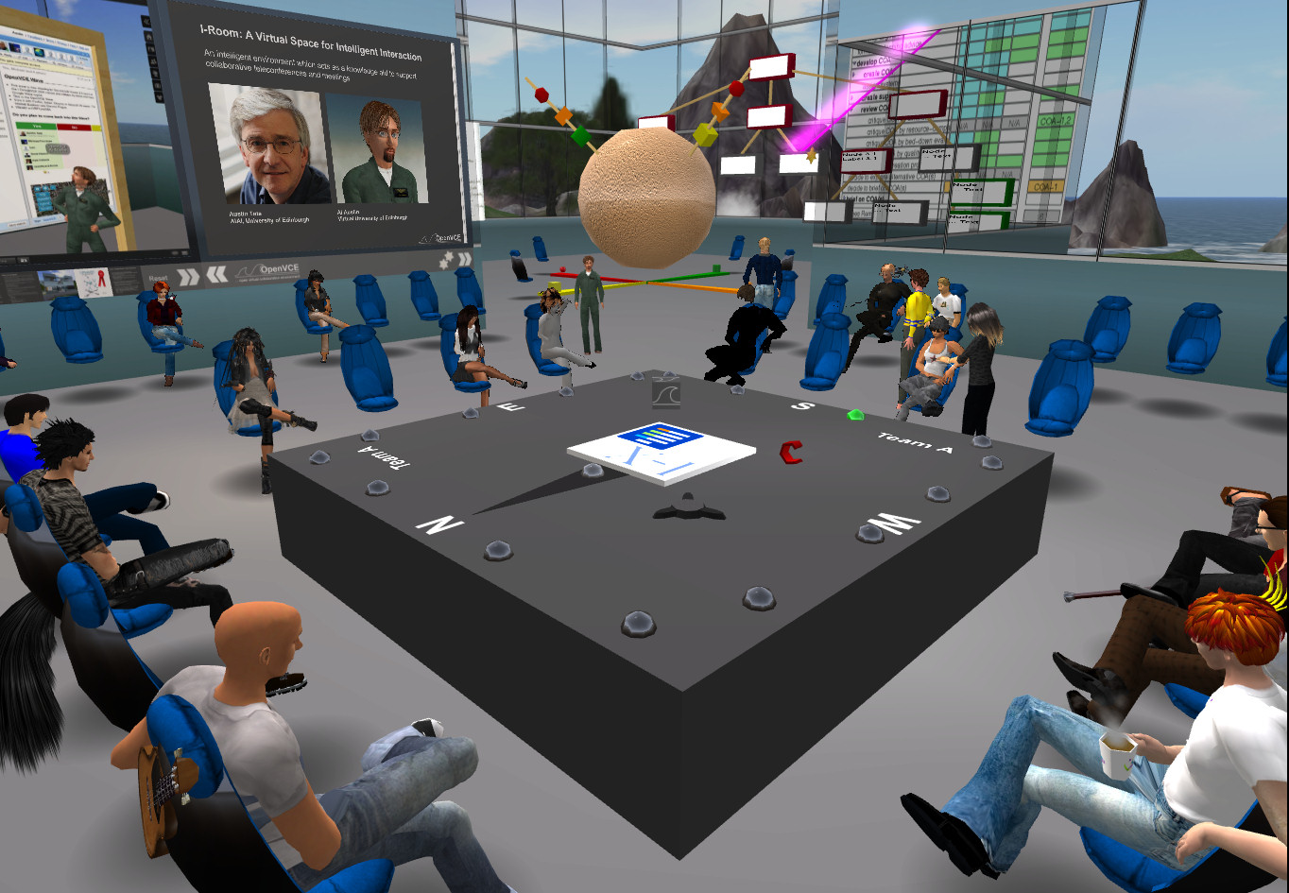
Figure 1. I-Room – a 3D virtual space for intelligent interaction.

With some justification, one could argue that this is not the most effective use of this technology and that it risks mistaking the inessential (and possibly, where collaboration is concerned, detrimental) physical aspects of these spaces in the real world for features that are somehow integral and necessary for collaboration. As a result, we risk replicating these accidental features in a virtual world. However, this must be weighed against the advantage of this approach, namely that the simulation of identifiable real-world spaces offers instant familiarity to users, most of whom have had little prior experience with virtual worlds. As the technology continues to improve and develop, and as our experience with developing and using I-Rooms expands, we expect to be able to hone these ideas into virtual spaces that are optimized for different types of collaboration. (See the “A Brief History of Virtual Collaboration” sidebar for previous work in this area.)

[[----Begin Sidebar ----------------------------------------------------------]]

A Brief History of Virtual Collaboration
While strongly influenced in recent years by advances in computer game technology, the origins of virtual worlds and their social networking aspects can be traced to research into multiuser persistent spaces that began in the late 1970s and explored object sharing and chat for collaborative systems.1 Adding object-oriented programming to script or control the objects in the shared space expanded the possibilities. Dating from 1990, LambdaMOO (http://lambdamoo.info) is one well-known example of this type of multiuser, object-oriented virtual space.
Work in this area has continued, with the environments now being used alongside teleconferencing, videoconferencing, and instant messaging with agent presence and status information. A good example is the Collaborative Virtual Workspace (http://cvw.sourceforge.net), originally built by MITRE between 1994 and 1999, that used a buildings-and-rooms metaphor for persistent storage of the documents and shared assets used in collaborations. Many videoconference support systems use the idea of setting up a virtual workspace “room” to give context to a particular presentation or meeting.
The foundations of the I-Room project, within the context of the wider I-X Research Program, lie in proposed extensions to this idea to make use of intelligent planning and collaboration aids alongside CVW. These represent just a handful of the proposals that have appeared over the last decade that describe a room for intelligent team-based interaction or a room that could itself act as a knowledge-based asset for a group. Some of these concepts were explored in the Collaborative Advanced Knowledge Technologies in the Grid (CoAKTinG) project.2

References
1. R.A. Bartle, “Early MUD History,”; http://www.mud.co.uk/richard/mudhist.htm
2. S. Buckingham Shum et al., “CoAKTinG: Collaborative Advanced Knowledge Technologies in the Grid,” Proc. 2nd Workshop Advanced Collaborative Environments, Advanced Knowledge Technologies (AKT), 2002; http://www.aktors.org/coakting/
[[---- End Sidebar ----------------------------------------------------------]]

Furthermore, the I-Room idea is not limited to supporting work processes. Another recent and fundamental change in society has been the growth of mass leisure time. This leisure time also is increasingly expended in information-based activities, with the Internet offering the chance to share pursuits with like-minded people all around the world. The I-Room can enhance these activities for participants.

I-Room Collaboration
A collaboration exists whenever at least two agents work together to achieve some agreed-upon goals. Additional agents can be brought in to participate in this collaboration, and participants can leave whenever appropriate. To sustain and further their collaboration, the participants must have some effective means of communication. The nature of this communication will depend on the nature of the activities currently underway and on the participants, their specific contexts and environments, and the technologies that they share. That is, for any sort of remote collaboration, there must be a sufficient technology overlap between participants to let them share information.
While this technology might be as commonplace as the telephone or e-mail, with the I-Room we propose the use of virtual worlds as the technology that lets us situate this communication in a richer (virtual) spatial context. Modern virtual-world platforms offer voice and text chat and messaging services that are familiar to most of us these days; moreover, they offer facilities for nonverbal gestural communication. Realizing the I-Room concept within a virtual world would give collaborators an intuitive grounding in a persistent 3D space in which representations of the participants (their avatars) appear. In addition, the artifacts and resources surrounding the collaboration can be granted a surrogate ‘reality’, which, where these items consist of information, might be more meaningful or compelling than their physical manifestations.

Conceptual Foundations
We can tentatively list a number of complementary concepts that will provide the foundations for the collaboration support an I-Room offers:
- The <I-N-C-A> model lets us represent the process and its current state, and the <I-N-C-A> methodology is used to further the collaboration, with principled communication based on sharing issues, activities and processes, state, event, agents, options, argumentation, rationale, presence information, and reports.
- The Issue-Based Information System (IBIS)3 and Questions-Options-Criteria (QOC) methodologies4 provide a structured approach for exploring the ramifications of issues and developing possible responses using argument-based evaluation. In a sense, these concepts provide one mechanism for enacting iterations of the <I-N-C-A> methodology by resolving issues in terms of activity nodes. Research has shown that graphical dialogue-mapping techniques and tools are useful for visualizing and recording applications of these methodologies,5 which lays the groundwork for their use in a virtual world.
- The Beliefs-Desires-Intentions (BDI) agency model provides a means for understanding and steering the behavior of individual (human and automated) participants. The incorporation of BDI into the <I-N-C-A> model, with beliefs corresponding to constraints and intentions to nodes, and with desires manifest in the decision-making processes, both allows a process-centric account of agent systems and provides a model for implementing and deploying rational intelligent agents within this system.6
- Shared or overlapping ontologies and associated vocabularies are the basis for formal and informal communication and mutual comprehension among participants. The use of intelligent systems and services during the collaboration will determine the extent to which these ontologies and their use need to be formalized and made explicit.
Obviously, introducing these complex concepts into practical use in an I-Room is not a straightforward task. It requires experimentation with alternative visualization and interaction metaphors, based on an evolving understanding of human perception of and interaction with the virtual space. Nonetheless, these concepts have all been used successfully (and in various combinations) in the past, at which times their human users have effectively developed their own ad hoc information spaces. It is these spaces that we are now trying to realize in a more formal and shared manner as I-Rooms.

Meeting Support
Collaborative effort can be divided into two types: synchronous effort requires the contemporaneous interaction of two or more participants and nonsynchronous effort, when the participants act separately to achieve individual subgoals. These, in turn, dictate the forms of communication involved. One example of synchronous collaboration is a scheduled project meeting. We have chosen to focus much of our initial effort on providing support for meetings of this type because they are, relatively speaking, easy to consider in conceptual terms, have a limited temporal extension, have clearly definable objectives, and as we shall see, lend themselves to the <I-N-C-A> methodology.
A formal meeting (process) occurs in shared time, and by extension, we can also say that it takes place in shared (conceptual) space—that is, the I-Room. The meeting usually consists of a sequence of conventional subactivities, such as a general meeting introduction, a review of minutes from the previous meeting, a review of actions placed on participants during previous meetings, the main discussion topics, and closing business. Within this, the various participants play one or more specific roles: meeting chair, secretary, presenter, or attendee.
In <I-N-C-A> terms, the meeting activities correspond to nodes in the meeting process. The methodology requires executing each of these activities in turn; the result of this is to generate information, in the form of minutes, decisions, additional activity nodes (actions on participants), and so on. The I-X tools are used to formalize this information as far as possible—for example, the meeting process is formalized into a plan—to control and monitor the meeting’s progress (that is, the meeting plan’s execution), provide links to the details of previous meetings, and automatically compose and distribute minutes. Various information presentation and sharing mechanisms support the meeting’s domain-specific content, revolving around discussions leading (usually) to decisions. Considering the meeting as simply one subprocess within a wider program of activity—as a meeting invariably is—lets participants provide and develop a richer body of contextual informational material.

Realizing the I-Room
The meeting activities take place within an I-Room. Simply put, the I-Room should provide a conceptual space (in this case, within a virtual world) amenable to a successful meeting. The examples we use to illustrate the I-Room concept in this article have all been built in the Second Life (http://secondlife.com) and OpenSim (http://opensimulator.org) virtual world environments, which provide users with individual avatars, allow the construction of detailed 3D spaces containing objects with programmable behavior, and provide all the communication channels (over voice, text chat and instant messaging, and gesturing) we have discussed so far. These environments also provide facilities to display external media (such as video, audio, graphics, and webpages), which in this context effectively become additional communication aids.
We have chosen to develop virtual spaces that closely resemble the sort of space that, if available, would naturally be chosen to host the meeting in real life. Thus, each I-Room is a virtual 3D space furnished with chairs for the avatars, arranged for roundtable discussions or seminar-like presentations as appropriate, and various meeting aids (such as display screens, flip charts, and the like) according to the nature of the meeting in question. We scale these spaces and the objects relative to the avatars’ average size, but always with an awareness of the software’s particular audio and visual characteristics (such as the in-world distance that voice chat carries).
Also, to interact with the technology, we provide additional tools to support the meeting by generating, manipulating, and controlling information. These include automated status monitors to keep track of participants as they come and go, tools to control the display of information within the I-Room, and tools to monitor and help document the meeting’s progress and content. Avatars can also be given virtual items (such as customized personal information displays and name tags to show others their real identities and affiliations) that help to smooth the meeting’s progress.
We created a special autonomous object in the I-Room (the I-Room Helper) to communicate information with the I-X tool suite elements, which run externally to the virtual world, thereby providing access to the process support offered by the underlying <I-N-C-A> methodology. The Helper also offers a route by which knowledge-based support in the shape of third-party intelligent systems can be made available to the I-Room and, hence, to the collaborative process.
These initial realizations of the I-Room concept have entailed a significant amount of specialized effort, requiring graphical modeling, human-computer interaction, and programming skills. This provides the necessary basis for experimentation with our conceptual ideas, which is our primary concern as informatics researchers.

Case Studies
Over the last couple of years, we have constructed and deployed I-Rooms for a range of meetings and other collaborations, such as training exercises, and always with the participation of real prospective end-users keen to see whether the technology can support their processes. These applications, all created in Second Life and OpenSim, support meetings in a creative industry (the development of multimedia video games), virtual operations centers for emergency response and public safety, and a social/educational activity (an expert-led whisky tasting). Without delving too deeply into the technicalities, these case studies are intended to give a flavor of the sort of collaborations that the I-Room technology currently supports and some indication of the directions in which future work will take these ideas.

Slam Games I-Room
Slam Games, a videogame developer, is typical of companies operating in the modern creative industries, with a strong emphasis on information creation and exchange. Working in partnership with Slam Games, we created an I-Room to assist the company’s game development process, which involves an international team of designers, artists, and managers. For game development, Slam Games itself concentrates on the game’s core design, programming, and development, while the design and production of most artwork, sound, and other media are outsourced to specialists, who may be located anywhere in the world. Hitherto, the company has maintained communication with these media artists via various channels (e-mail, telephone, instant messaging, a wiki, and an issue-tracking system), an arrangement which did not prove wholly adequate for supporting the sort of synchronous multiway interaction that is required occasionally during development.
The I-Room developed to address these communication failings has mechanisms for displaying artwork and animations as well as supporting the flow of meetings and recording argumentation, communications, and decisions. For instance, it allows artwork in the form of 2D stills from 3D models to be presented by the artist and then discussed by everyone present (see Figure 2). A meeting is seen as one in a wider sequence during which the artwork is successively developed and refined in response to criticism and other client feedback; this allows actions from previous meetings to be maintained, discussed, and carried forward, with outcomes noted as appropriate, placing the meeting in the wider context of the project with its global milestones, deadlines, and deliverables.

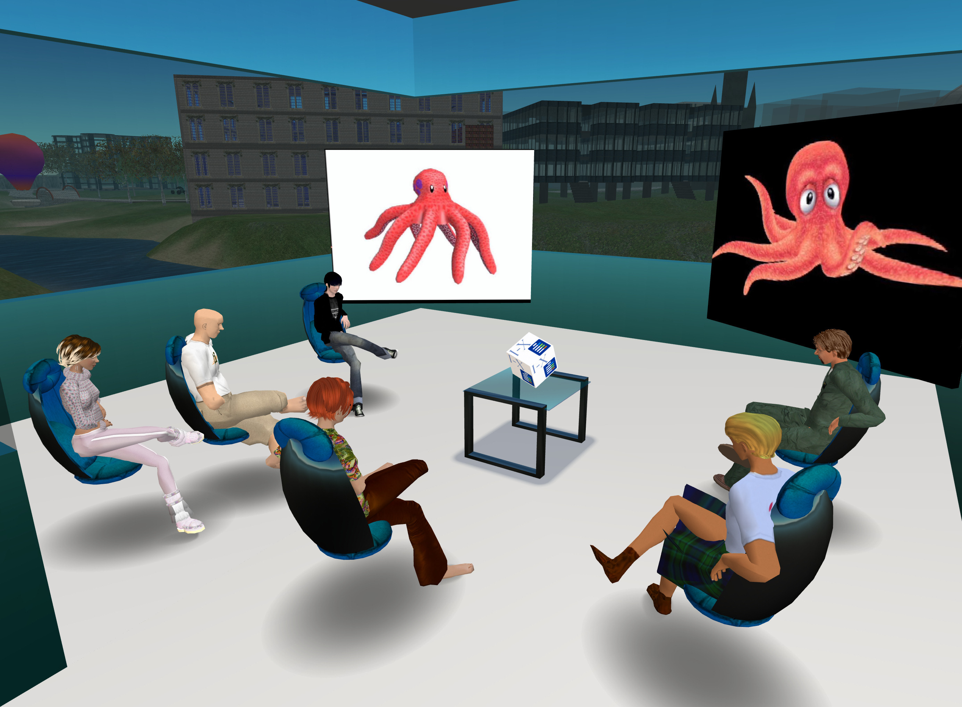
Figure 2. Discussing character design in the Slam Games I-Room. An artist can present artwork in the form of 2D stills from 3D models for the whole group to discuss.
In this manner, the I-Room provides means by which the various stakeholders can view and contrast artwork in a shared setting that also provides a persistent “memory” of previous meetings and the current state of the collaboration. We consulted with Slam Games employees during this I-Room’s development, and they participated in trial meetings based on the design of a real game and its related media. These trials allowed a basic qualitative evaluation, which confirmed the I-Room technology’s potential in the context of Slam Games’ requirements and the shortcomings of existing collaboration mechanisms.

Virtual Emergency and Crisis Management I-Rooms
An initial spur to the development of virtual I-Room technology arose from research into building the Helpful Environment,7 which is a vision for collaborative systems of sensors, people, systems and machines working at all scales from very local to truly global and employing a mix of human and machine intelligence to provide assistance and help when needed. More specifically, we designed the I-Room to be used for online collaborative planning and task-support systems by search and rescue teams and for emergency response. One focus of this work has been to demonstrate the I-Room concept to the Multinational Planning Augmentation Team (MPAT), an organization consisting of more than 30 Pacific Rim nations that helps coordinate more effective responses to regional crises such as the 2004 Asian Tsunami. As might be expected, effective communication and information sharing are essential for coordinating an effective response. Based on discussions with the MPAT Secretariat, along with analyses of their processes and information, we developed a prototype virtual operations center (VOC) I-Room for MPAT-type operations.8
This VOC I-Room found a role in the Public at Large Scale Events (PuLSE) Technology Demonstration program developed and promoted by EADS, a multinational company at the forefront of the aerospace, defense, and related service industries and owner of Airbus. EADS’s Innovation Works (IW) UK arm began developing the PuLSE program in early 2008, with an initial demonstration scenario centered around protecting the public from a terrorist threat to a high-profile sports event being held at the Celtic Manor Resort in South Wales. This location was chosen for its proximity to the EADS IW UK headquarters and because it is the venue for the 2010 Ryder Cup golf competition. As such, it is currently the focus of real security and safety preparations.
Colleagues in this scenario needed to interact in both real and virtual spaces. This, and the importance in such situations of providing an audit trail for post-incident review, led to the deployment of a customized VOC (see Figure 3) mirrored by a real-world briefing room that, in addition to standard communications facilities, was set up as an instrumented meeting room (IMR) that lets participants capture, tag, and timestamp audio, video, and other feeds (http://www.amiproject.org).
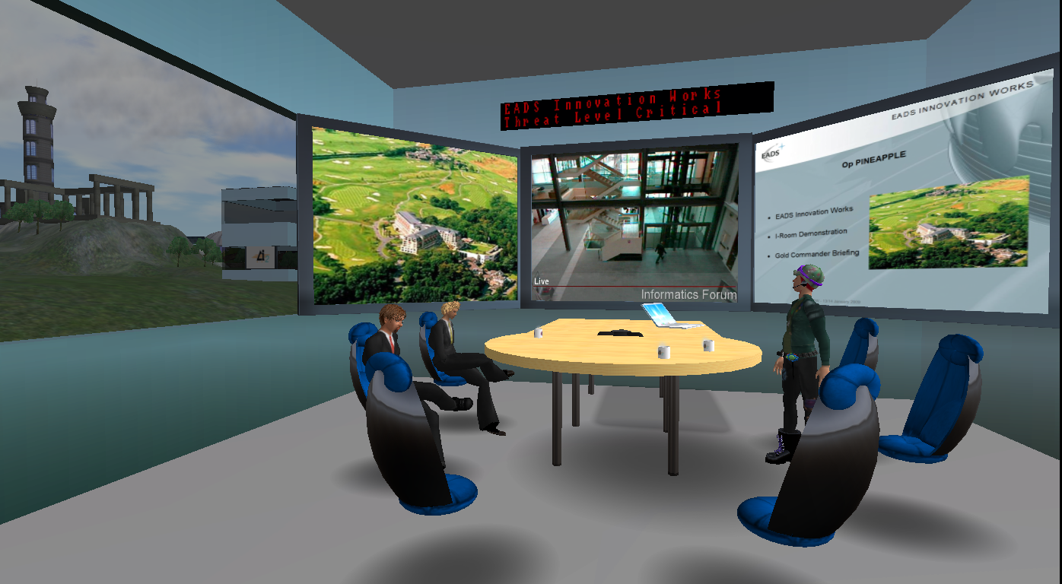
Figure 3. Inside the crisis response virtual operations center (VOC) I-Room. This instrumented meeting room (IMR) lets participants capture, tag, and timestamp audio, video, and other feeds to provide an audit trail for a post-incident review.

As it was played out, the scenario involved the local chief of security, located in the IMR briefing room, developing with his immediate local staff a plan of action (represented in <I-N-C-A> terms) and then uploading this plan into the VOC I-Room. A virtual meeting was convened with representatives of national government and security services, who were first briefed about the threat and the response plan and, after recommending modifications, were then able to endorse the final plan.

Virtual World of Whisky I-Room
Glenkeir Whiskies is a company dedicated to the promotion and sale of Scotch whisky to customers all around the world. Attracted by the social and commercial prospects offered by virtual worlds in the wake of a successful e-commerce venture, it proposed the development of a virtual whisky-tasting I-Room for hosting educational and social events, with an eye to commercial opportunities (see Figure 4).
A whisky tasting was held in the Virtual World of Whisky I-Room on 25 January 2008 to coincide with the traditional Scottish celebration of Burns Night. Supplied with real whisky in advance—there are limitations to virtual world technology!—the participants were led step by step through the tasting by a whisky expert. The tutorial itself was represented as an <I-N-C-A> process, with the I-X tools providing process support, which here included access to natural-language generation facilities that drew on an existing knowledge base of Scotch whiskies and distilleries to complement the tutor’s presentation with factual information delivered in a mixed-initiative manner. The success of this event—and the enjoyment it provided—has helped convince those involved of the potential of intelligent virtual world spaces for engaging social users and potential customers.

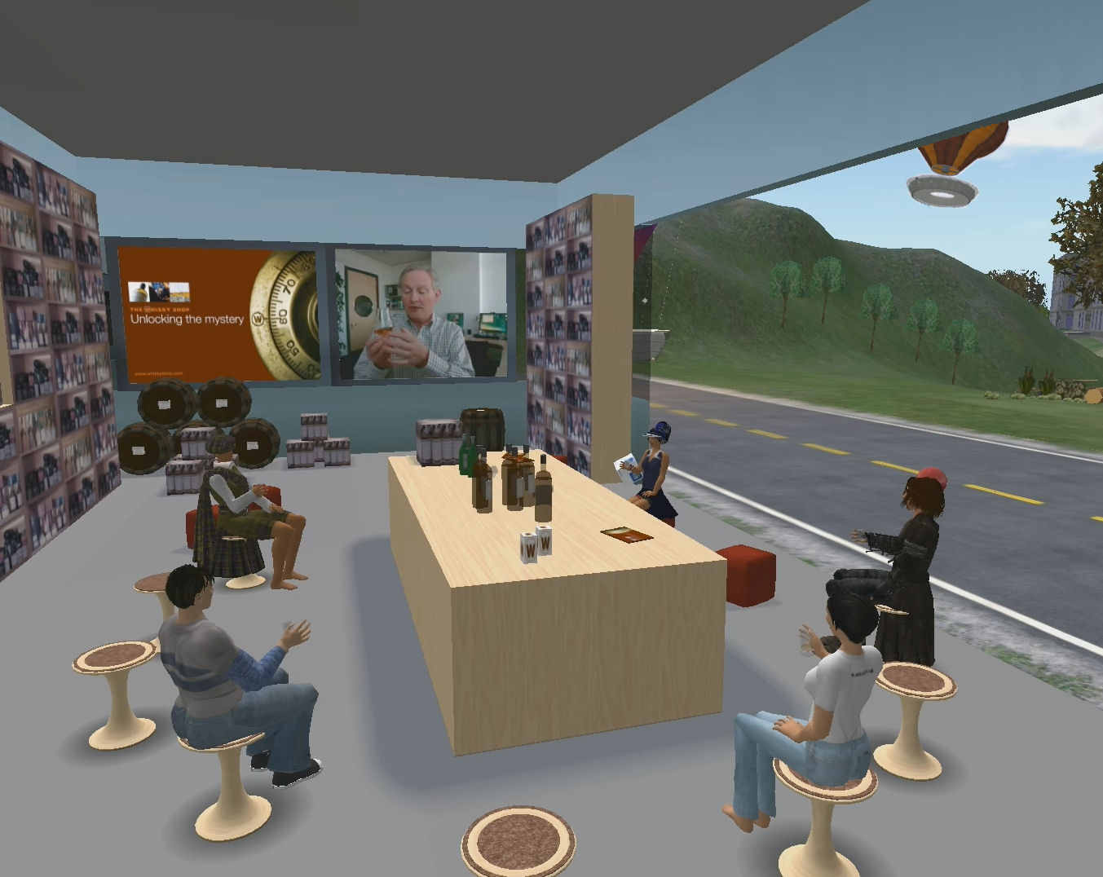
Figure 4. A virtual whisky-tasting I-Room. Participants enjoyed a tutored virtual whisky tasting in the Virtual World of Whisky I-Room.

What Does It Mean?
The I-Room concept is intended to support rich, process-driven interactions between participants located at physically remote locations. This is a new way of working, and as yet we lack detailed theories of how such collaborations proceed and, indeed, succeed. So far, we have taken a pragmatic approach by developing trial I-Rooms for different applications, some more successful than others. We have used these to further our own understanding of collaborative processes and, in particular, the effects of introducing virtual spaces into these processes. It is worthwhile reflecting a little here on the implications of the virtual workplace.
Humans are inveterate constructors of meaning, categorizing and organizing their perceptions of the world around them according to their own purposes. An I-Room introduces a number of artificial elements into this world, taking for granted that its users can intuitively grasp the use of a simulated 3D environment projected on a 2D plane (their computer screens), populated by (among other animate objects) avatars of fellow humans, and furnished with information-providing and information-managing objects. Some of these recognizably correspond to real objects, while others have no counterparts in external reality.
The popularity of videogames suggests that people can understand—assuming certain conventions are observed—computer-generated worlds and achieve specific objectives defined in terms of those worlds. These conventions are difficult to pin down, but they seem to involve some degree of persistence and continuity of form and behavior in the virtual spaces, objects, and avatars. As such, they draw on certain intuitive mathematical concepts (covering quantity, trigonometry, and change), some apparent conformance with the laws of physics, and a strict conformance with certain cognitive perceptual expectations (manifest in the use of perspective on a predominantly horizontal visual field).
In all but its purely social uses, we wish to ensure that I-Room users will ultimately be able to achieve things in the real world—that is, by producing artifacts or effecting changes to our environment and circumstances. Hence, the virtual process must necessarily and carefully preserve certain relationships with the real world, and moreover, these relationships must be clearly understood by all collaborators. The visual familiarity of the I-Rooms seems to help establish and maintain this understanding, but one could equally argue that these do not yet exploit the full potential of virtual worlds.
As we move toward visual representations of information—research underway involves the visualization of abstract elements of QOC as virtual objects for interactive decision making, for example—we need to find ways to maintain the essential links with reality and ensure that all participants understand the processes and their implications. A principled basis for doing this is not immediately apparent; builders of computer systems generally rely on the use of conventional symbols that are assumed to exist in the ontologies of their users—ontologies which are appropriately grounded in reality. Here, however, we want to introduce new symbols to represent existing, and perhaps even wholly new, concepts.
Virtual collaboration spaces can also confuse or complicate our notions of identity. Virtual world users will not typically be constrained to choose an avatar of the same name, race, social class, age, appearance, or gender, and indeed, some or all of these categories might be changed at any time at the user’s whim. This is one of the appeals for social users of virtual worlds because it lets them experience social interactions free of the prejudices that accompany their real appearances. However, this presents something of a problem for professional purposes. Although eliminating unfair discrimination from the workplace would be a positive side effect, this blurring of identity brings with it questions of trust and authority. These concepts are intimately bound up with questions of identity and the consistency of behavior. And this fluidity of identity also makes impersonation easier—how can we be sure that the person behind this avatar is who he or she purports to be?
This confusion does not lie only in a user’s relationship with others; a user’s relationship with their own avatar can be similarly perplexing. Activity in a virtual space gives users a certain amount of latitude to behave differently from how they would in analogous real-world situations. Although once again this ultimately might prove a strength of virtual collaborations, with users less inhibited than they would be in equivalent real-world situations, in practice it is necessary to observe—and, when necessary, enforce—certain behavioral protocols in order to follow the methodologies we propose. Current work is investigating the content and form that such protocols should adopt. But it is not just protocols that govern behavior. People modify their conduct—not to mention their dress and, to some degree, their appearance—according to the environments in which they find themselves. The I-Room must set the right tone for the activity it will contain: we want people to behave as if the I-Room were real.
We have adopted a pragmatic approach in developing the I-Room concept: armed with some basic conjectures, we construct prototype rooms and throw them open to users, watching what happens and hoping to gain a better understanding. From the perspective of the informatics researcher, the I-Room concept, in common with many areas of human-computer interaction, presents problems of critical evaluation and assessment of the methods adopted. Because it opens up possibilities for new ways of collaborating, there is no convenient benchmark of existing behavior against which to measure it. As we mentioned earlier, the goal of a collaborative process is to add value to the process and its results; time-and-motion studies of the process and the product’s value (assuming the product has a commodity value that can be realized in monetary terms) could provide quantitative evaluation. However, as the case studies demonstrate, there are plenty of collaborations that do not produce such commodities, and as such, we must resort to qualitative measures and subjective opinion. This remains a difficult question.
Notwithstanding the difficulties of applied research in this area, the results of our initial experiments are promising enough to encourage further work. We are continuing to develop I-Rooms for a variety of applications. In parallel, our research is leading us to experiment in areas such as virtual representation of process- and issue-based argumentation, automated tutoring systems, and semantic content tagging as well as the more fundamental—and as we see it, necessary—tasks of deploying process-support methodologies for virtual collaboration.

Acknowledgments
I-Room and I-X research has been supported by a number of grants including from the Defense Advanced Research Projects Agency (DARPA). The Slam Games I-Room and Virtual World of Whisky projects were funded by the European Regional Development Fund (ERDF) and the School of Informatics at the University of Edinburgh. Thanks to Scott Weide and John Bratton of the MPAT Secretariat for helpful discussions on the collaboration systems and standard operating procedures used by MPAT. Work on the emergency response I-Rooms was supported by the US Joint Forces Command, US Army Research Labs, OpenVCE.net project, Virtual University of Edinburgh (Vue) and EADS. The University and project funding partners are authorized to reproduce and distribute reprints and online copies for their purposes notwithstanding any copyright annotation hereon. The views and conclusions contained herein are those of the authors and should not be interpreted as necessarily representing the official policies or endorsements, either expressed or implied, of other parties. The University of Edinburgh is a charitable body, registered in Scotland, with registration number SC005336.

References
1. A. Tate, “<I-N-C-A>: An Ontology for Mixed-Initiative Synthesis Tasks,” Proc. Workshop on Mixed-Initiative Intelligent Systems (MIIS), 2003; http://lalab.gmu.edu/miis/papers/Tate-Austin.pdf.
2. A. Tate, “Intelligible AI Planning,” Proc. 20th British Computer Soc. Special Group on Expert Systems’ Int’l Conf. Knowledge-Based Systems and Applied Artificial Intelligence (ES2000), Springer, 2000, pp. 3–16.
3. H.W.J. Rittel, “Second Generation Design Methods,” Developments in Design Methodology, N. Cross, ed., Wiley & Sons, 1984, pp. 317–327.
4. A. MacLean et al., “Questions, Options and Criteria: Elements of Design Space Analysis,” Human-Computer Interaction, vol. 6 (3-4), 1991, pp. 201–250.
5. S. Buckingham Shum et al., “Hypermedia Support for Argumentation-Based Rationale: 15 Years on from gIBIS and QOC,” Rationale Management in Software Engineering, A.H. Dutoit et al., Springer-Verlag, 2006, pp. 111-132.
6. G. Wickler et al., “Planning and Choosing: Augmenting HTN-Based Agents with Mental Attitudes,” Proc. IEEE/WIC/ACM Int’l Conf. Intelligent Agent Technology (IAT 2007), IEEE CS Press, 2007, pp. 222–228.
7. A. Tate, “The Helpful Environment: Geographically Dispersed Intelligent Agents that Collaborate,” IEEE Intelligent Systems, vol. 27, no. 3, 2006, pp. 57–61.
8. A. Tate, S. Potter, and J. Dalton, “I-Room: A Virtual Space for Emergency Response for the Multinational Planning Augmentation Team,” Proc. 5th International Conf. Knowledge Systems for Coalition Operations (KSCO-2009), J. Lawton, J. Patel, and A. Tate, eds., Univ. of Southampton, Computing Service, 2009; http://www.aiai.ed.ac.uk/project/ix/documents/

Austin Tate is the director of the Artificial Intelligence Applications Institute (AIAI) and holds the Personal Chair of Knowledge-Based Systems at the University of Edinburgh. His research interests include emergency response using advanced knowledge and planning technologies, and collaborative systems especially using virtual worlds. Tate has a PhD in machine intelligence from the University of Edinburgh. He is a Fellow of the Royal Society of Edinburgh, a Fellow of AAAI, and an IEEE Intelligent Systems senior advisory board member. Contact him at a.tate@ed.ac.uk.

Yun-Heh Chen-Burger is a research fellow in informatics at the University of Edinburgh. Her research interests include business, process, and conceptual modeling, and workflow automation incorporating interdisciplinary theories and practices. Chen-Burger has a PhD in artificial intelligence from the University of Edinburgh. Contact her at j.chen-burger@ed.ac.uk.

Jeff Dalton is an honorary visitor at the University of Edinburgh’s AIAI, having previously been a research scientist at the institute. His research interests include planning, simulation, web-based software, and programming language design and implementation. Dalton has a BA in mathematics from Dartmouth College. Contact him at j.dalton@ed.ac.uk.

Stephen Potter is a member of AIAI at the University of Edinburgh. His research interests lie in knowledge-based systems and semantic web technologies, with a particular focus on their application in emergency response contexts. Potter has a PhD in mechanical engineering from the University of Bath, UK. Contact him at s.potter@ed.ac.uk.

David Richardson is a senior business development executive in the School of Informatics and a member of AIAI at the University of Edinburgh. In his current position, he is engaged in a number of commercialization projects involving artificial intelligence and computer science. Richardson has an MSc by Research in computer science from the University of Edinburgh. Contact him at djcr@ed.ac.uk

Jussi Stader was a senior researcher at the University of Edinburgh’s AIAI. She is now a crofter in North Scotland. Stader has a Dipl. Inform. in informatics from University of Hamburg. Contact her at jstader@gmail.com.

Gerhard Wickler is a senior researcher at the University of Edinburgh’s AIAI. His research interests include planning and intelligent agents applied to emergency response. Wickler has a PhD in artificial intelligence from University of Edinburgh. Contact him at g.wickler@ed.ac.uk.

Ian Bankier is the chairman of Glenkeir Whiskies and owner of The Scotch Whisky retail chain. Contact him at ian@whiskyshop.com.

Christopher Walton is the lead researcher at Metaforic, a software security company. His research interests include reasoning about software security, knowledge dissemination using web technologies, and the implementation of secure web-based computation. Walton has a PhD in informatics at the University of Edinburgh. Contact him at chris.walton@metaforic.com.

Patrick Geoff Williams is the EADS Innovation Works UK research team leader responsible for homeland security, critical national infrastructure protection, and cyberwarfare research projects. He is an intelligence and security professional, with extensive operational experience in mission planning and multisource intelligence data analysis and briefing. Williams has a BSc in economics and politics from the Open University. Contact him at patrick.williams@eads.com.

//digital library abstract & keywords//
An I-Room is a virtual environment intended to support a range of collaborative activities, especially those that involve sense making, deliberation and decision making. The I-Room acts as a space in which participants can collaborate using various communication, presentation, and support tools as well as collect, arrange, and maintain information. This concept is founded on a number of complementary principled approaches for guiding purposeful behavior, which in turn provide a basis for calls to external intelligent systems and knowledge bases. This article describes several prototype I-Rooms that have been constructed for interactive work and leisure activities.
computer-supported collaborative work, virtual worlds, intelligent systems

