I-Room: Integrating Intelligent Agents and Virtual Worlds
Austin Tate
Artificial Intelligence Applications Institute (AIAI)
School of Informatics, The University of Edinburgh, UK

Abstract
An I-Room is an “intelligent room” which can act as a knowledge aid to support collaborative meetings and activities, especially when these involve sense-making about the current context, planning, considering options, and decision-making. The I-Room provides a generic technology basis for a wide range of potential collaborative applications and uses. It provides a conduit for accessing intelligent systems and knowledge bases from collaborative interaction spaces such as virtual worlds. Applications of the I-Room to date include emergency response operations centres used for experimentation and exercises, support to a geographically dispersed cross-disciplinary team engaged in the creation of a multi-media video game product and to mixed-initiative tutored whisky-tasting.
Introduction
An I-Room is an environment for intelligent interaction. It can provide support for formal business meetings, tutorials, project meetings, discussion groups and ad-hoc interactions. The I-Room can be used to organise and present pre-existing information as well as displaying real-time information feeds from other systems such as sensor networks and web services. It can also be used to communicate with participants, facilitate interactions, record and action the decisions taken during the collaboration.
Using the I-Room concept within virtual worlds gives a collaboration an intuitive grounding in a persistent 3D space in which representations of the participants (their “avatars”) appear and the artifacts and resources surrounding the collaboration can be granted a surrogate reality – which, where these items consist of information, might be more meaningful or compelling than their physical reality. Avatars can meet each other ‘face-to-face’ in a virtual world when their human counterparts cannot. Some of the benefits of a real-world meeting are retained through immersion in the virtual world, and in some cases virtual world meetings may be an effective alternative to face-to-face meetings, telephone calls or video-conferences.
Beyond the advantages conferred by a shared interaction space, the I-Room can be used to deliver intelligent systems support for meetings and collaborative activities. In particular, the I-Room is designed to draw on I-X Technology (Tate 2000) which provides intelligent and intelligible (to human participants) task support, process management, collaborative tools and planning aids to participants. The I-Room can also utilise a range of manual and automated capabilities or agents in a coherent way. The participants share meaningful information about the processes or products they are working on through a common conceptual model called <I-N-C-A> (Tate 2003). The I-Room framework is flexible enough to provide participants in I-Room meetings with access to knowledge-base content and natural language generation technology that tailors utterances to specific experience levels of users.
I-Rooms have been in use since early 2008 for a range of collaborative groups, meetings and training exercises. Some I-Rooms are constantly available to their users through publicly accessible virtual worlds like Second Life™.

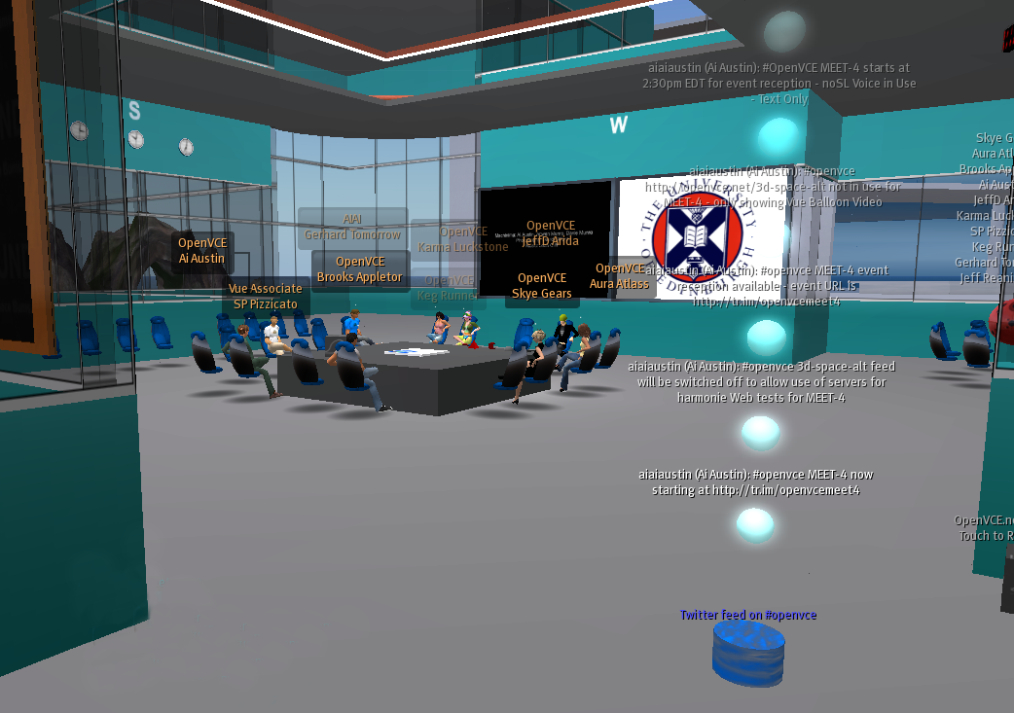
Figure 1- Sample I-Room showing information feeds and external agent links
Applications of the I-Room to date include emergency response operations used for experimentation and exercises centres (see Figure 1), support to a geographically dispersed cross-disciplinary team engaged in the creation of a multi-media video game product and to mixed-initiative tutored whisky-tasting (Tate et al., 2010).
I-X Technology
I-X (Tate 2000) is a suite of tools designed to aid in processes that create or modify one or more “products” (such as a document, a plan, a physical entity or even some desired changes in the world state). The I-X approach involves the use of shared models for task-directed communication between human and computer agents.
An I-X agent (or system of agents) carries out a process, which leads to the production of (one or more alternative options for) a product. The I-X agent/system considers this synthesised artefact to be represented by a set of constraints on the space of all possible artefacts in the application domain. This provides a common conceptual basis for sharing information on processes and process products. It is intended to provide a framework that is shared, intelligible to humans and machines, easily communicated, as formal or informal as the situation demands, and extendible.
The underlying conceptual information-sharing model on which I-X is based is the <I-N-C-A> (Issues-Nodes-Constraints-Annotations) ontology (Tate 2003) which represents a set of restrictions on processes or products:
- Issues: e.g. what to do? How to do it?
- Nodes: e.g. include specified activities or product parts;
- Constraints: e.g. temporal, spatial, or on resources;
- Annotations: e.g. rationale, provenance, progress.
To move towards achieving the goals of the collaboration, an I-X agent or system repeatedly moves through cycles of handling issues and managing domain constraints. To do this, a number of differing ‘mixed-initiative’ collaborative processes can be invoked, including:
- Issue-based sense-making, e.g. such as the gIBIS approach with its 7 question types (Conklin 2005).
- Activity planning and execution.
- Constraint Satisfaction, using AI and OR methods, or simulation.
- Note-making, rationale capture, logging, reporting.
The I-X Process Panel (I-P²) (Tate et al. 2002) provides the principal interface for a human user of an I-X system; its underlying representation and reasoning act on the current world state to present the user with context-sensitive options for action. The aim is to provide a planning, workflow and communications ‘catch all’ for the user. On behalf of its user, an I-P² can accept process-level activities to:
  - Handle an issue;
  - Perform an activity;
  - Respect a constraint;
  - Note an annotation.
Where appropriate, it can suggest performing these activities through:
  - Manual performance;
  - The invocation of internal or external capabilities;
  - Delegation to other agents or services;
  - Planning and executing a composite of these approaches.
Figure 2: I-X Process Panel with its Action Selection Menu
Through reporting mechanisms, the I-P² helps the user to understand both the current state of the world and the current status and progress of issues, activities and constraints within the system. At its simplest, the I-P² acts like an intelligent ‘to do’ list providing context-sensitive assistance (Figure 2). The panel shows a user his or her current issues and activities, for which business processes, plans or Standard Operating Procedures (SOPs) can be selected or combined. Constraints can be imposed, and rationale or other information kept as annotations. An intelligent planning system, I-Plan, is included in the I-X tool suite to generate novel options based on stored domain models. The I-X suite also supports the collaborative element, with tools such as a structured content instant messenger allowing issues and activities to be passed between different agents to support workflow across an organization. Web services can be called to gather information or can automatically enact steps of the processes involved.
Underlying Concepts for I-Room Collaboration
The underlying concepts employed by the I-Room enable human participants to benefit from intelligent systems support in meetings and collaborative activities. I-Room concepts include:
- A mixed-initiative collaborative model for refining and constraining processes and products;
- Principled communication based on sharing issues, activities, state information, events, agent presence, options, argumentation, rationale and reports;
- The use of the <I-N-C-A> ontology for representing the products that are developed during meetings;
- The use of the I-X technology and tool suite to provide task and process support;
- The use of issue-based argumentation, through the use of the Questions-Options-Criteria (QOC) methodology (Conklin 2005) and links to the Compendium sense-making tool (Buckingham-Shum et al. 2006);
- The use of agent presence models, as in instant messaging, and an I-X ‘I-Space’ for awareness of agent context, status, organizational relationships, capabilities and authorities;
- The use of external shared repositories of processes, products and other objects.
I-Room Meeting Support
An I-Room can be linked to I-X Process Panels to support meetings in virtual worlds or in the real world. It can support common requirements for meetings by:
- Loading a predefined meeting agenda or template;
- Making available a set of standard procedures for the conduct of the meeting;
- Keeping track of the progress through agenda items during the meeting itself;
- Recording decisions and taking minutes;
- Tracking existing actions and adding new ones;
- Providing access to minutes from previous meetings;
- Automatic generation of a draft of the meeting minutes;
- Automatic generation of an agenda for the next meeting including generic items (e.g. review of previous actions, AOB, date of next meeting).
Through a link to an autonomous object in the virtual world (the “I-X Helper”) that is able to sense the presence of avatars and respond to commands, it is possible to provide additional support by:
- Monitoring the participants in the meeting, and potentially noting their presence status throughout, and at which points they may leave and return;
- Displaying on in-world ‘screens’ and wallboards information and media content, such as the meeting agenda, or any relevant images or documents, at appropriate times during the meeting;
- Unobtrusively documenting the progress of the meeting and its outcomes.
While some of these tasks are simple, more complex tasks can only be completed to a high standard where the I-Room has background knowledge of meeting formats and the current collaboration. Linking the I-Room to existing, real-world knowledge-based systems can potentially extend the support offered into this virtual space, thereby distributing the knowledge they embody.
I-X Helper – Connectivity between I-X and a Virtual I-Room
Participants meeting in an I-Room may connect via I-X Process Panels or via their avatar using an appropriate virtual world viewer or interface. An I-X Helper, which can be any convenient object in the virtual world, acts as a conduit for channelling communications to the participants connecting via their avatars and to related capabilities available within the virtual world. This may take different forms depending on the communication and programming facilities within the virtual world platform.
Figure 3: I-X Helper Connects Virtual World to I-X Services
Within Second Life for example, as shown in Figure 3, the I-X Helper communicates to I-X Services via a communications channel that uses a mixture of HTTP and XML-RPC requests and responses. Messages can be queued and sent later if either the I-X Helper or I-X Services ends are not available, enabling asynchronous operations. The I-X Helper can communicate with avatars in the I-Room via open chat channels and can control suitable devices in the virtual world, such as displays, objects etc. Specific capabilities to provide flexible display of images, external web pages, and I-X screens are also incorporated.
I-Room Capabilities
There is a set of tools that can support participants in the I-Room. These can be accessed in a convenient fashion through avatars in the virtual world, or via I-X Services.
- I-X Helper: to communicate with external knowledge-based systems and to reliably set up the communications link to I-X Services and pass back and forth requests, content, and reports, and to act as a chat conduit between I-P² and the I-Room on need.
- Image Generator: a mechanism outside of the virtual world to take screens from I-P² and other external applications, web accessible images (however generated) and other video and live feed content and to make composite images suitable for display in virtual worlds.
- Display Screen: a screen that can show various images, media, movies or live video feeds. It can extract and display (tagged) elements from the composite images created by the Image Generator.
- LED Display: to display text in a number of different colours, fonts and styles.
- Media Controller: to change media and audio streams within the virtual world reliably for different types of virtual world land areas, and on group-owned areas.
- Avatar Sensor: to give information on avatars’ names, id, location, etc. to external systems and maintain a model of who is present in the I-Room.
- Inventory Giver: to offer avatars items relating to the current events and processes in the I-Room. [experimental]
- I-Room Questioner: to ask participants (multiple-choice) questions, letting them answer individually. This can be used, for example, to vote, to agree on a course of action, or to make a selection from a number of available options. [experimental]
Summary, Status and Future Work
An I-Room provides a shared persistent space with intelligent systems support for interaction and collaboration between users, systems and agents. It allows for the integration of a range of intelligent system aids, services and agents into the meeting.
An I-Room consists of elements inside a virtual world and external knowledge-based and intelligent systems. This especially includes the I-X planning, process and task support aids.
I-Rooms have been deployed in Second Life (on publicly accessible areas) and in OpenSim (on privately hosted servers). The software for I-X Services and the I-X Helper are available as open source code. Sample 3D I-Rooms have been packaged with the software to make for simple deployment and set up for trials.
I-Rooms have been running continuously since early 2008, and a number have been used for live events, collaboration meetings and discussions. This has included meetings in which participants have been located on three continents. AIAI regularly opens an I-Room in support of teleconferences to give a visual indication of presence, rich media sharing, and simple ways to initiate back channel interactions for participants, even when traditional video and audio channels outside of those available through the virtual world are in use with collaborators. Simulation scenarios and trials have been conducted in I-Rooms with companies such as Disney, EADS (Airbus), Kodak, Slam Games and Tata.
I-Rooms are also being applied to a range of national and international crisis and emergency response areas (Tate et al. 2009, Tate et al., 2010), homeland security, UAV mission monitoring, product design and review meetings, scientific project regular reviews, team training and simulation exercises. More details and software download links can be found at the I-Room project web site (I-Room 2009).
The basic I-Room AI concepts and technology are now being refined and made more generic. This work includes: the development of generalised links to knowledge-based systems; tailored natural language generation; capability modelling to identify and exploit opportunities in the virtual worlds; and semantic tagging of the various media and communication streams that constitute a virtual meeting to allow a higher level of context-sensitive support, with documentation, indexing and playback facilities.
A number of virtual world capabilities are being created to augment I-X support for intelligent interaction in virtual meeting spaces, virtual operations centres, and training rooms.
Acknowledgements
The I-X and I-Room projects have been funded from a number of sources including the US Defense Advanced Research Projects Agency, US Joint Forces Command/Army Research Labs/Alion (OpenVCE.net project), European Regional Development Fund and the School of Informatics at the University of Edinburgh. The University and project funding partners are authorized to reproduce and distribute reprints and on-line copies for their purposes notwithstanding any copyright annotation hereon. The views and conclusions contained herein are those of the authors and should not be interpreted as necessarily representing the official policies or endorsements, either expressed or implied, of other parties. The University of Edinburgh is a charitable body, registered in Scotland, with registration number SC005336.
References
Buckingham Shum, S., Selvin, A., Sierhuis, M., Conklin, J., Haley, C. and Nuseibeh, B (2006) Hypermedia Support for Argumentation-Based Rationale: 15 Years on from gIBIS and QOC. In: Rationale Management in Software Engineering (Eds.) A.H. Dutoit, R. McCall, I. Mistrik, and B. Paech. Springer-Verlag: Berlin
Conklin, J. (2005) Dialogue Mapping: Building Shared Understanding of Wicked Problems. Chichester: Wiley & Sons.
I-Room (2009) I-Room: A Room for Intelligent Interaction. http://www.aiai.ed.ac.uk/project/i-room/
Tate, A. (2000) Intelligible AI Planning. In Proceedings of ES2000, The Twentieth British Computer Society Special Group on Expert Systems International Conference on Knowledge Based Systems and Applied Artificial Intelligence, 3-16, Springer.
Tate, A. (2003) <I-N-C-A>: an Ontology for Mixed-Initiative Synthesis Tasks. In Proceedings of the Workshop on Mixed-Initiative Intelligent Systems (MIIS) at the International Joint Conference on Artificial Intelligence (IJCAI-03). Acapulco, Mexico, August 2003.
Tate, A., Chen-Burger, Y-H., Dalton, J., Potter, S., Richardson, D., Stader, J., Wickler, G., Bankier, I., Walton, C. and William, P.G. (2010) I-Room: A Virtual Space for Intelligent Interaction, IEEE Intelligent Systems (to appear).
Tate, A.; Dalton, J.; and Potter, S (2009) I-Room: a Virtual Space for Emergency Response for the Multinational Planning Augmentation Team, Proceedings of the Fifth International Conference on Knowledge Systems for Coalition Operations (KSCO-2009), Chilworth Manor, Southampton, UK, 31st March to 1st April 2009.
Tate, A., Dalton, J., and Stader, J. (2002) I-P2 – Intelligent Process Panels to Support Coalition Operations. In Proceedings of the Second International Conference on Knowledge Systems for Coalition Operations (KSCO-2002). Toulouse, France, April 2002.

© 2010, University of Edinburgh. Reproduction allowed.
http://secondlife.com
Different virtual worlds provide different flexibility for displaying external web pages, images, etc. Some allow an HTML or image URL to be shown on any face of any 3D object. Others, such as Second Life currently limit any land plot to a single media URL. Using an MxN matrix of images composed into a single entity that can be unpacked in Second Life can overcome such limitations.

