Horses for Courses –
Distributed Collaboration for Learning Environments

Essay for Introduction to Digital Environments for Learning

Austin Tate, 16th December 2011

Abstract

There is much discussion of the future of computer-assisted learning environments in educational institutions for both on-campus and distance education. The approach of older style centralised and institutionally provided Virtual Learning Environments (VLEs) which provide a controlled “walled garden” is giving way to a more open “Web 2.0” style of collaborative environment. This can still be centralised in institutionally provided, but more modular, learning environments, or can tend towards support for an individualised Personal Learning Environment (PLE) approach. But these stratiated approaches tend to compartmentalise and constrain interactions between the participants.

This essay will look at the more general and ubiquitous requirements for different elements of distributed collaboration and seek to apply these to the specific context of the educational tools and facilities provided in typical VLEs and PLEs. After examining some of the issues that arise in providing and using such tools. I will suggest that an appropriate mixture, based on a modular approach, could be a direction to take in future. It could offer a genuine basis to support lifelong learning for students. But it will require an understanding and adoption of open standards, and a degree of sophistication on the part of the educational institutions, teachers and students in understanding and communicating knowledge and practices related to long term asset value and ownership, copyright, legitimate use and the importance of portability.

Keywords: Virtual Learning Environments, Personal Learning Environments, Distributed Collaboration, Open Source, Standards, Modularity.

Introduction

Virtual Learning Environments (VLEs) are widely used to deliver on-line course content to on-campus and distance education students. They typically provide an authenticated access mechanism through which students can obtain course materials which may have copyright limitations, engage in discussions about the course content, receive news from tutors about the course and submit assignments for assessment. These are all things which clearly require access security and authentication, as well as a closed environment where students may engage in discussions that are not meant to be open to public scrutiny. The typical VLE is highly stratiated (Bayne, 2004, p.312) to provide containers for information and resources for courses, week-by-week content, assignments, etc. To allow for participant discussions and student inputs simple forms of collaboration have been added on, often also restricted to the same type of course container already there.

The rapid development of attractive social media and community support platforms and web sites, the so-called “Web 2.0 technologies” (O’Reilly, 2005), has been negatively received by some educational institutions, and the tools have “been marginalised, unsupported or even in some cases banned” (Wilson et al., 2007). But other institutions have been encouraged to open up their VLE services (Downes, 2005) and use a mix-and-match or “mashup” approach (Beemer and Gregg, 2009) to social media provision alongside their institutional VLEs.

As students participate in courses they collect resources and produce results which they may wish to continue to have available or reuse on related courses, or much later in their careers and lives. Where the work is the student’s own, or where copyright permits, the sharing of these resources across courses and for subsequent use in lifelong learning is an important requirement. Personal Learning Environments (PLEs) (McAlpine, 2005) have been proposed as one way to achieve this, and some provide means to export and import content across different platforms.

Some institutions are also moving to support individual learners in various ways including using “e-Portfolio” systems (Attwell, 2007) intended to allow the student’s own content to be stored, managed and reused, and for assessment to take place. But a number of issues related to ownership and the true sources and destinations for import and export in a lifelong learning situation need to be addressed.

These systems tend to follow the typical design approach in some established educational institutions and bodies that “pedagogy must lead the technology”. Like Cousin (2005), I believe this “mantra” is detrimental to understanding the true potential of the tools available. It tends to enforce a stratiated course-centric view of tool use which does not encourage a more constructivist approach to learning (Piaget, 1954). If we flip the viewpoint to one in which we encourage a community to interact in a social setting in a smooth way while engaging in the specifics of educational tasks and objectives we might be able to make more effective use of the available tools (Bayne, 2008, p.405), and draw on research beyond education on effective social collaboration (e.g., Cross and Parker, 2004).

Requirements for Distributed Collaboration in an Educational Setting

Distance learning requires resource sharing and collaboration between members of a course – tutors, students and assessors. Course content, readings and other materials should be effectively made available to those engaged in teaching and learning. Means of providing news, holding discussions, sharing information and so on needs to be provided. Many of the same resource sharing and collaboration needs arise in the support of on-campus and physically co-located participants too.

Virtual Learning Environments (VLEs) such as Moodle and Blackboard’s WebCT are platforms to support the provision of material for a course to its participants, and also to offer a range of tools to support collaboration in a class. But the nature of distance learning and the distributed collaboration involved demands that appropriate ways to facilitate a number of means of communication, resource management and collaboration are available. Tools to support this should be focussed on the requirements of such a distributed collaborative community. These requirements are not unique to education, and arise in almost any community that needs to collaborate while performing their tasks.

Cognitive Work Analysis for Distributed Collaboration

In studies of the requirements of distributed communities which collaborate, a Cognitive Work Analysis (CWA) (Vicente, 1999; Lintern, 2009) has been used to provide a framework for understanding the role of tools which might “facilitate” their interactions (e.g., Hansberger et al., 2010; Tate et al., 2012).

Figure 1a shows a CWA for a community of emergency responders and those collaborating with them in dealing with natural events, or with medical emergencies. But the comprehensive list of the types of activity involved and the breakdown into various modalities of interaction is quite generic, and would apply to a greater or lesser extent to most communities engaged in distributed collaboration.

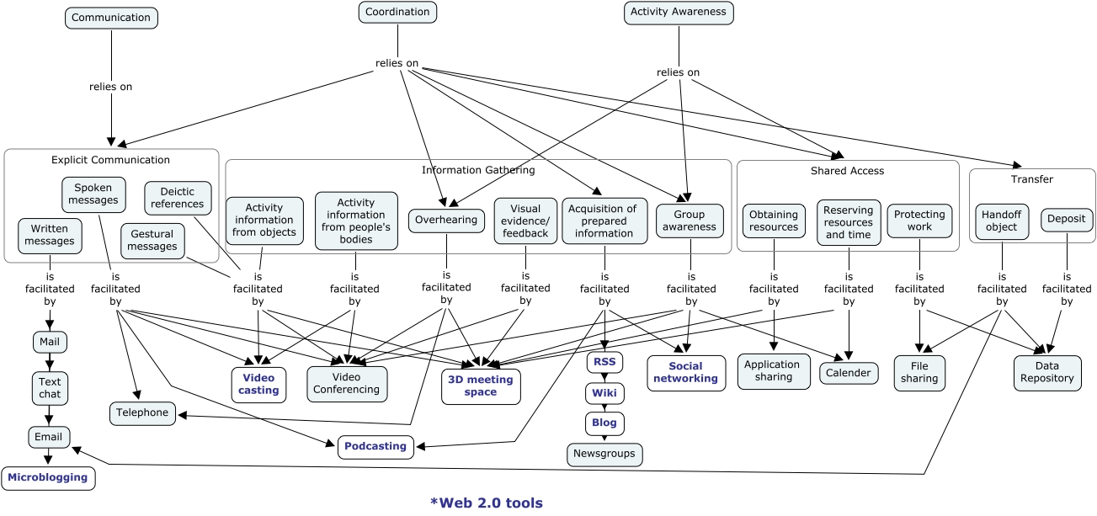

Figure 1a: Collaborative Work Analysis for Distributed Collaboration (Hansberger et al., 2010)

The top level core needs involve Communication, Collaboration and Activity Awareness, and these cover a number of tasks for Explicit Communication, Information Gathering, Shared Access and Transfer (see Appendix A for pointers to more detailed work that could be of relevance). The specific mechanisms suggested by this particular CWA may depend more on the type of community involved, but are indicative of those needed in an educational distributed learning environment too. The CWA is used to ensure appropriate tools and platforms are selected to support the collaboration by ensuring that they “facilitate” the required collaboration elements identified:

- Web Site – definitive edited content and index pages (under editorial control)
- News and Calendar – activity awareness
- Discussion Forums – threaded discussions within the community
- Wiki – community knowledge creation and refinement
- Blogs – individual web logs
- (Video-)Teleconference, Text Chat, Instant Messaging, E-mail
- Status Messages – current activity
- Comments – can be added to most elements to facilitate community discussion

Requirement for both Asynchronous and Synchronous Collaboration Tools

What emerges is that some elements of the requirements need to support independent “asynchronous” activity, and some are needed for coordinated “synchronous” activity within the group. The combination working well together gives good support to the distributed collaboration needs of the community. See Table 1.

 | Institution | Course | Individual
Tight Synchronous | (Video-)Teleconference  IM/Text Chat
Loose Synchronous | News & Calendar  E-mail | VLE Course Support | Status Messages
Asynchronous | Institution Web Site  Institution Wiki | Discussion Forums  Course Wiki | Individual Blogs
Long Term Asset Repository | Institution Web Site | VLE | PLE  Web Site

Table 1: Tools and how they meet Synchrony Requirements across a range of Domains

Synchronous elements are, of course, something that an institution must provide over all participants in the collaboration. And that is true for a number of other elements that support asynchronous work but which are directed at use of institutional facilities or provide restricted access to resources and materials.

Lessons for Learning Environments

We may be able to adopt an approach that a “smooth” set of collaboration tools and mechanisms should be provided over which the specific “stratiated” (Bayne, 2004) capability for specific educational courses and assignments can be provided through appropriate controlled mechanisms.

We can see a comprehensive learning environment as involving the following elements:

- Social platform for groups at various levels – institution, school, course, tutorial group.
- Resource management space at various levels – institution, course, project, individual.
- Application of these facilities to education.

This is not what typical VLEs, whether proprietary or open source, are seeking to do. Until very recently, these tend to try to provide the social collaboration and asset storage facilities within themselves and make them available within a course container rather than supporting more general community wide communication, resource sharing and means of integration.

Approaches Adopted by VLEs, PLEs and In-Between-Es

The following sections look at a number of prototypical examples of popular educational technology approaches and examine the roles played by them, including:

- Virtual Learning Environments (VLEs) like Blackboard's WebCT and Learn 9 (Coopman, 2009) or the open source Moodle and Sakai VLE platforms;
- Personal Learning Environments (PLEs) (McAlpine, 2005) of various kinds;
- e-Portfolios (Attwell, 2007) such as the commercial PebblePad and open source Mahara systems.

Weller (2010) examines the issues surrounding both a centralised and decentralised model. He includes pedagogic, support, financial, reliability, data and technical issues. He suggests that the arguments for a centralised VLE can be summarised as:

- Uniformity of student experience
- Centralised support
- Quality assurance
- Efficiency
- Robustness
- Integration of different tools
- Staff development
- Platform for expanding e-learning offerings and technical issues

The arguments for a decentralised model are summarised by Weller as:

- Quality: specialist tools may out perform offerings in an integrated tool
- Flexibility
- Pedagogic suitability
- Relevance
- Educator control
- Personalisation

VLE Example – Blackboard’s WebCT

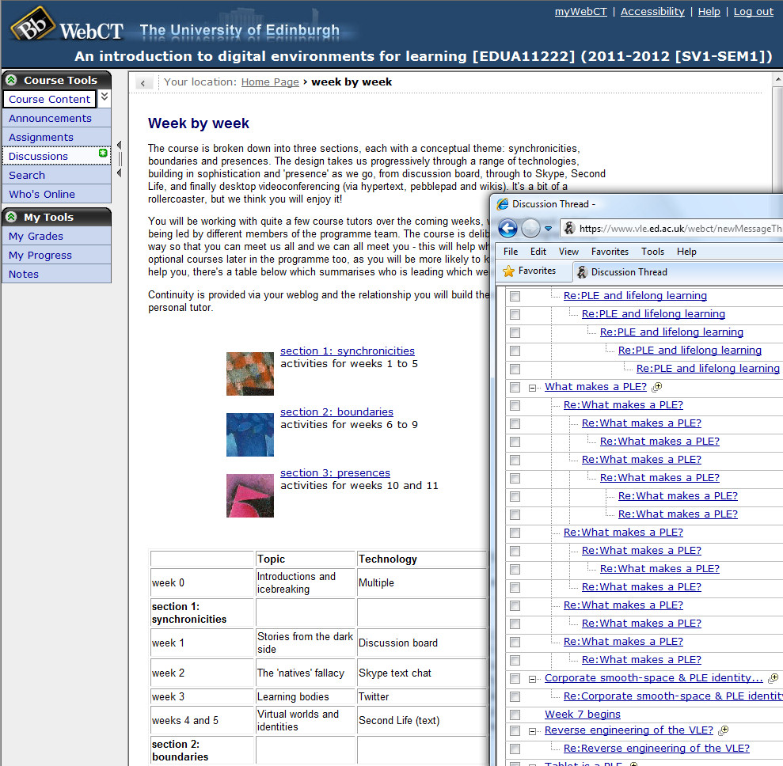

Figure 2: Example VLE – Blackboard’s WebCT

WebCT is a prototypical virtual learning environment and the platform used by the University of Edinburgh currently – see example in Figure 2. Blackboard’s various VLE products have a similar approach in the way that they constrain and facilitate interactions between teachers and students (see, e.g., Coopman, 2009, for an analysis). The “Walled Garden” provided is there for a number of reasons (but also see Appendix B for some observations on the complexity and reality of user roles and permission settings in some VLEs):

- To protect those inside;
- To protect and control access to the assets inside;
- To keep out undesirables;
- To provide a clear gateway where people can enter, or request entry.

The VLE typically provides a space for each course which will include the week-by-week course outline, readings and resources alongside collaboration tools such as course participant news exchange, a discussion forum, and a means to submit assignments. Specific accreditation to use each course is given for the relevant registered students.

WebCT provides a mechanism for course participant interaction via “Discussion Forums”, but otherwise is not supportive of modern social interaction in classes. Hence teachers tend to use external tools for this. The replacement for WebCT to be adopted by the University of Edinburgh in 2012 is called “Learn 9” and adds in a number of tools that can be used within its own confines.

VLE Example – Moodle

Moodle is an open source virtual learning environment which has a modular structure for extensions. It does provide a traditional week-by-week course orientated view, but can also support alternatives including a “social” format centred on interaction for a community, and a “topic” format based around an unordered set of topics (as shown in Figure 3). It does though still tend to be very course-orientated in its approach and many administrators and teachers (as well as students) have to struggle to fight its stratiated structure to share resources across the site – a common complaint on Moodle user blogs.

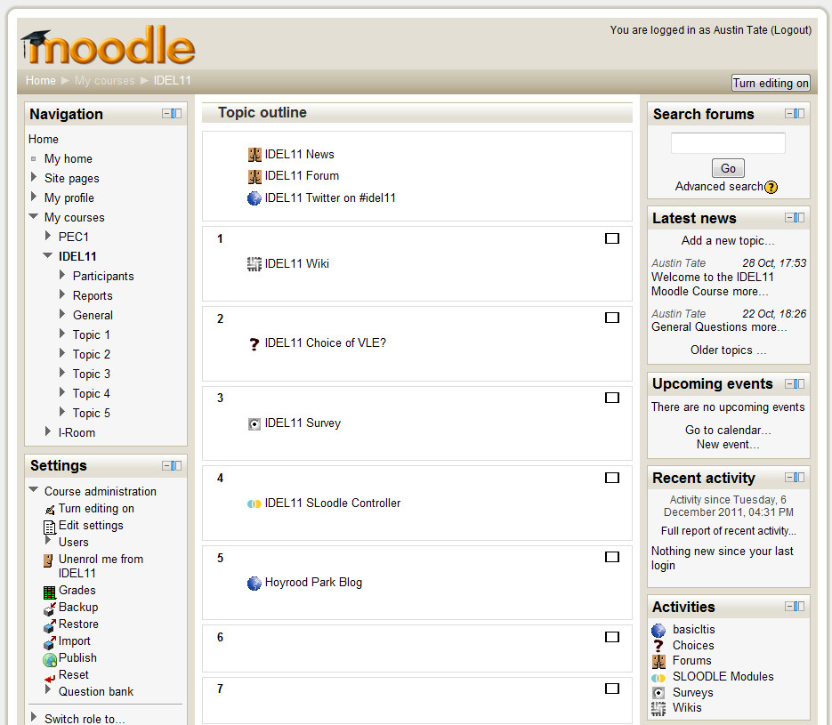

Figure 3: Example VLE – Moodle

Moodle has provided course-related discussion forums for some time. The Moodle individual blogging facility provides a means to aggregate in a student’s other blog sites that may be external to the VLE, for example using RSS feeds for cross blog aggregation.

In more recent versions, tools typical of “Web 2.0” approaches such as a Wiki (from Moodle 2.0) and more general third party tool inclusion (from Moodle 2.2, Henrick, 2011) have been added (see Figure 4 which shows an ELGG Blog used in a Moodle course), but they are again linked to stratiated course activity and cannot be seen as directly supporting a smooth cross-course community capability.

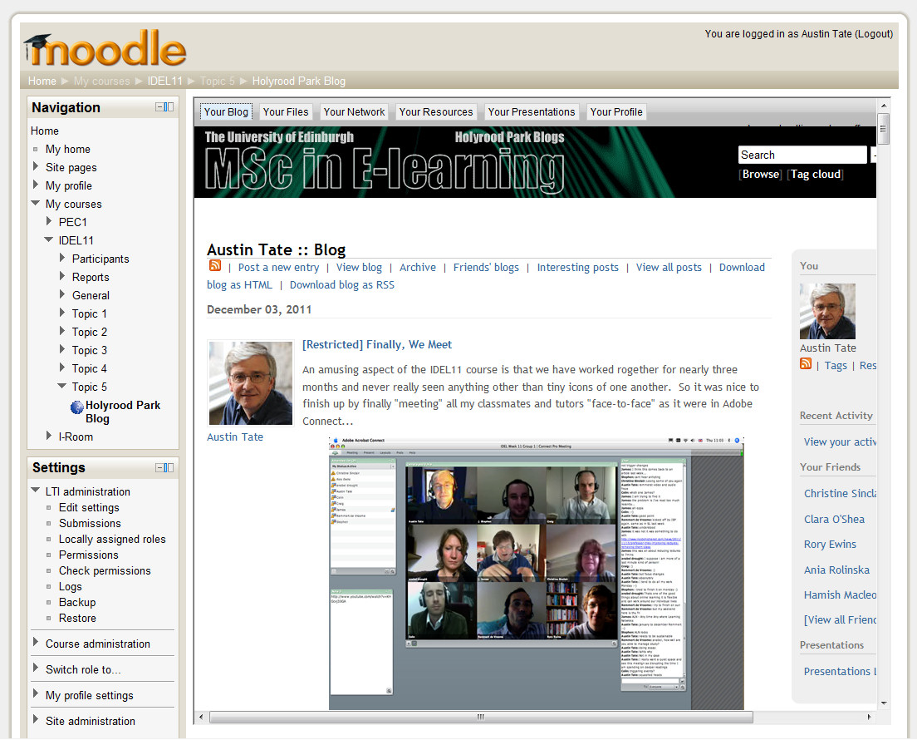

Figure 4: Modular VLE Example – Moodle 2.2 access to External Tools

Sakai (http://sakaiproject.org/) is another open source learning management and collaboration platform with similar capability to that described for Moodle.

PLE Example – iGoogle – A “Container” for Content

iGoogle (http://www.google.com/ig) is sometimes used as a framework for an individual’s PLE, since it provides a convenient and readily accessible “container” for a range of widgets and content items which can easily be added and removed. It is also relatively open in the types of widget and content that can be embedded (see Figure 5).

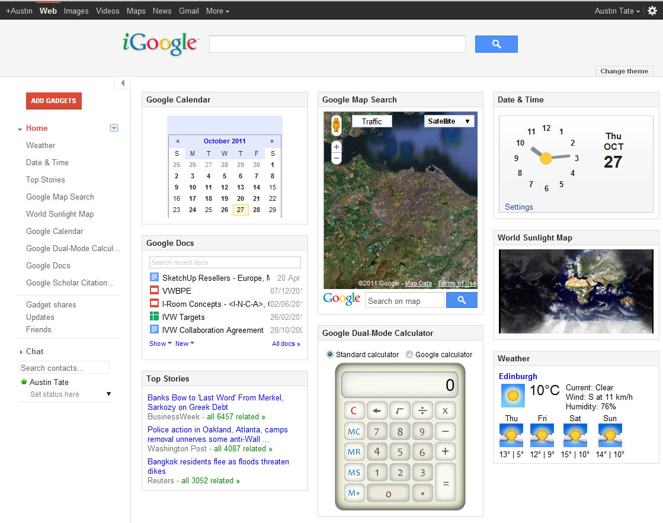
Figure 5: PLE Example – Container – iGoogle

However, iGoogle is not a resource repository, or single point of content management for a student, and such a repository must be separately selected. Users tend to scatter these across sites like Flickr (for images), YouTube (for videos), Google Docs (for documents, spreadsheets and presentations) and file sharing sites (for general files, especially larger ones). Weller (2010) observed this and said “many people have created a personal learning or working environment, without the explicit intention of doing so, simply by accruing a number of tools they use regularly”. iGoogle provides a way to pull these together for convenient access.

PLE Example – Individual Blog as a Basis for a PLE

Some users and students have successfully used an individual blog as the basis for a PLE. This may be hosted on an educational institution’s blog service, or externally, such as on the free to use WordPress.com. These blog sites allow for the embedding of images and videos, and attachment of files with general content. They are usually based on open source general purpose content management systems such as Drupal, Joomla or WordPress which provide convenient additional facilities such as column layout, blocks in to which content can be placed, and even mashup capabilities right down to adding custom HTML and PHP code (if permitted by the site). See Figure 6 for an example.

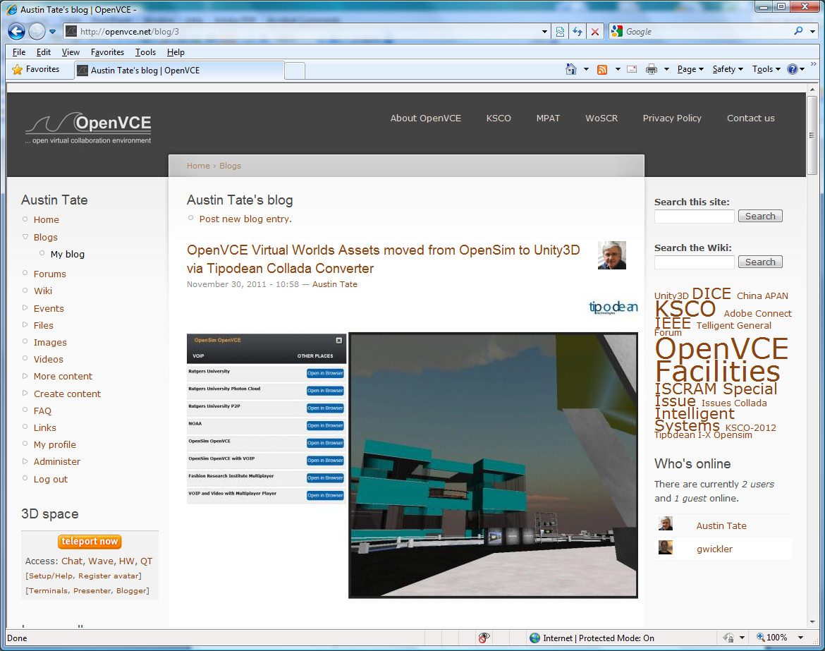

Figure 6: PLE Example – Individual Blog as a Basis for a PLE

PLE Example – Web Area as a Personal Learning Environment and Mashup Space

Some technically able students may also be able to set up and use a personal web area as the basis for their own PLE to gain maximum flexibility and control. This is my own preferred approach as shown in Figure 7, though I did this with a very simple web page template, rather than mounting a full content management systems and underlying data base like Drupal or Joomla.

This approach gives me a "Big Space" for laying out my work. This unconstrained approach to laying out projects and work is one I prefer, whether it’s a real space such as a table top or a virtual metaphor for such a space, e.g., on the web, for organising and accessing resources for a project. Don Norman (1993) has made observations about the value of large layout spaces for access to artifacts involved in cognitive tasks, especially when collaboration is involved.

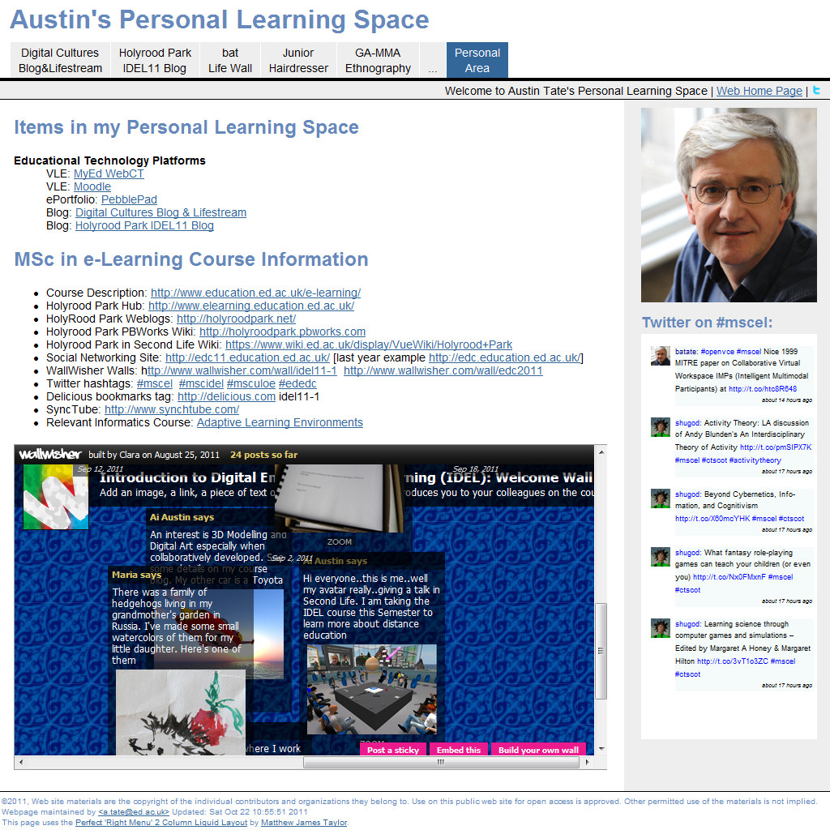

Figure 7: PLE Example – Personal Web Site

In-Between-E – e-Portfolio Example – Pebblepad

Attwell (2007) defines an e-Portfolio as “a purposeful collection of student [or teacher] work that illustrates efforts, progress, and achievement in one or more areas over time”. He points out that their use is often focussed on assessment, with little effort given to supporting reuse and sharing of information by the student beyond specific courses or beyond a specific educational institution. Attwell describes how e-Portfolios are also now seen as a powerful tool for Continuing Professional Development, especially in the medical and education professions. He goes on to analyse a number of issues related to ownership in the various processes and aspects of putting e-Portfolios to use.

e-Portfolio systems are usually hosted by an educational institution or may be provided as a service via a commercial third party. Where not mandated for assessment proposes, an e-Portfolio may be made available by an institution as just one offering a student could choose to organise their own resources, and in that case is therefore closer to the aims of a PLE.

An example of an e-Portfolio is the PebblePad system which is used to support personal learning spaces in the University of Edinburgh. See Figure 8.
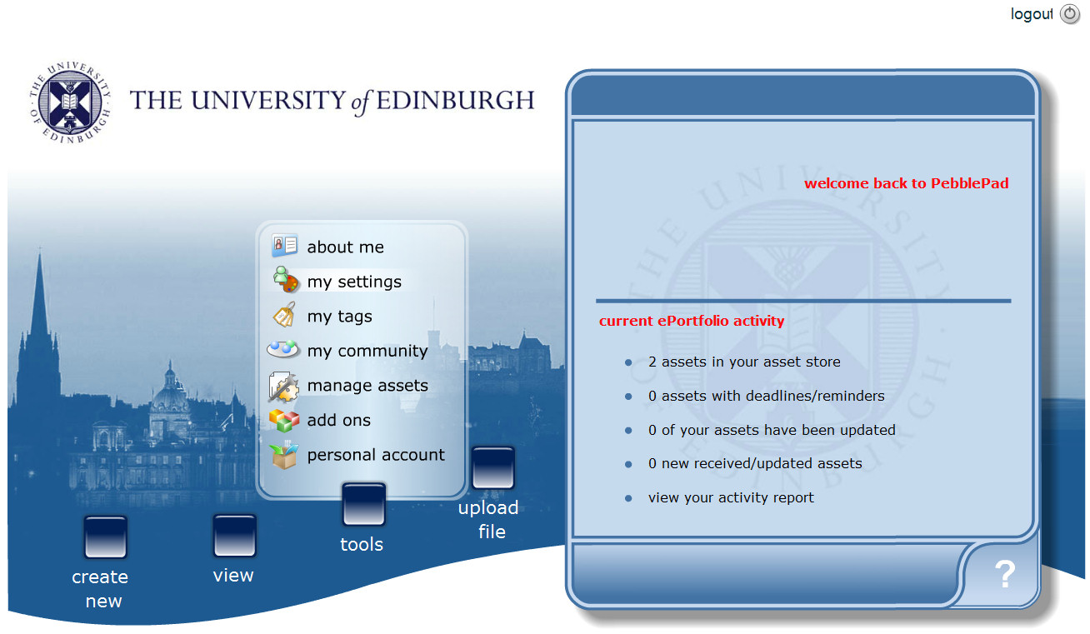

Figure 8: e-Portfolio Example – PebblePad

Mahara (2011) is an alternative open source e-Portfolio. It seeks to address issues of ownership, sharing, reuse and fine grained visibility of assets through a mechanism called “Views” (which is similar to the ELGG platform’s “Presentation”).

Modular VLEs with Open APIs and Embeddable Tools

One approach that is becoming more popular is to ensure that the core institutional VLE itself has open “Application Programming Interfaces” (APIs) which support a number of embedding, access and viewing choices. The interface might be provided in the form of custom modules or blocks or via served “widgets” which can be incorporated into any suitable container or wrapper – such as iGoogle, some blogging environments (if they allow for embedded elements) or a personal web area. For a discussion of this approach see Wilson et al. (2007).

Examples of this type of approach are the EU Responsive Open Learning Environments (ROLE - http://www.role-project.eu/) project tools (see Figure 9) which can use the OpenSocial API for widgets (http://opensocial.org) and the Moodle 2.2 facility to integrate third party tools via the IMS Learning Tool Interoperability standard (see earlier Figure 4).

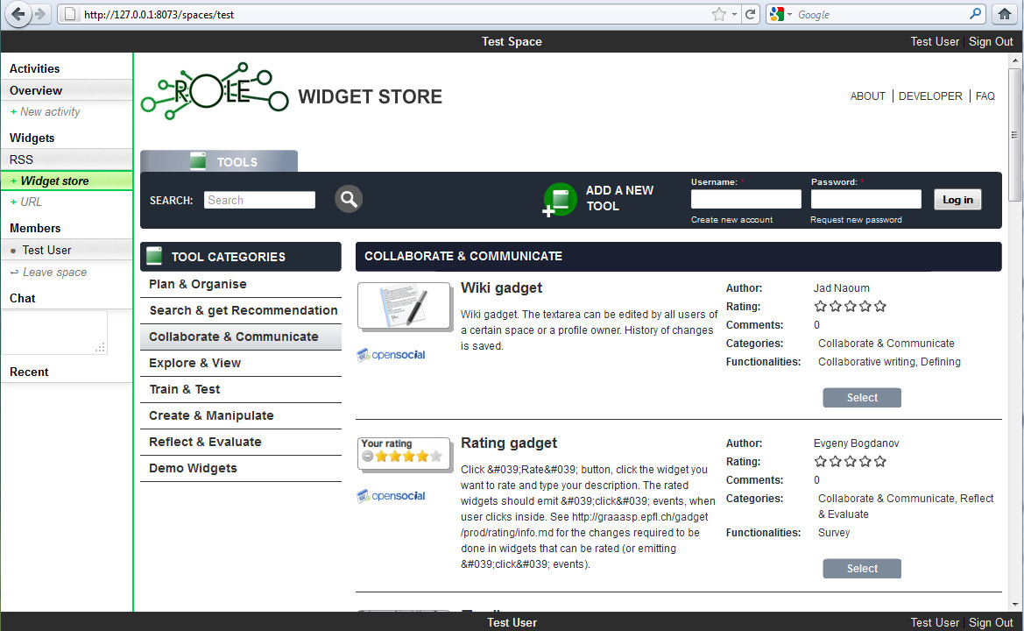

Figure 9: Modular VLE Example – EU ROLE Tools using OpenSocial API

Issues in Adopting a PLE Approach

It is important to look at ways in which using a PLE or the basic approach of using a personalised web page and web area as the basis for a PLE might be made more widely accessible and acceptable within the constraints of an educational institution's role and requirements. An educational establishment can encourage the use of PLEs alongside their institutional learning support systems. It could seek to provide a framework or "template" approach which all students can adapt to an arrangement that suits them, and that they feel comfortable will support them and the degree of autonomy they seek.

Issue of security and legal aspects must also be taken into account when PLEs are in use. There can be legal constraints on the monitoring which an institution is obliged to perform on its own staff communications, and in some cases on the official communications of its students. Issues of copyright infringement may also need to be investigated. These legal requirements can be made more difficult in highly decentralised and personalised environments.

Schaffert and Hilzensauer (2008) describe seven crucial aspects to consider in the adoption of PLEs:

- Role of learner
- Personalisation
- Content
- Social involvement
- Ownership
- Educational & organisational culture
- Technological aspects

We will consider here just a few of these, especially ones of concern to myself involving data ownership, rights to reuse, privacy, long-life asset management and portability.

Who Owns What – Privacy and Policies for Personal Data Use

A key issue in providing serious support for a PLE by an educational institution is the question of clarity of asset types, ownership and rights to use or reuse, and over what period if that is limited. In today’s heavy data surveillance society that are very many threats to individuals who store personal data on-line – whether in social networks or in systems hosted by an educational institution. McAlpine (2005, pp. 383-384) in the context of the Scottish Qualifications Authority (SQA) lists the very many sources of the threat of data exposure, cross-agency sharing and surveillance which is embodied in UK law, and he goes on to note that:

E-portfolios, by their nature, are designed to be repositories for all kinds of personal data and provide a shadow of the entity behind the screen. While the data gathering and information sharing, which the above legislation provides for, only capture objective facts, access to the contents of an e-portfolio could give out more about the subjective life of the entity.

PLEs might contain private notes, records of incomplete and not submitted essays, ideas and experiments that are left for later development, etc. Some of these might expose personal opinions and reflections not intended to be seen by tutors, the hosting service or institution. This can be a genuine and long term threat to an individual. Clarke (1994) notes:

The digital persona is a model of the individual established through the collection, storage and analysis of data about that person. It is a very useful and even necessary concept for developing an understanding of the behaviour of the new, networked world. … The digital persona is also a potentially threatening, demeaning, and perhaps socially dangerous phenomenon. One area in which its more threatening aspects require consideration is in data surveillance, the monitoring of people through their data. Data surveillance provides an economically efficient means of exercising control over the behaviour of individuals and societies.

Care needs to be taken to explain to students the various institutional processes, monitoring policies (e.g., Land and Bayne, 2002), external assessment, and laws that govern the data surveillance they are under by storing such data.

Role of Standards

The contrary side of this is the freedom to access and move one’s own personal assets. Standards are the product of a “society” to potentially enable greater and more effective collaboration but are also used to “lock-in” users to specific narrow viewpoints and tools, and even to reinforce commercial advantage (through the so called “industry standards”). Aspects of standards used in education are described in Friesen (2005) and in Friesen and Cressman (2007).

Standards such as those created by the IMS Global Learning Consortium (http://imsglobal.org) and SCORM (2011) allow for sharing resources for virtual learning environments so that they can be used within the “walled garden” requirements of specific educational institutions and courses. More general purpose Internet standards, such as RSS and ATOM for blog and event feeds, have an important role to play in opening up educational environments to a new approach based on open social platforms and personal learning environments.

The current mode of using proprietary products for learning environments that lack standards, and are poor at import and export, militates against a more open approach. As Schaffert and Hilzensauer (2008, p. 7) note:

“The learner's data within LMS are often sealed in these tools and can just insufficiently be (re-) extracted by the learner him-/herself. So, even as owner of the content and data, the learner has in fact limited possibilities; his/her data is under the control of the educational institution or organisation.”

In setting up my own personal learning space at http://atate.org/space/, the very first thing I did was ensure that all work being done in any tool in use on the MSc in E-Learning courses could be saved or exported in a form that would allow reuse later. This is not the same as getting a printout as a flat PDF file for media-rich artifacts or blogs. The experience was not good, as many of the tools are poor at archiving or exporting their contents for reuse. For those of us involved in cross-platform and cross-institution work, or in my case with a data base background, the first question that should be asked is how you get content out of a tool you propose to use.

Professional Respect for Ownership and Appropriate Right to Reuse Assets

Students need to be made aware of the law and their responsibilities when using on-line assets to ensure they build and maintain a sustainable attitude towards what they can and cannot reuse and store. See Downes (2011) for a collection of essays on this topic (e.g., “Copyright, Ethics and Theft”). Some educational institutions do ensure that issues of copying and downloading are brought to the attention of students when they first join an educational establishment, mostly to address issues of illegal music download over university networks.

Teachers of course have a similar issue to address when selecting readings and making sure copies are easily available to students. They also have to consider their own attitude when creating and managing, as well as sometimes sharing, their course materials and readings across VLEs within the institution and beyond. The packaging of course content for transportability is to some extent addressed by standards such as IMS and SCORM. Increasing use of a “Creative Commons” licence for the provision of educational materials and readings also assists in making sure that work can be shared and hosted where appropriate, including copies being legitimately kept in a student’s personal learning environment.

Conclusion – Support for Lifelong Learning

I believe that there is great potential in adopting a “horses for courses” mix-and-match approach for computer technology to support lifelong learning by combining good facilities for distributed collaboration with the best aspects of institutional VLEs, the emerging modular approaches to mashups involving external tools and widgets, standards based approaches for content exchange, and a serious commitment to supporting the individual learner in building and refining their own personal assets and personal workspace.

But such an approach will require a degree of sophistication on the part of the educational institutions, teachers and students in understanding and communicating knowledge and practices related to asset ownership, legitimate use and the importance of portability. Institutions must also respect the personal data of the individual and not treat it as a commodity in its dealings with service providers.

I believe that in future students when they first join a good educational institution should be given access to an e-mail address or equivalent, individual blog and a resources space which they can use for life. It will support them while a student, and later in their professional lives and into retirement. It will allow for alumni links and continuing educational engagement. Such a personal resource repository must use open standards and allow for ease of movement across to a new institution in whole or in part. It should allow the user to create and store assets they can use via a single stable URL or URI for life... for images, documents, assignments, artifacts or various kinds.

A facility like this needs to be primarily centred on being a service and benefit to the individual, not as a marketing mechanism for the hosting institution. The information must be secure and not allowed to be sold to some external hosting company for data mining – there are currently offers of “free” educational services such a “Google Apps for Education” and “Microsoft’s Live@edu” to tempt educators to use external hosting companies who in return may use alumni data for their own commercial purposes. Issues of privacy and ownership and stored location of a student’s information and assets immediately are an issue when that is contemplated. The approach needs to respect personal data protection on the Internet (e.g., see the views of Moglen, 2010, on the protection of the information about an individual on the Internet).

Acknowledgements

I have partially aimed this essay to a reader on the Distance Education Initiative (DEI) steering group, as that provided a focus inspired by a presentation prepared for them, and which discussed the types of social media to support the institution and the individual that are needed to support distributed collaboration in a distance education setting. Very many thanks to the DEI for funding my studies on the MSc in e-Learning, and to my Head of School, Dave Robertson, for allowing me to join in the studies to gain distance education experience. I am grateful for the help of Christine Sinclair, Clara O’Shea, Jen Ross and other tutors and participants on the IDEL11 course for a most interesting engagement.

References

Attwell, G. (2007) “E-Portfolios – the DNA of the Personal Learning Environment?”, Journal of e-Learning and Knowledge Society, Vol. 3, No. 2.
http://je-lks.maieutiche.economia.unitn.it/en/07_02/05Art_attwell_inglese.pdf

Bayne, S. (2004) “Smoothness and Striation in Digital Learning Spaces”, E-learning, Vol.1, No. 2, pp. 302-316.
http://www.wwwords.co.uk/elea/content/pdfs/1/2/6_bayne_elea_1_2_web.pdf

Bayne, S. (2008) “Higher Education as a Visual Practice: Seeing through the Virtual Learning Environment”, Teaching in Higher Education, Vol 13, No. 4, pp 395-410, Routledge.

Beemer, B. and Gregg, D. (2009) “Mashups: A Literature Review and Classification Framework”, Future Internet, Vol. 1, No. 1, pp.59-87.
http://www.mdpi.com/1999-5903/1/1/59/

Coopman, S. (2009) “A critical examination of Blackboard’s e-learning environment”, First Monday, Vol. 14, No. 6 (17th May 2009). http://firstmonday.org/htbin/cgiwrap/bin/ojs/index.php/fm/article/view/2434/2202

Cousin, G. (2005) “Learning from cyberspace”, in Land, R. and Bayne, S. (eds) Education in cyberspace, pp.117-129, Routledge Falmer.

Cross, R. and Parker, A. (2004) “The Hidden Power of Social Networks”, Harvard Business School Press, Boston, MA.

Downes, S. (2005) “E-Learning 2.0”, eLearn Magazine, Vol. 2005, Issue 10, An ACM Publication. http://elearnmag.acm.org/featured.cfm?aid=1104968

Downes, S. (2011) “Free Learning – Essays on open educational resources and copyright”, Open Access e-Book, 16th August 2011.
http://www.downes.ca/me/mybooks.htm

EDUCause Learning Initiative (2009) “7 things you should know about... Personal Learning Environments”, May 2009. http://www.educause.edu/eli

Friesen, N. (2005) “The Politics of E-Learning Standardization”, Ipseity, July 12, 2005.
http://ipseity.blogsome.com/2005/07/07/the-politics-of-e-learning-standardization/

Friesen, N. and Cressman, D. (2006) “The Political Economy of Technical E-Learning Standards”, in Koolhang, A. and Harman, K. (eds.), Learning Objects: Theory, Praxis, Issues, and Trends, pp. 507-526, Informing Science Press.

Hansberger, J.T., Tate, A., Moon, B. and Cross, R. (2010) “Cognitively Engineering a Virtual Collaboration Environment for Crisis Response”, Proceedings of the 2010 ACM Conference on Computer Supported Cooperative Working. (CSCW 2010), Savannah, Georgia, USA, 6-10 February 2010.

Henrick, G. (2011) “Moodle 2.2 will support connecting to IMS LTI Tools” Blog, 28th November 2011. http://www.somerandomthoughts.com/blog/2011/11/28/moodle-2-supports-connecting-to-ims-lti-tools/

Land, R. and Bayne, S. (2002) “Screen or monitor? Surveillance and disciplinary power in online learning environments” in Rust, C. (ed.) Improving Student Learning using Learning Technology, pp. 125-38, Oxford, OCSLD.

Lintern, G. (2009) “The Foundations and Pragmatics of Cognitive Work Analysis: A systematic approach to design of large-scale information systems”.
http://www.cognitiveSystemsDesign.net

McAlpine, M. (2005) “E-portfolios and digital identity: Some issues for discussion”, E-learning, 2(4), pp. 378-387.

Mahara (2011) “Mahara – Open Source e-Portfolios”. http://mahara.org/

Moglen, W. (2010) “Freedom in The Cloud”, Presentation at NYU, 5th February 2010. http://www.youtube.com/watch?v=QOEMv0S8AcA

MOSEP (2011) “More Esteem with my e-Portfolio”, EU project. http://www.mosep.org/

Norman, Donald (1993) “Things that make us smart: defending human attributes in the age of the machine”, Distributed Cognition, Chapter 6, pp. 139–154, Addison-Wesley.

O’Reilly, T. (2005), “What is Web 2.0 – Design Pattern and Business Models for the Next Generation of Software”, Blog, 30th September 2005. http://oreilly.com/web2/archive/what-is-web-20.htm

Piaget, Jean (1954) “The Construction of Reality in the Child”, Routledge. Digital Edition 1999. See http://books.google.co.uk/books?id=hK37xrpqdIkC

Pinelle D., Gutwin C., Greenberg, S. (2003) “Task analysis for groupware usability evaluation: Modeling shared-workspace tasks with the mechanics of collaboration”, ACM Transactions on Computer-Human Interaction (TOCHI), 10 (4), 281-311.

Schaffert, S. and Hilzensauer, W. (2008) “On the way towards Personal Learning Environments: Seven crucial aspects”, in eLearning Papers, No. 9, July, 2008.

SCORM (2011) “Wikipedia – Sharable Content Object Reference Model”.
http://en.wikipedia.org/wiki/Sharable_Content_Object_Reference_Model

Taraghi, B., Ebner, M., Till, G. and Muhlburger, H. (2010) “Personal Learning Environment - A Conceptual Study”, iJET - Volume 5, Special Issue 1: "ICL2009 - MashUps for Learning", January 2010.

Tate, A., Potter, S., Wickler, G. and Hansberger, J.T. (2012) “Virtual Collaboration Spaces and Web 2.0: Bringing Presence to Distributed Collaboration”, in “Reshaping Research and Development Using Web 2.0-based Technologies”, Baker, M. (ed.), Nova Science Publishers, 2012. [In preparation]

Tuckman, Bruce (1965) “Developmental sequence in small groups”. Psychological Bulletin, 63 (6), 384-399.

Vicente, K. J. (1999) “Cognitive Work Analysis”, Lawrence Erlbaum Associates, Mahwah, NJ.

Weller, M. (2010) “The Centralisation Dilemma in Educational IT”, International Journal of Virtual and Personal Learning Environments, Vol. 1, No. 1, pp. 1-9.

Wilson, S., Liber, O., Johnson, M., Beauvoir, P. Sharples, P. and Milligan, C. (2007) “Personal Learning Environments: Challenging the dominant design of educational systems”, Journal of e-Learning and Knowledge Society, Vol. 3, No. 2, pp. 27-38. http://je-lks.maieutiche.economia.unitn.it/index.php/Je-LKS_EN/article/viewFile/248/230

Appendix A: A More Detailed Cognitive Work Analysis

This appendix is included as it provides further levels of analysis of distributed collaboration and goes into greater depth than I felt was necessary for the current essay focus. The further analysis is in terms of the “Domain Functions”, “Work Tasks” and “Work Situations” of a distributed community above the more detailed “Physical Functions” and mapping to “facilitating” Tools (“Physical Objects”). This could be useful to follow up on at a later stage in a more detailed study relevant to distance education.

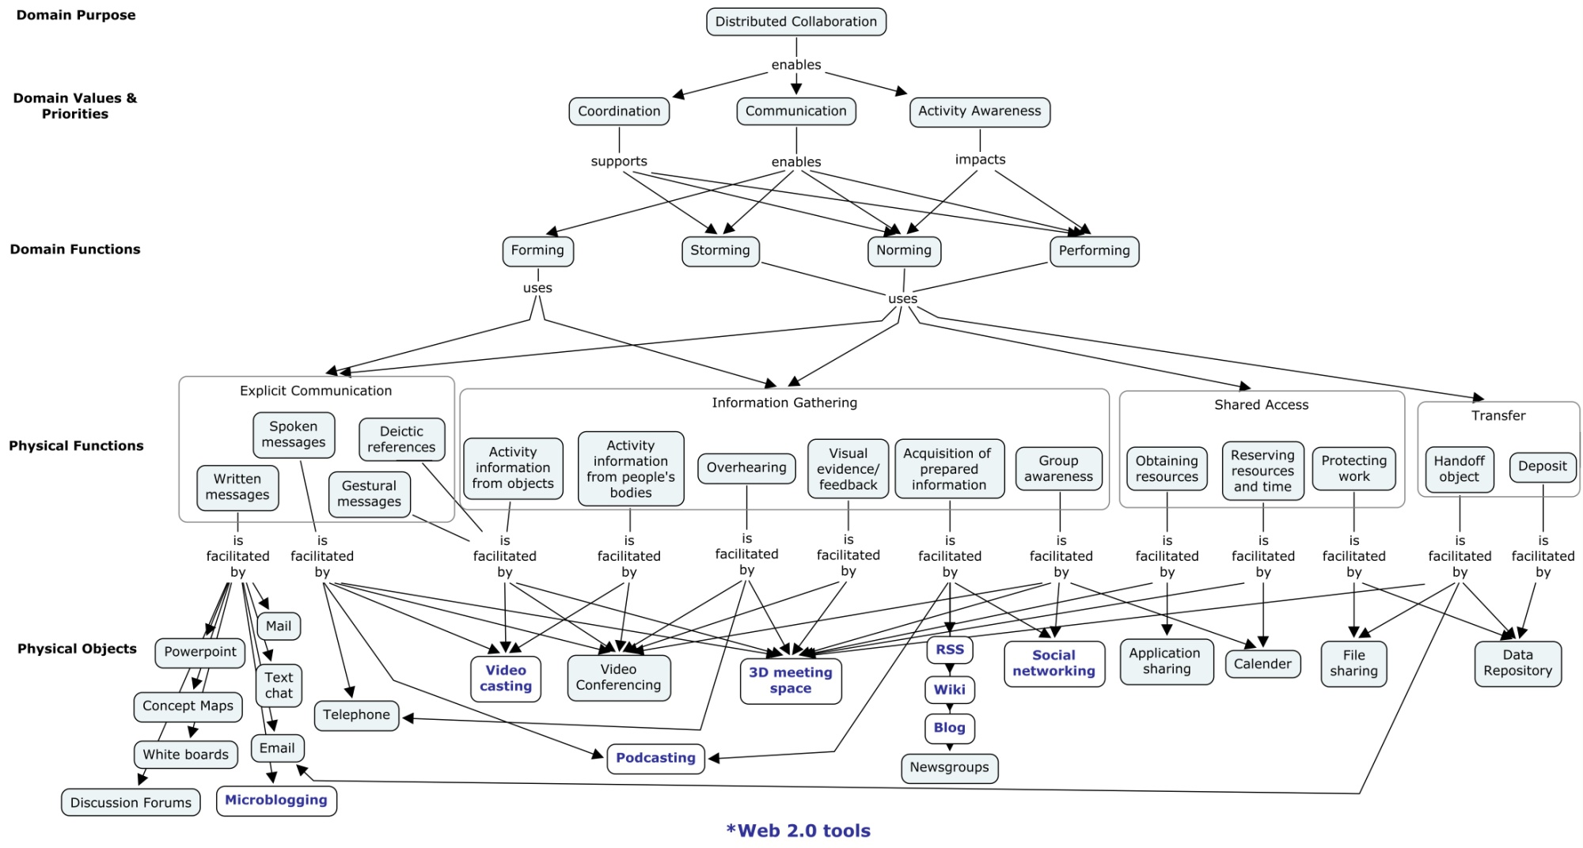

Figure 1b: CWA Phase I: Work Domain Analysis for Distributed Collaboration

Requirements for distributed collaboration for a number of communities (e.g., Hansberger et al., 2010) were studied using a cognitive work analysis (CWA) (Lintern, 2009; Vicente, 1999) for distributed collaboration. A CWA consists of multiple phases that systematically analyze the constraints across work tasks, collaborators/colleagues, organizations, and activities. A CWA typically focuses on how work can be done
compared to other types of task analyses that focus on how work should be done in a limited set of situations, which can decrease the flexibility and adaptability of the sociotechnical system. The CWA identified the critical functions to facilitate distributed collaboration and allowed us to select the appropriate technology to support those functions (Pinelle et al., 2003).

A higher level abstraction of collaboration is provided using Tuckman’s (1965) “Forming, Storming, Norming, and Performing” collaboration model and how individuals communicate and collaborate through social networks (Cross and Parker, 2004). It addresses some of the unique capabilities and challenges of distributed collaboration within a distributed user community including presence and trust, teamwork, and group activity awareness.

- CWA Phase I: Work Domain Analysis (see Figure 1b)
- CWA Phase II: Work Organizational Analysis (see Figure 1c)

Figure 1c: CWA Phase II: Work Organizational Analysis for Distributed Collaboration – Work Tasks along a Work Situation Dimension

The two phase approach could be relevant to studies of tool provision in distributed educational contexts with an appropriate adaptation of the “Work Situations” to be relevant to the educational institution, the courses involved and the communities within and external to the institution in which collaboration occurs. The Work Situations would range from individual and personalised tasks, through course levels, to school and overall educational institution levels, and perhaps to broader collaboration beyond the institution.

Appendix B: VLE Issues – Management Complexity for Self-Hosted Solutions

VLEs such as Blackboard's WebCT provide a "Wall Garden" approach to tool and resources access for courses.

An argument for using a commercially maintained VLE is the potential complexity of hosting and managing the open source alternatives. Our experience of setting up the open source Moodle VLE as an administrator, for a couple of sample courses of different kinds (weekly, topic based and social format) and by adding in the SLoodle module both in the web end of Moodle and in a Second Life classroom has been a frustrating experience. This is a mostly due to the very many layers of user permissions, user roles, different styles of setup, confusion over what happens at site, user and course levels, and interactions between these, and so on.

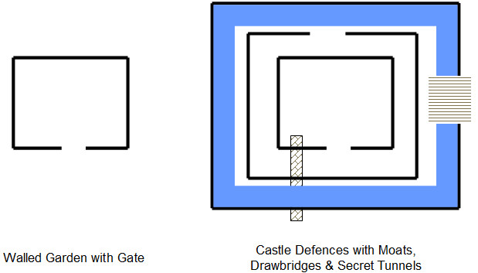

Figure 10: Potential Complexities of Administering VLEs

The model is more like a complex arrangement of "Castle Defences" (see Figure 10) with multiple battlements, with entry points offset from one another and the direction to turn not obvious at every level. There are moats and some bridges across. But you are not sure where they all are. There may even be secret tunnels you don't know about and that others may be able to use, and you suspect there are as it is all so labyrinthine.

This is a serious issue for those choosing to adopt open source approaches, for which the management and risk falls on the educational institution or teacher to set up, use and maintain such systems.

Appendix C: Proposed Specific Assessment Criteria

As background, as a scientist and engineer, I cannot resist going back to the systematic approach I would take on any project and look at the "requirements" for systems in my area of study. There are methods from cognitive psychology, soft systems modelling and requirements engineering that do get used in my own fields, especially when dealing with "human in the loop" and collaborative systems. I have explored, as part of the IDEL11 essay, just such a task and work analysis for distributed collaboration and how it applies to a distance education collaboration context. Of course I can barely scratch the surface here, but I think this area holds promise, and I have already gone into some greater depth than can be included in the essay, but which I include as an appendix. That way it will be around should I (or someone else) be able to return to this in future. It might make a nice cross Education/Informatics Ph.D. topic one day.
During IDEL11, to address one of my objectives for participation in the MSc in e-Learning, I looked at a lot of VLEs, PLE approaches, e-Portfolio systems and emerging open source tools and platforms. I wanted to provide a summary of the different approaches and their relevant contributions to what I consider a necessary mix and match approach for the future. There are screen shots of each platform or tool which I find useful, and since they do not add to the word count I have included them in-line with the text of the essay.

Another of my aims for participation in the MSc in e-Learning was to gain experience and potentially provide inputs to the University’s Distance Education Initiative (DEI) and my own School’s distance education programme discussions, and especially on tool choice and appropriate means to support distributed distance learners with social media and learning environments.

Given this background, I propose the following additional essay specific evaluation criteria:

- Use of “Systems” Approach – Did the inclusion of a generic distributed collaboration requirements and task analysis and literature sources related to this work well? Assess under “Framing and analysing practice” of general assessment scheme.

- Showcase of VLEs, PLEs and Essay-Relevant Features – How well did the essay framework act as a vehicle for showcasing the wide range of educational technology platforms and issues which I gained experience of and explored during IDEL11? Assess under “Development of professional practice” of general assessment scheme.

- Would the analysis provided assist an educational institution in guiding their provision of future educational technology? Assess under “Framing and analysing practice” of general assessment scheme.

Word Count

Title, Abstract and Keywords: 260
Core Text: 4350 (incl. Section Titles and Figure Captions: 200)
Acknowledgements: 120
References: 650
Appendix A: 380
Appendix B: 250
Appendix C (Assessment Criteria): 470

