Support for Distributed Collaboration in the Dismounted Incident Collaboration Environment (DICE)

Austin Tate(1), Jeffrey T. Hansberger(2), Stephen Potter(1) and Gerhard Wickler(1)

- Artificial Intelligence Applications Institute, University of Edinburgh
- US Army Research Laboratory

We are working on support for distributed collaboration for the Dismounted Incident Collaboration Environment (DICE). The overall DICE project at the US Army Research Lab’s Human Research & Engineering Directorate is seeking to give support to offer best advice and specialist assistance when soldiers are injured and are being treated. Distributed collaboration, as required for the DICE community, is typical of the needs of many communities that work across national and organisational boundaries as in multi-national coalitions. This paper gives a summary of work in progress on the DICE project and its distributed collaboration experimentation.

OpenVCE.net and the WoSCR Community

Previous work (Tate et. al, 2010) has developed the open-source approach Open Virtual Collaboration Environment (OpenVCE) facilities and instantiated them in the OpenVCE.net web portal with connections to virtual worlds meeting spaces in Second Life (http://secondlife.com) and the open source OpenSim (http://opensimulator.org). These were used to support a range of experiments and community workshops for the “Whole of Society Crises Response” (WoSCR) Community (Hansberger et al., 2010).

Cognitive Work Analysis
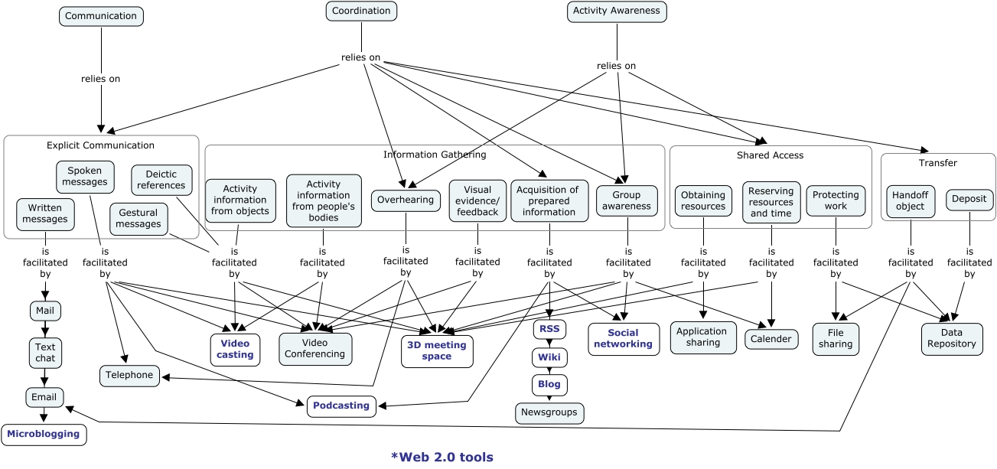
As for the original OpenVCE.net work with the WoSCR community, a “Cognitive Work Analysis” (CWA) (Vicente, 1999) is being performed with the DICE community to establish the main activities they are engaged in when involved in distributed collaboration.

This CWA bottoms out in a number of types of tool or technology which “facilitate” the required communications methods and activities. This set of requirements and types of technology is used to guide selection and provision of key features in the experimental collaboration environment.

Evaluation of Platforms and Technology Features versus the Requirements

Against this set of requirements a table comparing the platforms, tools and techniques which may be employed against the set of required activities is used to structure discussions within the project. A key aim for the OpenVCE-based DICE distributed collaboration support is to simplify the offering and address a number of usability issues discovered in work with the WoSCR community.

Usability and Access Issues

Experience of the use of the OpenVCE.net web portal and the virtual worlds Second Life I-Room meeting space (Tate et al, 2010a) by the WoSCR community (Tate et al., 2010b) indicated that there were a number of issues that it will be best to address in future use by new communities. Some of these involve firewalls and requiring permission to mount software in government and controlled commercial environments. Others related to the "clutter" of items not strictly needed. The call is to "simplify" both the web portal and the virtual worlds meeting space and pare it down to just what is needed to support the DICE requirements.

Warburton (2009) discusses the use of virtual worlds in educational contexts. He provides a table with a rich variety of synchronous and asynchronous communications and presence indication methods, as well as listing some of the issues for usability of virtual worlds like Second Life for education and collaboration. These indicate the particular niche which virtual worlds meeting spaces have in providing support to sync meeting facilities, as well as showing a large degree of overlap of the issues users have in using such spaces with those found during the OpenVCE project use by the WoSCR community.

Fit for Purpose

In a comparison of the platforms available against the DICE cognitive work analysis there is a distinct difference between those features supported on the one hand by the Drupal web portal (mostly for asynchronous activities) and, on the other, by the Virtual Worlds platform (mostly for asynchronous activities), though there is some overlap in community activity awareness. What has emerged in early studies, though, is that Skype provide many of the same kind of sync capabilities needed by the community. In other words, a combination of a web portal and Skype also supports much of the requirement. Interestingly, the MPAT (Multinational Planning Augmentation Team) has found a combination of a web portal and the Skype Voice-Over-IP service is suitable to meet its own requirements for multinational distributed collaboration for coalition activities in support of emergency and crisis response in the Pacific Rim.

Simplifying the OpenVCE.net Web Portal

The Drupal open source content management system (http://drupal.org) was adopted as the core content management and web support framework for the previous OpenVCE.net web portal after experiments with a range of content management and group collaboration tools such as Drupal, Joomla, Moodle, Ning Groups, Facebook, Google Groups, Yahoo Groups, Grou.ps, and other platforms. However, a large number of plug-in modules were added to Drupal to provide the OpenVCE.net facilities. These included Organic Groups, Views, Images, a visual editor, etc. These are now all under scrutiny to check what minimum set meets the DICE user requirements for the web portal.



The existing Drupal open-source software-based web portal as used in OpenVCE.net is assumed as a basis for the work on DICE in this project. This is not an overall choice for the US Army DICE program, but is a choice within our element of the work to maximally draw on the previous work on openVCE.net for the WoSCR Community.
Simplifying the Sync Meeting Spaces – Virtual Worlds Collaboration Facility

Under investigation are simplified and uncluttered versions of the virtual worlds-based I-Room in both Second Life and OpenSim. Eventually the facility is likely to be hosted on the US Army Research Labs’ own MOSES OpenSim-based grid (MOSES, 2011). This will have a very much simplified entry web page to get users in quickly, and provide direct meeting support in the space. A lot of facilities provided for experimentation and demonstrations in the previous WoSCR I-Rooms will be removed.
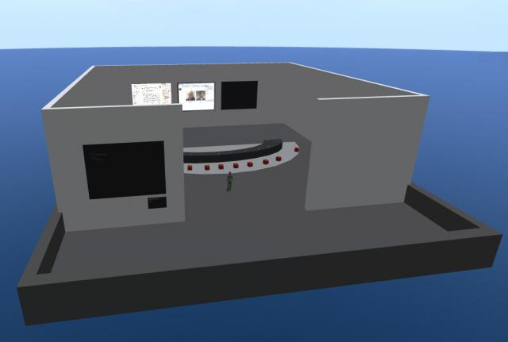
Eventually the DICE I-Room is likely to be located on a dedicated OpenSim region where a range of simplifications can be made. The initial DICE I-Room is placed at 500 virtual metres above an unused area of the region (VCE in Second Life) to be clear of all distractions and other objects.

A single web page at a stable URL will provide everything needed in as short a form as possible. This will be more controllable in OpenSim, with custom simple starter avatars (perhaps basic male and female with self-selected coloured shirts, ethnic skin colour and hair).

The Virtual Worlds Environment will provide a fixed sun set at 11am (so lights are not needed and no changing arrival conditions are encountered by inexperienced users). It would have a fixed arrival point for the facility so an avatar would arrive just outside and to the rear of the meeting, out of normal visual direction for those already in the meeting.

The design of the simplified I-Room may include:

- I-Room orientated pointing North for obvious orientation on arrival.
- Platform simply designed and coloured. Walled so avatars cannot walk over edge, but not too high to act as a hard visual barrier, so looks open and airy.
- Main space 30m x 30m essentially square but with open doorway, and no roof.
- Text chat range is constrained to 20m so no avatars should be seated more than 20m apart.
- An outside arrival area set behind the normal visual field of seated avatars in a meeting.
- Avatars seated generally facing the screens.
- Table in front of avatars to give a feeling of being round the table together.
- A separately placed sideways on "chairperson" seat.
- Some observer seats cleared at the back of the room.
- Seats simple, all areas can be clicked on for sitting. Seats set to allow single click to sit. One simple colour for seats (could be different colours for different I-Rooms to allow instant differentiation).
- Clicker per avatar seat for basic interaction, voting and acknowledgement of some action complete, etc.
- Chairperson has clicker reset button (may not need to be visible to others?)
- Screens provided: a) Central main screen with media-on-a-prim and video capabilities, bookmarks for easy setup and meeting use, and also provided general URL and uploaded image capability on need. b) General shared co-browser. C) Blackboard/whiteboard for notes, text items, URLs and tags, etc.
- Arrival point information board.

Experiments are taking place with the OpenSim open-source virtual worlds platform. In particular the project has a simulator region set up on the US Army’s Simulation Training Center’s MOSES grid. Project MOSES is an exploratory effort designed to evaluate the ability of the Open Simulator to replace Second Life Enterprise (SLE) for independent and secured access to a Virtual World environment. See http://fvwc.army.mil/moses/

Acknowledgements

Research was sponsored by the US Army Research Laboratory and was accomplished under Cooperative Agreement Number W911NF-11-2-0083. The University of Edinburgh, the U.S. Government and research sponsors are authorized to reproduce and distribute reprints and online copies for their purposes notwithstanding any copyright annotation herein. The views and conclusions contained in this document are those of the authors and should not be interpreted as necessarily representing the official policies or endorsements, either expressed or implied, of other parties.

References

MOSES (2011) MOSES: Military Open Simulator Enterprise Strategy.
http://fvwc.army.mil/moses/

Tate, A., Chen-Burger, Y-H., Dalton, J., Potter, S., Richardson, D., Stader, J., Wickler, G., Bankier, I., Walton, C. and Williams, P.G. (2010a) I-Room: A Virtual Space for Intelligent Interaction, IEEE Intelligent Systems, Vol. 25, No. 4, pp 62-71, July-August 2010, IEEE Computer Society.

Tate, A., Chen Burger, Y-H., Dalton, J., Potter, S., Wickler, G., Carley, K.M., Kunkel, F., Cross, R., Hansberger, J.T. and Moon, B. (2010b), Open Virtual Collaboration Environment for the Whole of Society Crisis Response Community, Proceedings of the Sixth International Conference on Knowledge Systems for Coalition Operations (KSCO-2010) (Lawton, J. (ed.)), Vancouver, B.C., Canada, September 21-23, 2010.

Vicente, K. J. (1999). Cognitive Work Analysis. Lawrence Erlbaum Associates, Mahwah, NJ, USA.

Warbuton, S. (2009). "Second Life in higher education - Assessing the potential for and the barriers to deploying virtual worlds in learning and teaching", British Journal of Educational Technology, 40(3), 414-426.

